Purpose of the Blight and Substandard Study
The purpose of completing this Blight and Substandard study is to examine existing conditions within a specific part of Grand Island. This study has been commissioned by the CIK Investments in order to analyze the possibility of declaring the area as blighted and substandard.

The City of Grand Island, when considering conditions of Blight and Substandard, will be looking at those issues and definitions provided for in the Nebraska Community Redevelopment Law as found in Chapter 18, Section 2104 of the Revised Nebraska State Statutes, as follows:

“The governing body of a city, to the greatest extent it deems to be feasible in carrying out the provisions of Sections 18-2101 to 18-2144, shall afford maximum opportunity, consistent with sound needs of the city as a whole, to the rehabilitation or redevelopment of the community redevelopment area by private enterprises. The governing body of a city shall give consideration to this objective in exercising its powers under sections 18-2101 to 18-2144, including the formulation of a workable program, the approval of community redevelopment plans consistent with the general plan for the development of the city, the exercise of its zoning powers, the enforcement of other laws, codes, and regulations relating to the use and occupancy of buildings and improvements, the disposition of any property acquired, and providing of necessary public improvements”.

The Nebraska Revised Statutes §18-2105 continues by granting authority to the governing body for formulation of a workable program. The statute reads,
“The governing body of a city or an authority at its direction for the purposes of the Community Development Law may formulate for the entire municipality a workable program for utilizing appropriate private and public resources to eliminate or prevent the development or spread of urban blight, to encourage needed urban rehabilitation, to provide for the redevelopment of substandard and blighted areas, or to undertake such of the aforesaid activities or other feasible municipal activities as may be suitably employed to achieve the objectives of such workable program. Such workable program may include, without limitation, provision for the prevention of the spread of blight into areas of the municipality which are free from blight through diligent enforcement of housing, zoning, and occupancy controls and standards; the rehabilitation or conservation of substandard and blighted areas or portions thereof by replanning, removing congestion, providing parks, playgrounds, and other public improvements by encouraging voluntary rehabilitation and by compelling the repair and rehabilitation of deteriorated or deteriorating structures; and the clearance and redevelopment of substandard and blighted areas or portions thereof.”

Blight and Substandard are defined as the following:
“Substandard areas means an area in which there is a predominance of buildings or improvements, whether nonresidential or residential in character, which, by reason of dilapidation, deterioration, age or obsolescence, inadequate provision for ventilation, light, air, sanitation, or open spaces, high density of population and overcrowding, or the existence of conditions which endanger life or property by fire and other causes, or any combination of such factors, is conducive to ill health, transmission of disease, infant mortality, juvenile delinquency, and crime, (which cannot be remedied through construction of prisons), and is detrimental to the public health, safety, morals, or welfare;”

“Blighted area means an area, which (a) by reason of the presence of a substantial number of deteriorated or deteriorating structures, existence of defective or inadequate street layout, faulty lot layout in relation to size, adequacy, accessibility, or usefulness, insanitary or unsafe conditions, deterioration of site or other improvements, diversity of ownership, tax or special assessment delinquency exceeding the fair value of the land, defective or unusual conditions of title, improper subdivision or obsolete platting, or the existence of conditions which endanger life or property by fire and other causes, or any combination of such factors, substantially impairs or arrests the sound growth of the community, retards the provision of housing accommodations, or constitutes an economic or social liability and is detrimental to the public health, safety, morals, or welfare in its present condition and use and (b) in which there is at least one of the following conditions: (i) Unemployment in the designated area is at least one hundred twenty percent of the state or national average; (ii) the average age of the residential or commercial units in the area is at least forty years; (iii) more than half of the plotted and subdivided property in an area is unimproved land that has been within the city for forty years and has remained unimproved during that time; (iv) the per capita income of the area is lower than the average per capita income of the city or village in which the area is designated; or (v) the area has had either stable or decreasing population based on the last two decennial censuses. In no event, shall a city of the metropolitan, primary, or first class designate more than thirty-five percent of the city as blighted, a city of the second class shall not designate an area larger than fifty percent of the city as blighted, and a shall not designate an area larger than one hundred percent of the as blighted;”

This Blight and Substandard Study is intended to give the Grand Island Community Redevelopment Authority, Hall County Regional Planning Commission and Grand Island City Council the basis for identifying and declaring Blighted and Substandard conditions existing within the City’s jurisdiction. Through this process, the City and property owners will be attempting to address economic and/or social liabilities which are harmful to the well-being of the entire community.

The study area can be seen in Figure 1 of this report. A Redevelopment Plan to be submitted in the future will contain, in accordance with the law, definite local objectives regarding appropriate land uses, improved traffic, public transportation, public utilities and other public improvements, and the proposed land uses and building requirements in the redevelopment area and shall include:
- The boundaries defining the blighted and substandard areas in question (including existing uses and conditions of the property within the area), and
- A list of the conditions present which qualify the area as blighted and substandard.

Blight and Substandard Eligibility Study
This study targets a specific area within an established part of the community for evaluation. The area is indicated in Figure 1 of this report. The existing uses in this area includes several commercial uses within the corporate limits of Grand Island.

Through the redevelopment process the City of Grand Island can guide future development and redevelopment throughout the area. The use of the Community Redevelopment Act by the City of Grand Island is intended to redevelop and improve the area. Using the Community Redevelopment Act, the City of Grand Island can assist in the elimination of negative conditions and implement different programs/projects identified for the City.

The following is the description of the designated area within Grand Island.

Study Area
The Study consists of area described as follows: The Point of Beginning is the NW corner of a lot described as Bosselman Brothers Second Sub Lot 2; thence, northeasterly along the north property line of said lot and continuing northeasterly to the NE corner of a lot described as Bosselman Brothers Sub Lot 5; thence, southerly along the east property line of said lot and continuing southerly along the eastern property lines of properties until intersecting with the southeast corner of Lot A Stehr’s Sub Lot 10; thence westerly along the south lot line of said lot to the southwest corner of said lot; thence, southerly along the west property line of Lot E of Stehr’s Sub Lot 10 and continuing southerly along west property lines to the centerline of E. Seedling Mile Road; thence, westerly along said centerline to the extended east property line of Lot 3 Stehr’s Subdivision; thence, northerly along said east property line to the northeast corner of said corner; thence, westerly along the north property to the northwest corner of said lot; thence, southerly along the west property line to the centerline of E. Seedling Mile Road; thence, westerly along said centerline to the extended western property line of a Lot described as Bosselman Brothers Sub Lot 1; thence, northerly along said extended west property line and continuing to the POB. Total area is 35.62 acres.

Figure 1
Study Area Map
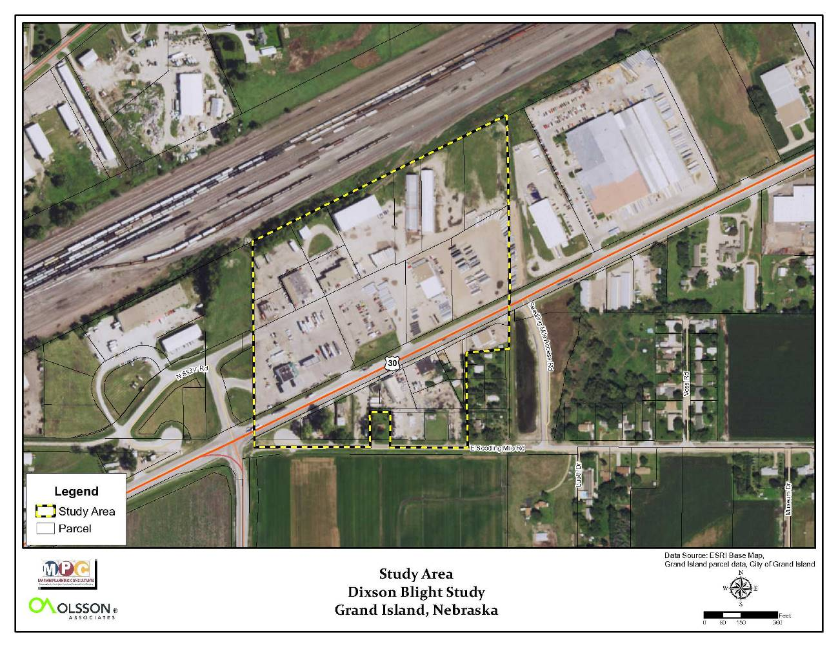
Source: Marvin Planning Consultants 2016

Existing Land Uses
The term “Land Use” refers to the developed uses in place within a building or on a specific parcel of land. The number and type of uses are constantly changing within a community, and produce several impacts either benefitting or detracting from the community. Because of this, the short and long-term success and sustainability of the community is directly contingent upon available resources utilized in the best manner given the constraints the City faces during the planning period. Existing patterns of land use are often fixed in older communities and neighborhoods, while development in newer areas is often reflective of current development practices.

Existing Land Use Analysis within Study Area
As part of the planning process, a survey was conducted through both in-field observations, as well as data collection online using the Hall County Assessors website. This survey noted the use of each parcel of land within the study area. These data from the survey are analyzed in the following paragraphs.

TABLE 1: EXISTING LAND USE, GRAND ISLAND - 2016
Source: 2016 Grand Island Blight Study Area 21, Marvin Planning Consultants

Table 1 includes the existing land uses for the entire study area. The table contains the total acres determined per land use from the survey; next is the percentage of those areas compared to the total developed land; and finally, the third set of data compare the all uses to the total area within the Study Area. As discussed previously, the Study Area is commercial (86.6%) and land considered vacant accounts for only 2.8% of the total area.

Figure 2

Existing Land Use Map

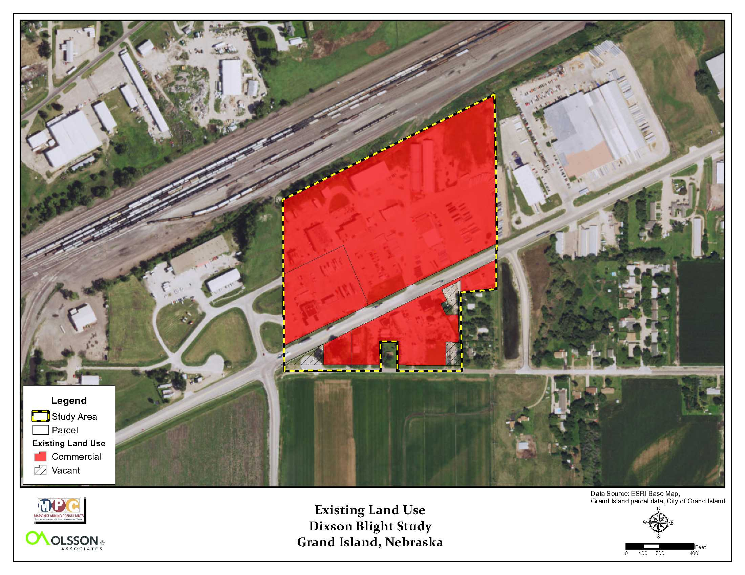
Source: Marvin Planning Consultants, 2016

Findings of Blight and Substandard Conditions Eligibility Study
This section of the study examines the conditions found in the study area. The Findings Section will review the conditions based upon the statutory definitions.

Contributing Factors
There were several conditions examined and evaluated in the field and online. There are many conditions that will be reviewed in detail, on the following pages, while some of the statutory conditions are not present.

Structural Conditions
Structural conditions were evaluated, structures were either rated as: Very Good, Good, Fair, Average, or badly worn. The data and rating system comes from the Hall County Assessor’s database and is the same database used to value properties in the area.

Based upon the data provided to the planning team, the following is the breakdown for structures in the study area:
- 0 ( 0.0%) structures rated as very good
- 1 ( 3.9%) structures rated as good
- 0 ( 0.0%) structure rated as fair
- 16 (61.5%) structures rated as average
- 9 (34.6%) structure rated as badly worn

Figure 3
Structural Conditions
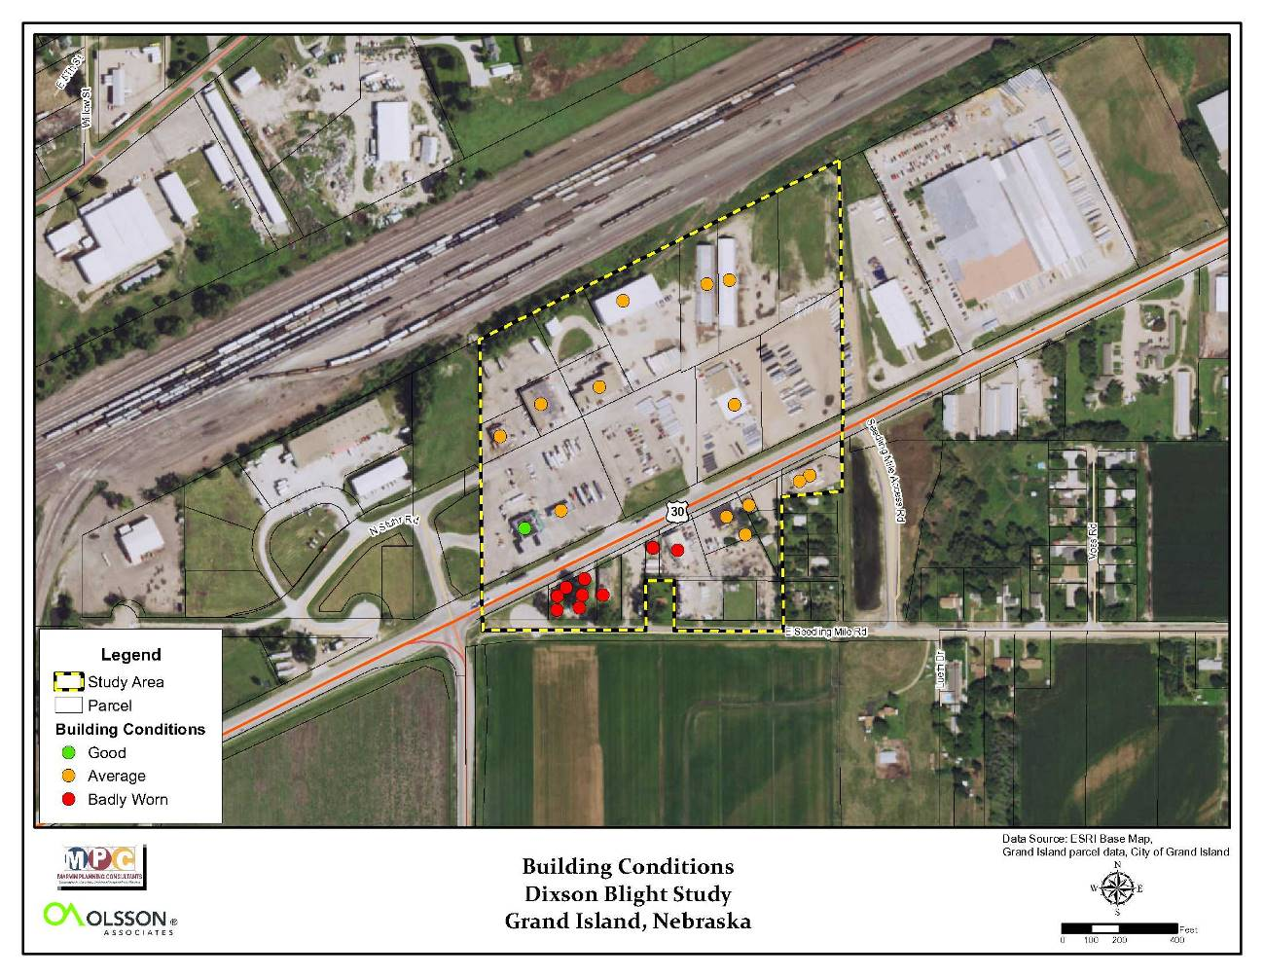
Source: Marvin Planning Consultants, 2016

Based upon these data, an assumption has been made that average condition and less would constitute less than desirable conditions due to age and conditions. It is common that the older a structure gets the more maintenance and upkeep are required to maintain a good or higher condition. Even an average structure will show some signs of deteriorating which in turn can become a dilapidated structure in the future if it is not addressed over time. Overall, 96.1% of the structures in this study area are average condition or worse.

Due to the stated conditions found in the Hall County Assessor’s data, the condition of the structure is a contributing factor.

Deterioration of Site or Other Improvements
Sidewalk Conditions
Sidewalks, regardless of the area and uses within a community, should provide a safe means of movement for pedestrians. Sidewalks become increasingly more important along transportation routes considered to be arterials and highways. A sidewalk allows for pedestrian movement while keeping people off heavily traveled streets.

The sidewalk conditions were analyzed in the Study Area. The sidewalks were rated on four categories; adequate, deteriorating, dilapidating, and missing completely.

Figure 4
Sidewalk Conditions
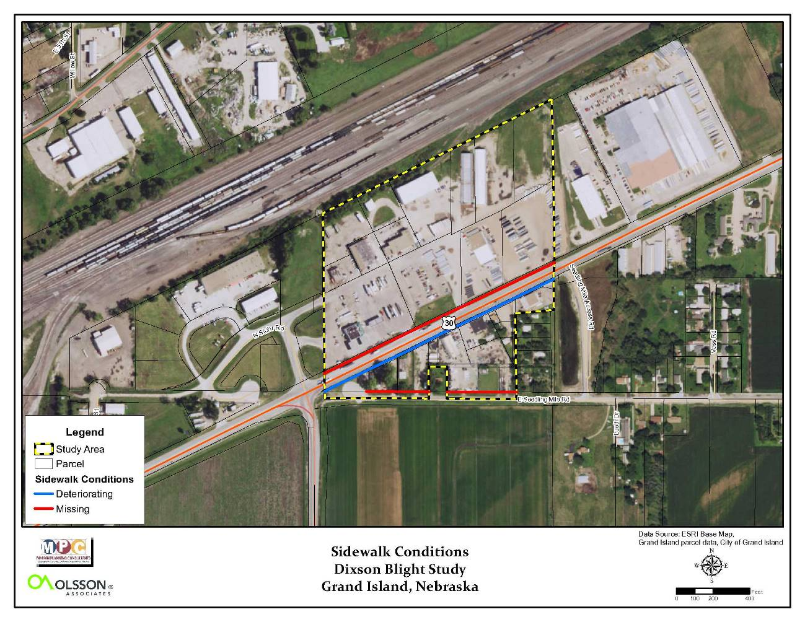
Source: Marvin Planning Consultants, 2016

Within the study area there is approximately 3,508 lineal feet of area where sidewalk could or should be located. After reviewing the conditions in the field, the following is how the sidewalk conditions breakdown within the study area:
- 0 (0.0%) lineal feet of adequate sidewalk
- 1,394 (39.7%) lineal feet of deteriorating sidewalk
- 2,114 (60.3%) lineal feet of no sidewalk.

The only sidewalk in the study area is along the south side of US Highway 30. There is no sidewalk located along the north side or along Seedling Mile Road.

Drainage Conditions
Grand Island has a long history of drainage issues due to the extreme flatness of the area, as well as the high-water table. Topography and soils can have a major impact on how a given portion of the city drains. The area designated in this Study Area is nearly flat or has an extremely small slope.

The field survey examined the entire area for potential drainage problems.

Another item of note deals with the actual number of stormwater inlets in the study area. This area was developed as a large hard surfaced and graveled area; therefore, there are very few places for the water to run during wet periods.

Figure 5 is an existing topographic map from the City of Grand Island’s website. The map confirms the flatness of the area along US Highway 30. The most common contour identified on the map is the 1835; however, they are separated by a great deal of distance. This distance is what identifies the flatness of the area.

The potential for standing water on this site is great. Standing water from poor drainage can be a catalyst for health issues like West Nile due to the potential mosquito breeding during the summer months.

Figure 5
Topographic Map of Study Area
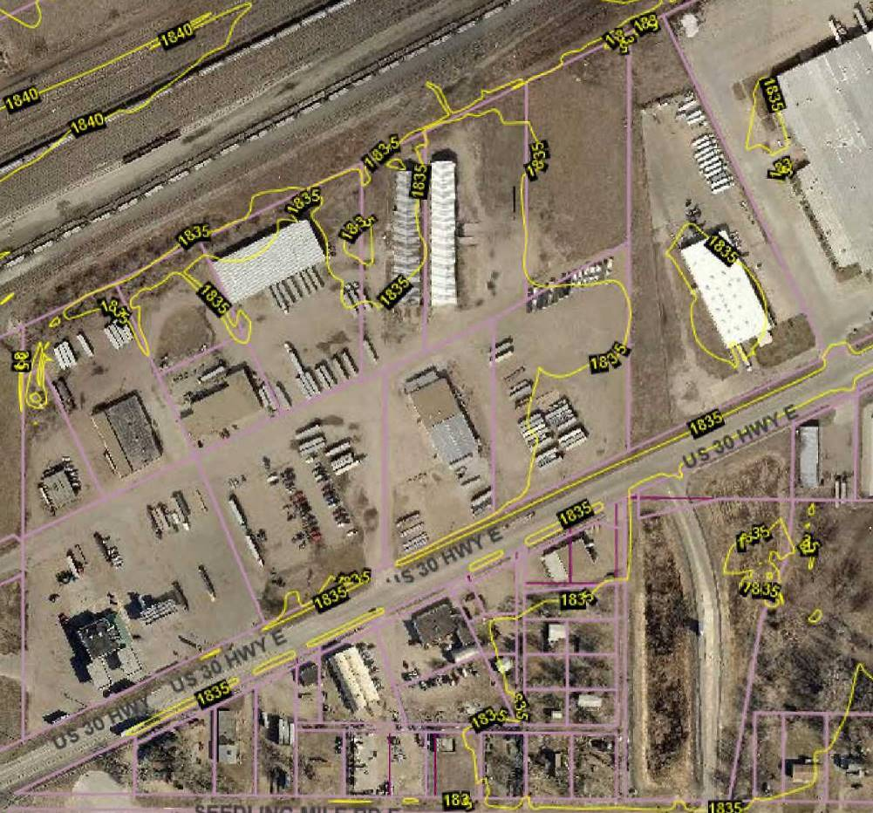
Source: City of Grand Island (topographic map) and Marvin Planning Consultants

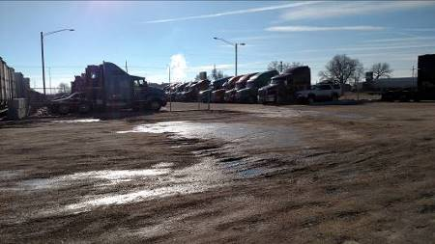
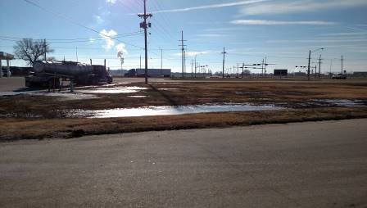
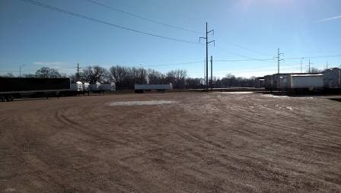
Faulty Lot Layout
Faulty lot layout can lead to several issues including size of a lot, adequacy of the lot for the use, accessibility to the lot and/or the usefulness of the lot. There are a few factors to examine within this particular study area.

Accessibility of the Lots
Currently, the area has three points of access. Two of these are located along US Highway 30 and lead directly onto properties located along US Highway 30. The third access point is off Stuhr Road and leads directly onto a lot. None of the three access points go to an internal roadway system or right-of-way. Even with properly filed easements, access to some of these lots could become an issue in the future.

Figure 7
Lot Layout of Study Area
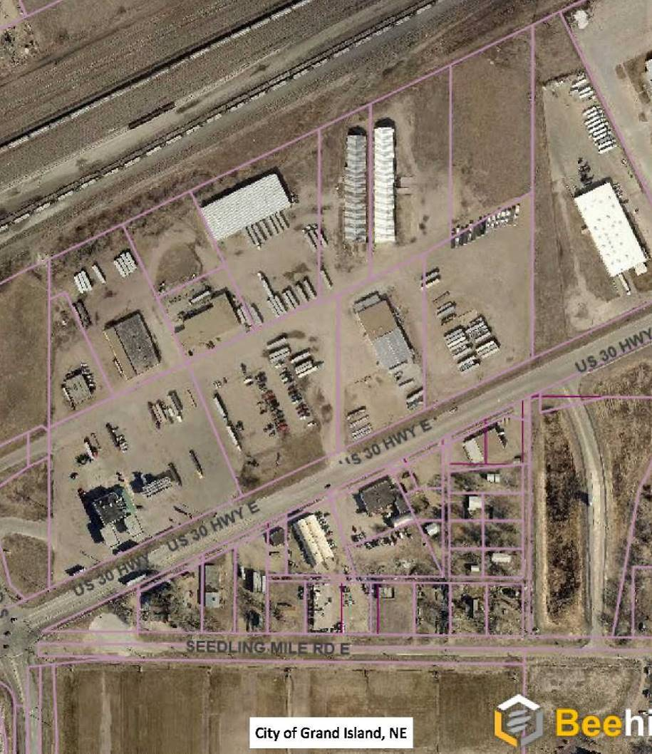
Lots along the north side of the study area does not have direct access from US Highway 30 except via easements or across other lots owned by similar owners.
Basic travel ways are across properties and property lines.
Source: City of Grand Island (Lot lines) and Marvin Planning Consultants

Insanitary or Unsafe Conditions
There are several factors tending to fall under this category. The study area was found to have several factors falling into insanitary and unsafe. The following will outline the conditions found.

Detention Cell
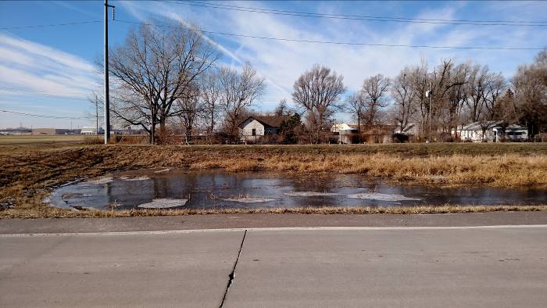
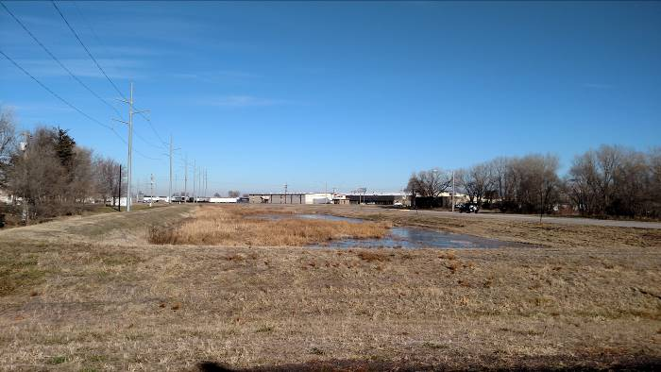
The study area is bounded by a larger detention cell on the east. Although this cell is not in the study area, its proximity creates potential unsafe conditions. At the time of the study, the cell was partially filled due to recent rains and snow melt. The cell, though necessary to drain portions of the area, it still presents an unsafe condition.
Unsecured Areas
The primary parcel is currently unsecured and has the hazardous building as discussed in the previous paragraph. Steps need to be taken to either secure the property or eliminate the hazardous conditions. These areas include different trucking materials, tractors, damaged vehicles, semi-trailers, and more.

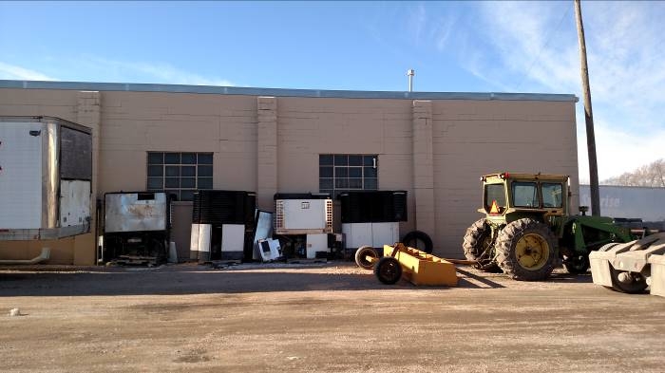
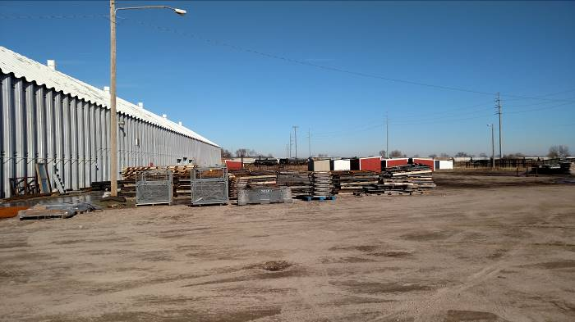
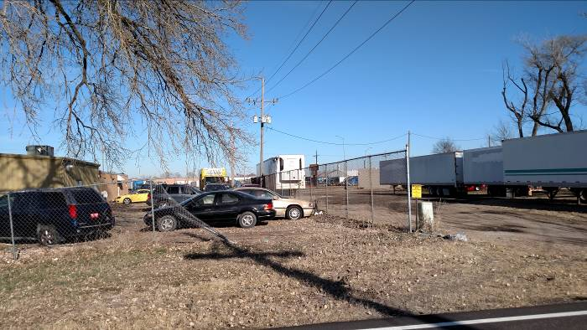
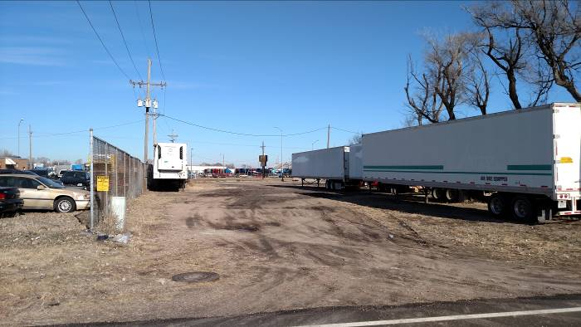

Existence of Conditions endangering life or property due to fire or other causes
Located within the study area there are factors present that are a danger to life or property due to fire or other causes. Many these factors have been previously discussed in this report. These factors include:
- Detention cell near the study area
- Proximity to the Union Pacific Railroad Mainline. The mainline, considering the number of trains per day provides a risk for derailment and or sparks creating a fire along the route.
- Number of incompatible uses including industrial uses with outside storage adjacent to inhabited residential structures.

Based upon the field analysis, there are sufficient elements present to meet the definition of dangerous conditions within the Study Area.

Combination of factors which are impairing and/or arresting sound growth
Within this study area there are many factors that are impairing or arresting sound growth. A couple of these include:
- The lack of good access to several properties within the study area.
- The Union Pacific Railroad Mainline to the north blocks any possible growth to the north.
- Size of lots (smaller), especially along the south side of the study area.

Based upon the review of the area, there are sufficient elements present to meet the definition of combination of factors which are impairing and/or arresting sound growth within the Study Area.

Stable or decreasing population based on the last two decennial censuses
Over the past 20 years the population within the study area has been stable or decreasing. The population within the Study Area has had limited population for the past two decennial censuses. Therefore, it meets the criteria for a stable or decreasing population.

Diversity of Ownership
Within this small study area, there are 17 different property owners including the City of Grand Island and the State of Nebraska. Coordination of any redevelopment of this area may require specific intervention that a Blight and Substandard designation offers.

Figure 8
Improper Subdivision or Obsolete Platting
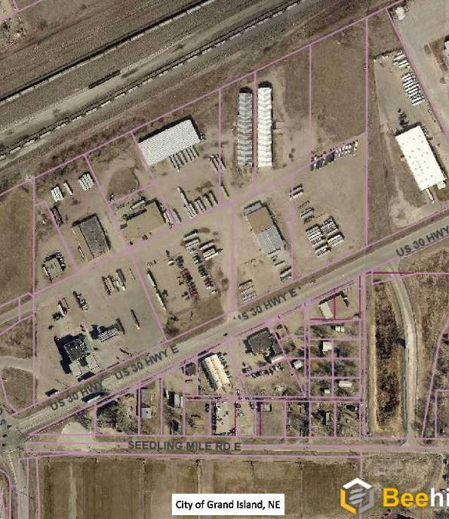
Source: City of Grand Island and Marvin Planning Consultants
Improper Subdivision or obsolete platting
This criterion follows closely with the Faulty Lot Layout. Much of this area can be considered to be improperly platted. Access is an issue for parts of this study area, See Figure 8.

Defective/Inadequate street layouts
This area contains defective street layouts, primarily since there are minimal platted streets within the area. The northern portion of the study area has no platted streets, only access easements. Someone unfamiliar with the area may be unaware of critical movement patterns made by the truck traffic in the area.

Average age of the residential or commercial units in the area is at least 40 years
Age of structures can be a contributing factor to the blighted and substandard conditions in an area. Statutes allow for a predominance of structures 40 years of age or older to be a contributing factor regardless of their condition. The following paragraphs document the structural age of the structures within the Study Area. Note the age of structure was determined from the Appraisal data within the Hall County Assessor’s website data.

Within the study area there is a total of two primary structures. After researching the structural age on the Hall County Assessor’s and Treasurer’s websites, the following breakdown was determined:
- 23 (88.5%) units were determined to be 40 years of age or older
- 3 (11.5%) units were determined to be less than 40 years in age

In addition, if all the actual ages of the structures were added together, then divided by the 26 structures within the study area, the mean age would be 58.07 years of age, see Table 1. The mean age also exceeds the 40-year requirement.

The age of the structures would be a direct contributing factor.

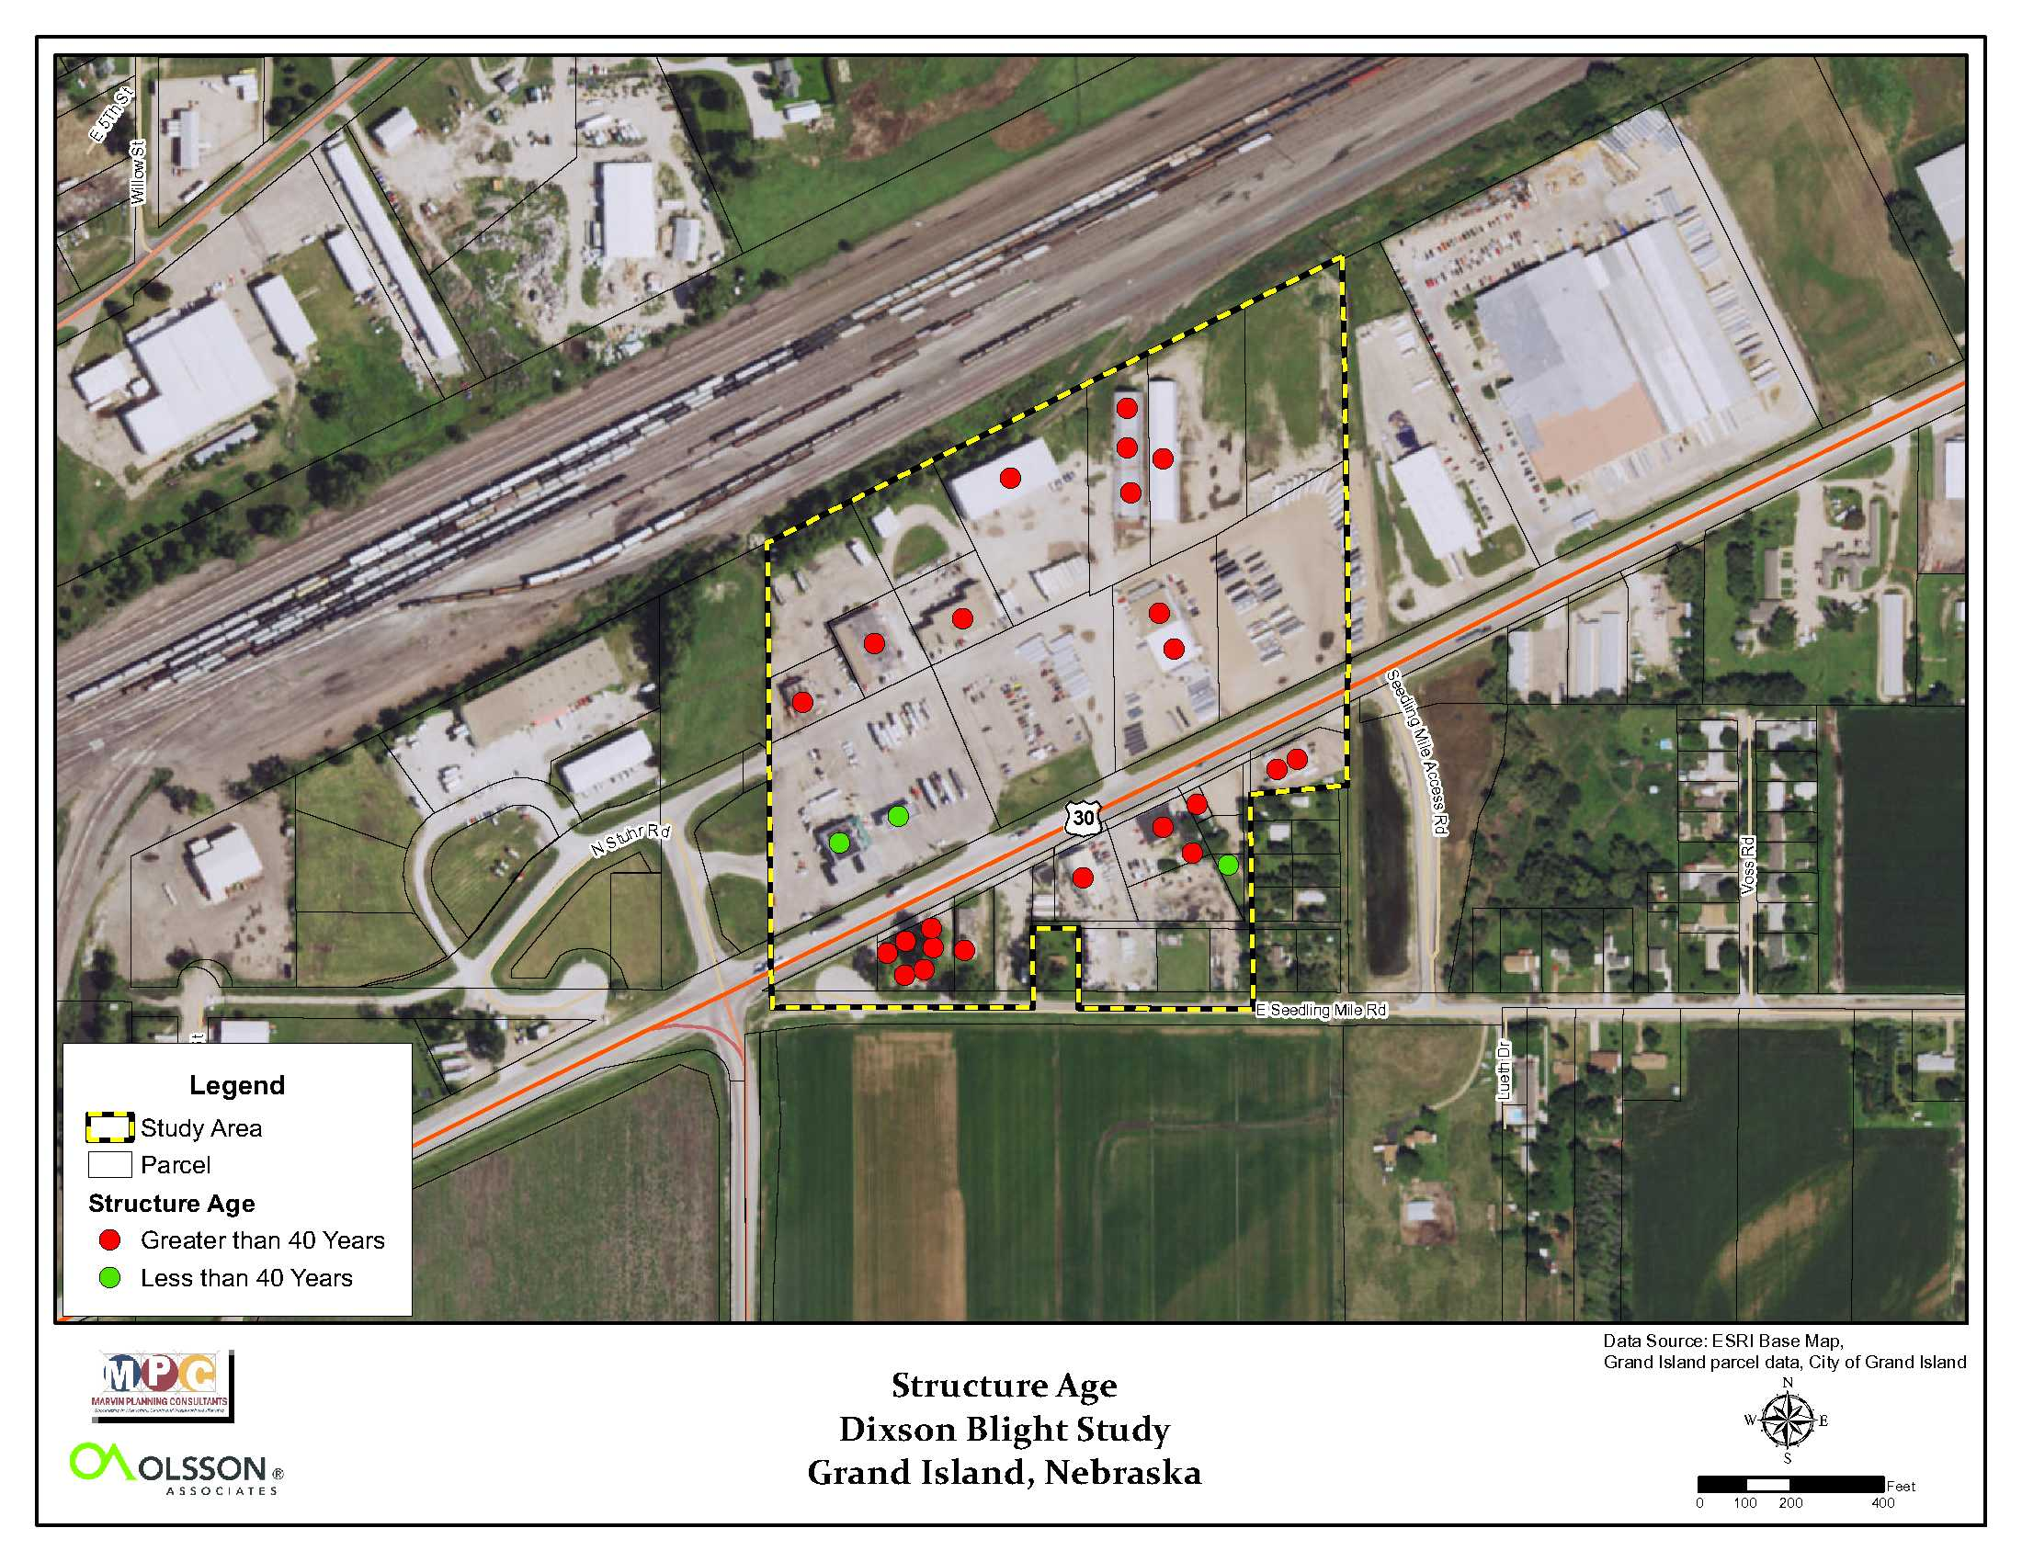
Figure 9 Unit Age Map

Source: Marvin Planning Consultants, 2016

Table 2 Average Unit Age Calculation

Blighting Summary

Criteria under Part A of the Blight Definition

These conditions are contributing to the blighted conditions of the study area.

- Substantial number of deteriorating structures
  - Within the study are 96.1% of the structures were deemed to be in a deteriorated state or worse.

- Deterioration of site or other improvements
  - The only sidewalk in the area is located along the south edge of US Highway 30 and is in a deteriorated state.
  - Drainage of existing site is difficult based upon the existing topography.

- Faulty Lot Layout
  - Accessibility to some lots is currently a problem.

- Insanitary or Unsafe Conditions
  - Lack of sidewalk in the Study Area.
  - Deteriorated structure.
  - Unsecured site which contains hazardous materials.
  - Detention cell adjacent to the study area.

- Dangerous conditions to life or property due to fire or other causes
  - Dilapidated structures in study area.
  - Lack of sidewalk within the Study Area
  - Union Pacific Railroad Mainline adjacent to the study area
  - Lack of defined trafficways within the area.

- Combination of factors which are impairing and/or arresting sound growth
  - Lack of good access to the site.
  - Union Pacific Railroad Mainline adjacent to the area.

- Diversity of Ownership
  - There are currently 16 different owners listed for the property within the Study Area.

- Improper Subdivision or Obsolete Platting
  - Accessibility to some lots is currently a problem.
  - Lack of platted rights-of-way within the area, especially in the northern portion.

- Defective/Inadequate street layouts
  - Lack of platted rights-of-way within the area, especially in the northern portion.

Criteria under Part B of the Blight Definition
- The average age of the residential or commercial units in the area is at least forty years
- 23 (88.5%) units were determined to be 40 years of age or older
- 3 (11.5%) units were determined to be less than 40 years in age

- Stable or decreasing population based on the last two decennial censuses
  - The population of the Study Area has remained stable over the past 22 years.

Other criteria for Blight were not present in the area
- Tax or special assessment delinquency exceeding fair value of the land.
- Defective or unusual condition of title,
- Unemployment in the designated area is at least 120% of the state or national average.
- One-half of unimproved property is over 40 years old.
- The per capita income of the area is lower than the average per capita income of the city or village in which the area is designated.

These issues were either not present or were limited enough as to have little impact on the overall condition of the study area.
Substandard Conditions
Average age of the residential or commercial units in the area is at least 40 years
Age of structures can be a contributing factor to the blighted and substandard conditions in an area. Statutes allow for a predominance of structures 40 years of age or older to be a contributing factor regardless of their condition. The following paragraphs document the structural age of the structures within the Study Area. Note the age of structure was determined from the Appraisal data within the Hall County Assessor’s website data.

Within the study area there is a total of two primary structures. After researching the structural age on the Hall County Assessor’s and Treasurer’s websites, the following breakdown was determined:
- 23 (88.5%) units were determined to be 40 years of age or older
- 3 (11.5%) units were determined to be less than 40 years in age

In addition, if all the actual ages of the structures were added together, then divided by the 26 structures within the study area, the mean age would be 58.07 years of age, see Table 1. The mean age also exceeds the 40-year requirement.

The age of the structures would be a direct contributing factor.

Figure 10 Unit Age Map

Source: Marvin Planning Consultants, 2016

Table 2 Average Unit Age Calculation

Substandard Summary
Nebraska State Statute requires that “…an area in which there is a predominance of buildings or improvements, whether nonresidential or residential in character, which, by reason of dilapidation, deterioration, age or obsolescence, inadequate provision for ventilation, light, air, sanitation, or open spaces, high density of population and overcrowding, or the existence of conditions which endanger life or property by fire and other causes, or any combination of such factors, is conducive to ill health, transmission of disease, infant mortality, juvenile delinquency, and crime, (which cannot be remedied through construction of prisons), and is detrimental to the public health, safety, morals, or welfare;”

This Study Area in Grand Island meets the defintion of Substandard as defined in the Revised Nebraska State Statutes.

Findings for Grand Island Blight Study Area #21
Blight Study Area #21 has several items contributing to the Blight and Substandard Conditions. These conditions include:

Blighted Conditions
Part A of the Blight Definition
- Substantial number of deteriorated or deteriorating structures
- Deterioration of site or other improvements
- Faulty Lot Layout
- Insanitary and Unsafe Conditions
- Combination of factors which are impairing and/or arresting sound growth
- Stable or decreasing population based on the last two decennial censuses
- Diversity of Ownership
- Improper Subdivision or Obsolete Platting
- Defective/Inadequate Street Layout
Part B of the Blight Definition
- The average age of the residential or commercial units in the area is at least forty years
- Stable or decreasing population based on the last two decennial censuses

Substandard Conditions
- Average age of the buildings and improvements in the area is at least forty years

