City Council  Linna Dee Donaldson,  Michelle Fitzke  Chuck Haase  Julie Hehnke  Jeremy Jones  Vaughn Minton, President  Mitch Nickerson  Mike Paulick  Roger Steele  Mark Stelk | 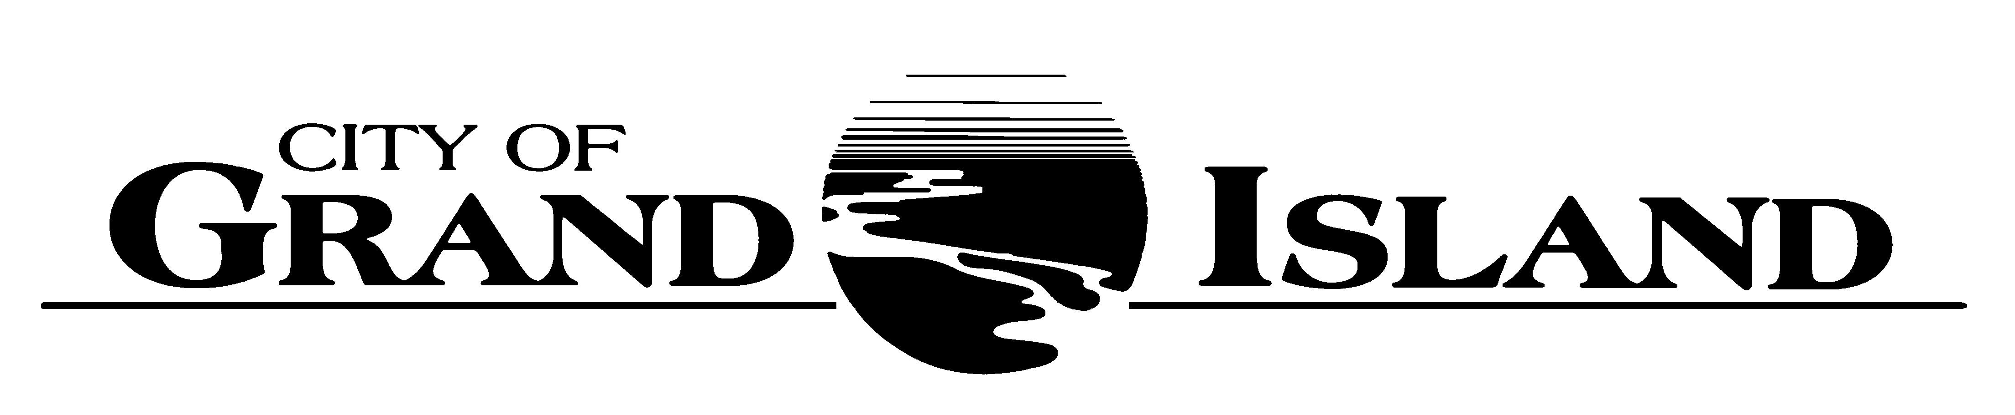  City Council Meeting Agenda  Council Chambers  City Hall  100 East First Street | Mayor  Jeremy L. Jensen  City Administrator  Marlan Ferguson  City Clerk  RaNae Edwards
Regular Meeting of January 9, 2018
7:00 p.m.

CALL TO ORDER

INVOCATION – Pastor Kelly Karges, Trinity United Methodist Church, 511 North Elm Street

PLEDGE OF ALLEGIANCE

ROLL CALL

A - SUBMITTAL OF REQUESTS FOR FUTURE AGENDA ITEMS

Individuals who have appropriate items for City Council consideration should complete the Request for Future Agenda Items form located at the Information Booth. If the issue can be handled administratively without Council action, notification will be provided. If the item is scheduled for a meeting or study session, notification of the date will be given.

B - RESERVE TIME TO SPEAK ON AGENDA ITEMS

This is an opportunity for individuals wishing to provide input on any of tonight's agenda items to reserve time to speak. Please come forward, state your name and address, and the Agenda topic on which you will be speaking.

C – PRESENTATIONS AND PROCLAMATIONS

None Scheduled.

E – PUBLIC HEARINGS

A public hearing is a formal process intended to solicit public comment. A public hearing is structured, in part, to meet legal requirements. After a brief presentation on the item, any public comments will be heard. Questions and discussion from the Council will take place under the respective action items.

E-1. Public Hearing on Amendment to the Redevelopment Plan for CRA Area No. 1 located at 209 West 3rd Street (Take Flight Investments, LLC).

E-2. Public Hearing on Acquisition of Permanent Easements for West Stolley Park Road and Engleman Road Sanitary Sewer Extension; Project No. 2017-S-3 and Sanitary Sewer District No. 540T (Garner, Rowe, and Shafer & Hartmann Farms, LLC).

F – ORDINANCES

F-1. #9672 - Consideration of Amendment to Chapter 22-151 and 22-153 of the Grand Island City Code Related to Motor Vehicle Fee.

G – CONSENT AGENDA

G-1. Approving Minutes of December 19, 2017 City Council Regular Meeting.

G-2. #2018-1 - Approving Certificate of Final Completion for and Setting the Board of Equalization Hearing for February 13, 2018, for Water Main District 470T - Hwy 2 from North Road east about 1/2 Mile.

G-3. #2018-2 - Approving the Purchase of Power and Concentric Neutral Cable.

G-4. #2018-3 - Approving the Purchase of Distribution Transformers.

G-5. #2018-4 - Approving Authorization for Emergency Sanitary Sewer Repair at 1st Street and Elm Street.

G-6. #2018-5 - Approving the Certificate of Compliance with the Nebraska Department of Transportation for Maintenance Agreement No. 12; Calendar Year 2017.

G-7. #2018-6 - Approving Temporary Construction Easements for West Stolley Park Road and Engleman Road Sanitary Sewer Extension; Project No. 2017-S-3 and Sanitary Sewer District No. 540T (Garner, Rowe, and Shafer & Hartmann Farms, LLC).

G-8. #2018-7 - Approving Acquisition of Permanent Easements for West Stolley Park Road and Engleman Road Sanitary Sewer Extension; Project No. 2017-S-3 and Sanitary Sewer District No. 540T (Garner, Rowe, and Shafer & Hartmann Farms, LLC).

G-9. #2018-8 - Approving Purchase of Heating & Air Conditioning Unit at Jackrabbit Run Golf Course.

G-10. #2018-9 - Approving Emergency Procurement of Fuel Oil for Burdick Station.

H – REQUESTS AND REFERRALS

None Scheduled.

I – RESOLUTIONS

I-1. #2018-10 - Consideration of Amendment to the Redevelopment Plan for CRA Area No. 1 located at 209 West 3rd Street (Take Flight Investments, LLC).

J – PAYMENT OF CLAIMS

J-1. Approving Payment of Claims for the Period of December 20, 2017 through January 9, 2018.

The City Council may vote to go into Closed Session on any agenda item as allowed by state law.

A continuously current agenda is maintained in the office of the City Clerk. Inquiries and correspondence concerning the City Council Agenda may be addressed to:

RaNae Edwards, City Clerk Telephone
P.O. Box 1968 (308) 385-5444 Ext. 111
Grand Island, NE 68802-1968
www.grand-island.com

