City Council  Linna Dee Donaldson,  Michelle Fitzke  Chuck Haase  Julie Hehnke  Jeremy Jones  Vaughn Minton, President  Mitch Nickerson  Mike Paulick  Roger Steele  Mark Stelk | 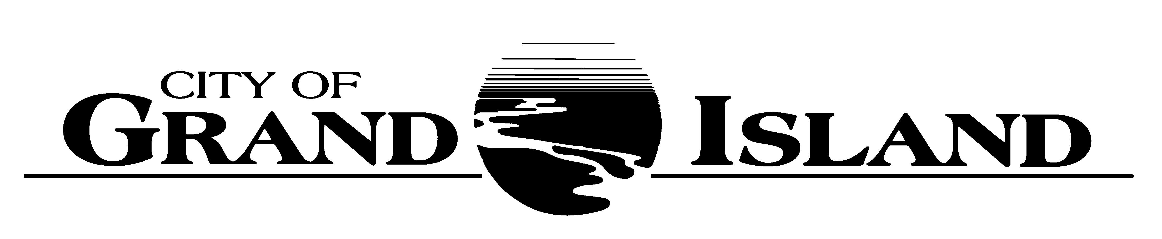  City Council Meeting Agenda  Council Chambers  City Hall  100 East First Street | Mayor  Jeremy L. Jensen  City Administrator  Marlan Ferguson  City Clerk  RaNae Edwards
Regular Meeting of March 13, 2018
7:00 p.m.

CALL TO ORDER

INVOCATION – Pastor Mark Oberbeck, Northridge Assembly of God, 3025 Independence Avenue

PLEDGE OF ALLEGIANCE

ROLL CALL

A - SUBMITTAL OF REQUESTS FOR FUTURE AGENDA ITEMS

Individuals who have appropriate items for City Council consideration should complete the Request for Future Agenda Items form located at the Information Booth. If the issue can be handled administratively without Council action, notification will be provided. If the item is scheduled for a meeting or study session, notification of the date will be given.

B - RESERVE TIME TO SPEAK ON AGENDA ITEMS

This is an opportunity for individuals wishing to provide input on any of tonight's agenda items to reserve time to speak. Please come forward, state your name and address, and the Agenda topic on which you will be speaking.

C – PRESENTATIONS AND PROCLAMATIONS

C-1. Presentation of Veteran’s Legacy Project Master Plan Phase 1 and 2.

E – PUBLIC HEARINGS

A public hearing is a formal process intended to solicit public comment. A public hearing is structured, in part, to meet legal requirements. After a brief presentation on the item, any public comments will be heard. Questions and discussion from the Council will take place under the respective action items.

E-1. Public Hearing on Request from Casey’s Retail Company dba Casey’s General Store #1768, 420 No. Broadwell Avenue for a Class “D” Liquor License.

E-2. Public Hearing on Request from Casey’s Retail Company dba Casey’s General Store #2737, 1814 No. Eddy Street for a Class “D” Liquor License.

E-3. Public Hearing on Request from Casey’s Retail Company dba Casey’s General Store #2742, 2223 South Locust Street for a Class “D” Liquor License.

E-4. Public Hearing on Request from Casey’s Retail Company dba Casey’s General Store #2903, 3428 W. Capital Avenue for a Class “D” Liquor License.

E-5. Public Hearing on Request from Casey’s Retail Company dba Casey’s General Store #2707, 806 North Eddy Street for a Class “D” Liquor License.

F – ORDINANCES

F-1. #9680 - Consideration of Annexation of Property Located at 3406 and 3412 South Blaine Street - Gard Subdivision (Second Reading).

G – CONSENT AGENDA

G-1. Approving Minutes of February 27, 2018 City Council Regular Meeting.

G-2. Approving Appointments of Russell Rerucha and Dave Koubek to the Citizens Advisory Review Committee Board.

G-3. Approving Appointment of Amos Anson to the Downtown Business Improvement District 2013 Board.

G-4. Approving Liquor Manager Request for Corky Anderson, 16320 Madison Street, Omaha, Nebraska for Fresh Thyme Farmers Market, 3535 West 13th Street, Suite 113.

G-5. #2018-60 - Approving Request from Casey’s Retail Company dba Casey’s General Store #1768, 420 No. Broadwell Avenue for a Class “D” Liquor License and Liquor Manager Designation for Tina Krings, 1212 Blue Stem Circle, Norfolk, Nebraska.

G-6. #2018-61 - Approving Request from Casey’s Retail Company dba Casey’s General Store #2737, 1814 No. Eddy Street for a Class “D” Liquor License and Liquor Manager Designation for Tina Krings, 1212 Blue Stem Circle, Norfolk, Nebraska.

G-7. #2018-62 - Approving Request from Casey’s Retail Company dba Casey’s General Store #2742, 2223 South Locust Street for a Class “D” Liquor License and Liquor Manager Designation for Tina Krings, 1212 Blue Stem Circle, Norfolk, Nebraska.

G-8. #2018-63 - Approving Request from Casey’s Retail Company dba Casey’s General Store #2903, 3428 W. Capital Avenue for a Class “D” Liquor License and Liquor Manager Designation for Tina Krings, 1212 Blue Stem Circle, Norfolk, Nebraska.

G-9. #2018-64 - Approving Request from Casey’s Retail Company dba Casey’s General Store #2707, 806 North Eddy Street for a Class “D” Liquor License and Liquor Manager Designation for Tina Krings, 1212 Blue Stem Circle, Norfolk, Nebraska.

G-10. #2018-65 - Approving Bid Award - Precipitator Bottom Ash and Boiler Industrial Cleaning - Spring 2018 Outage.

G-11. #2018-66 - Approving NACE Coating Inspection Services for the Elevated Water Storage Tower.

G-12. #2018-67 - Approving Bid Award - Transmission Circuit Breaker Inspection Services.

G-13. 2018-68 - Approving Contract Renewal for Annual Pavement Markings for the Streets Division of the Public Works Department.

G-14. #2018-69 - Approving Purchase of a New ½ Ton, Four-Wheel Drive, Extended Cab Pick-up for the Streets Division of the Public Works Department.

G-15. #2018-70 - Approving Change Order No. 1 for Concrete Pavement and Storm Sewer Repair 2018, Various Locations.

H – REQUESTS AND REFERRALS

None Scheduled.

I – RESOLUTIONS

I-1. #2018-71 - Consideration of Approving Contract with Cornerstone Bank for Banking Services.

I-2. #2018-72 - Consideration of Approving one (1) Full-Time Equivalent Park Maintenance Worker for the Parks & Recreation Department.

I-3. #2018-73 – Consideration of Adopting Veteran’s Legacy Project Master Plan Phase 1.

J – PAYMENT OF CLAIMS

J-1. Approving Payment of Claims for the Period of February 28, 2018 through March 13, 2018.

The City Council may vote to go into Closed Session on any agenda item as allowed by state law.

A continuously current agenda is maintained in the office of the City Clerk. Inquiries and correspondence concerning the City Council Agenda may be addressed to:

RaNae Edwards, City Clerk Telephone
P.O. Box 1968 (308) 385-5444 Ext. 111
Grand Island, NE 68802-1968
www.grand-island.com

