Hall County TIF Valuation Report

1994-2016

Submitted: January 22, 2018

Knotwell GeoAnalytics

Summary

The primary question is: does TIF designation increase property valuation, leading to increased tax revenue that enhances development? Though the answer is not definitive, it remains a reasonable probability that, YES, TIF designation does what it is intended to do; in the most fundamental sense--TIF matters.

* TIF parcels generally changed value differently year-to-year than non-TIF parcels. Parcels that ultimately were designated TIF, were decreasing in value until designated for TIF, at which point, or within a year or two, they began to increase in value—in nearly all cases. TIF designation *correlates* directly with subsequent valuation increases.
* NON-TIF parcels, on the other hand, maintained a gradual, fairly steady increase, quite likely driven more by commercial valuation increases rather than residential, which seemed to fluctuate more, or be affected more by external housing valuation—forces operating at a state or national level.
* There does seem to be some sort of TIF-Adjacency Factor working on parcels within close proximity to TIF parcels, although it seems to work differently on different types of parcels: residential or commercial. This effect of this factor, though, is weak and dissipates quickly with distance, hardly more than 1/20th mile (264’).
  + Residential parcels within 264’ of TIF projects changed valuation in the same direction as residential non-TIF parcels further away, but rate-of-change was “flatter”, perhaps the influence of TIF improvements.
  + Commercial parcels within 264’ were slow to keep pace with generally increasing commercial valuations of commercial non-TIF parcels further away, perhaps the result of the generally depressed valuation that motivated TIF designations in the first place; valuations did seem to be increasing after a considerable lag time (10 years), suggesting further examination beyond this lag period, or on a project-by-project basis.

In the most fundamental sense Tax Increment Finance (TIF) projects are initiated to increase tax valuations for the properties so designated. There are, theoretically, additional benefits associated with TIF designations, but these seem unlikely to accrue unless these areas “perform” in the primary way they are intended, which is to provoke an increase in value that generates an increase in tax revenue. This analysis examines TIF land parcel valuations to see if that is occurring in Hall County, and if those parcels that have been TIF-designated respond differently, in terms of assessed valuation, than those parcels that have not been TIF-designated.

The analysis concludes that there *are* noticeable differences in valuation changes over time between these inside parcels (TIF) and outside parcels (NON-TIF), coinciding with initiation and accumulating instances of TIF designations from year to year, beginning in 2003 and accumulating annually since.

***TIF PARCELS – Total Assessed Value***

Figure 1

The key element of this comparison is slope direction. Cumulative Total Assessed Values (TAV) in TIF parcels, sloped negatively until 2004, two years after the first TIF projects were designated, then sloped positively at much steeper rate since 2004, approximately six times steeper than before; increasing, but still not increasing as fast as non-TIF parcels after changing direction[1](Figure 1). Non-TIF parcels, contrastingly, vary gradually with little variation, trending generally upward (positively) at about the same rate throughout the analysis period, until the last couple years when they begin to trend upward a bit more steeply (Figure 2).

There are two features of TIF parcels at this scale that are noteworthy for our narrow purposes, that distinguish TIF parcels from non-TIF: 1) in terms of constant dollars, they were actually decreasing in value at the beginning of the study period, which tends to justify their consideration for TIF designation in the first place; and 2) after TIF projects are introduced from 2003 on, with possibly a lag period of a year or so, maybe more, TIF parcel land valuations change direction from negative to positive, and stays positive in terms of valuation growth.

***NON-TIF PARCELS – Total Assessed Value***

Figure 2

Over the last couple years of the study period, cumulative valuations increase at a steeper rate for both groups, though the rate is tempered among NON-TIF parcels somewhat, it is unknown at this point why, but some suggestions appear as the NON-TIF parcels are further separated and examined for variation among types of NON-TIF parcels: rural v. urban/town, adjacency to TIF, inside or outside Grand Island, Grand Island Residential v. Grand Island Commercial.

TIF PARCELS FIRST

There are 43 TIF projects spread throughout Grand Island containing 316 land parcels, many of which had zero assessed value until the last couple years of the study period, which partly explains the recent valuation spike; improvement assessments also shot up in these parcels by several tens of thousands of dollars these last two years as well. Of these TIF projects, 27 (56%) affect commercial (C) parcels, and 16 (37%) affect residential (R) parcels. These TIF projects went into effect almost annually from 2002, through 2016, although a few were date unknown, with more per year from 2009 onward peaking at 9 initialized in 2012.

|  |  |  |  |
| --- | --- | --- | --- |
| **Year** | **Projected Value** | **Type** | **Number** |
| 2002 | 355,000 | C | 1 |
| 2003 | 1,063,000 | C | 1 |
| 2004 | 3,500,000 | R | 1 |
| 2006 | 1,825,476 | 3C | 3 |
| 2007 | 1,400,000 | R | 1 |
| 2008 | 7,030,000 | 2C 1R | 3 |
| 2010 | 3,895,653 | 3C 1R | 4 |
| 2011 | 150,316 | R | 1 |
| 2012 | 18,163,734 | 4C 5R | 9 |
| 2013 | 35,369,145 | 1C 1R | 2 |
| 2014 | 25,775,000 | 3C 1R | 4 |
| 2015 | 34,333,829 | 4C 1R | 5 |
| 2016 | 3,034,351 | 2C | 2 |

Beginning in the early years of TIF project introduction, TIF-designated parcel values, in terms of constant dollars, were either decreasing or flat, but most increased substantially in valuation in the year following TIF project initiation, then generally stabilizing at the higher rates. The 2007 data was skewed in the database provided by values attributed to parcel #400494116, that then zeroed out in year 2000, no explanation was given, so that early part of the 2007 TIF parcel curve should be ignored in this pattern. None of these TIF parcels, though, seems to have benefitted from the rapid infusion of improvement valuations at the end of the period.

The middle years, too, show signs of post-TIF designation valuation improvement, but with 2011 and 2013 parcels showing considerable pre-TIF value fluctuation: 2011 spiking upward in 2006 as well as 2011, and 2013 increasing gradually from 2000 – 2004, then decreasing substantially 2004 – 2012, then spiking a bit post-2013, then again spiking post 2015 (Figure 4). There were 4 projects started in 2010, plus one in 2011 to contribute to the post-2011 valuation increase, the earlier increase is harder to explain, although one of these projects was very close to a 2005 TIF project and could have benefitted some from that, although, in general, as will be shown later, adjacent parcels did not necessarily share valuation spiking with TIF parcels. The pattern of post-TIF valuation improvement continues in the later years as well, as shown in Figure 5. The magnitude of valuation change, though, is much more drastic than earlier in the period, suggesting there may be some external factors affecting valuation within the last few years of the study period. Still, the sequencing remains fairly consistent with a post-TIF valuation increase immediately following project initialization.

***TIF PARCELS BY YEAR INITIATED – Total Assessed Value***[2]

Figure 3

Figure 4

Figure 5

NON-TIF PARCELS

Non-TIF land parcels during the first half of the study period, 1994 - ~2004/2005, are increasing gradually with little fluctuation in rate of increase with non-TIF values inside Grand Island city limits increasing a bit faster, driven primarily by Grand Island commercial parcels (GI residential trending upward as well, but flatter). Rural land values are also increasing similarly during this period, but smaller town parcels hardly changing at all the entire period. Land parcels within 1/8th of a mile of a soon-to-be TIF project, though, are increasing generally, but also a slower rate, lending weight to the notion that a TIF was generally located within a neighborhood, or small area of relatively depressing land values (Figure 6)[3].

Post-2004, since institution of TIF projects in Grand Island, land valuation curves tell a different story. Non-TIF land values seemed to have slowed in their increase. In Grand Island, commercial non-TIF parcels are more actively increasing in valuation; residential non-TIF has been flat until just the last year or so. Parcels adjacent to pending TIF zones during this time are also flat, with perhaps even a slight loss in value, more on this later. Small town values have changed very little over this time period. These valuation curves differ substantially from those attached to TIF project parcels.

***NON-TIF PARCELS BY LOCATIONAL GROUP***

Figure 6

NON-TIF PARCELS ADJACENT TO TIF PARCELS

In order to examine the issue of the proximal impact of TIF projects we selected parcels that were within a short distance of any TIF project, to see if they displayed a different valuation change pattern than other non-TIF parcels—it was expected that they would be more similar with TIF parcels than non-TIF parcels. The first subset of adjacent parcels consisted only of those parcels within 1/8 of a mile of a TIF project.

***NON-TIF PARCELS WITHIN 1/8 MILE OF TIF PROJECT – TOTAL ASSESSED VALUE***

Figure 7

Up until about 2007 these adjacent non-TIF parcels change very similarly to non-TIF in general, but then, instead of continuing to rise, the begin to flatten out, even decline a bit before rebounding to flat. Since these parcels are all parcels in Grand Island alone, we selected out Grand Island parcels from the rest of Hall county, and then again by Grand Island commercial and Grand Island residential (Figure 8). In these two groups a noticeable distinction shows up: residential parcels all over the city flattened out in 2005 continuing flat through the peak 2008 housing crisis, a massive external event that may have had an overriding influence on city housing, depressing residential values across the entire U.S. including Grand Island (see below). Some valuation rebound may be evident in the last year or so.

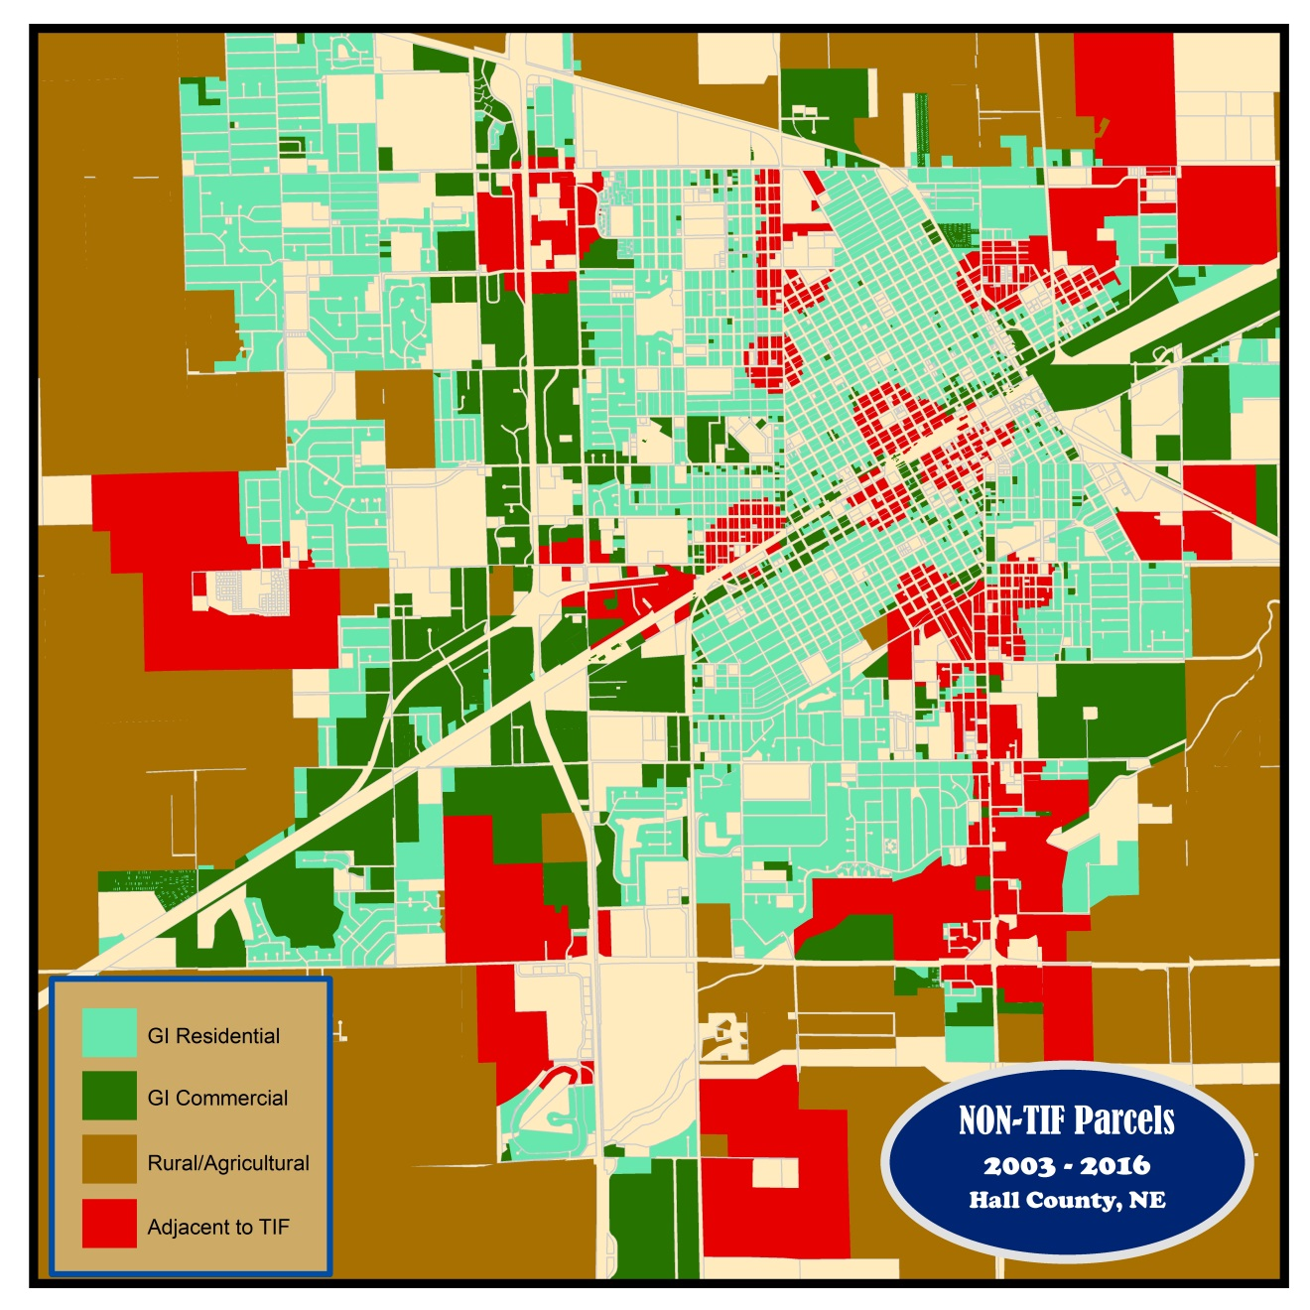

Figure 8

***GRAND ISLAND RESIDENTIAL NON-TIF PARCELS – TOTAL ASSESSED VALUE***

Figure 9

***GRAND ISLAND COMMERCIAL NON-TIF PARCELS – TOTAL ASSESSED VALUE***

Figure 10

THE TIF-ADJACENCY FACTOR

Non-TIF commercial parcels varied differently over this span of time: valuation growth was much steadier despite a two-year aberration (2014-2015), although the slope of positive change diminished beginning 2006. This was similar to residential parcels prior to the period between 2005-2007, but to a much lesser degree after that, suggesting that external depressional forces are influential and may even over-ride potential extended TIF impacts nearby. So we dove deeper in selecting adjacent parcels to see how far from TIF designations might parcels be affected if at all, by further parsing out parcels within the 1/8th mile range into groups of 264’ (0.05 mile), and 528’ (0.1 mile)—beyond this distance any potential adjacency influence was not noticeable. We also examined valuation changes within these two adjacency groups relative to whether the TIF project was Residential or Commercial, yielding eight groups: four groups within 264’ of a TIF and four groups between 264-528’ of a TIF.

* Residential parcels adjacent to Residential TIF
* Residential parcels adjacent to Commercial TIF
* Commercial parcels adjacent to Residential TIF
* Commercial parcels to Commercial TIF

Any parcels that were adjacent to both a commercial and a residential TIF were excluded from the samples (See Figure 11).

In short, the impact of adjacency to TIF projects on valuation is slight but noticeable, but that impact does not extend very far from the TIF boundary, probably less than 1/10th of a mile, and more likely less than 1/20th (264’).

Valuation change patterns of residential parcels immediately adjacent to TIF projects, regardless if those TIF projects were residential or commercial, were still depressed post-2005, but those within 264’ of a TIF project depressed at a noticeably slower rate (a much flatter post-2005 curve), than those further than 264’ (See Figures 12-15). Plus, if the TIF was commercial, it appears to have delayed the valuation depression by a couple years for those residential parcels immediately adjacent. Valuation change patterns of commercial parcels, on the other hand, did not increase as much if they were within 264’ of a TIF project, than they did if they were beyond 264’; though there is evidence in the curves to suggest a lag effect on the commercial parcels nearest TIF projects, perhaps as much as 10 years. The data suggest that a TIF-Adjacency-Factor may exist in many cases, but when it is present, its affect is subtle, weak, and dissipates fairly quickly with distance.

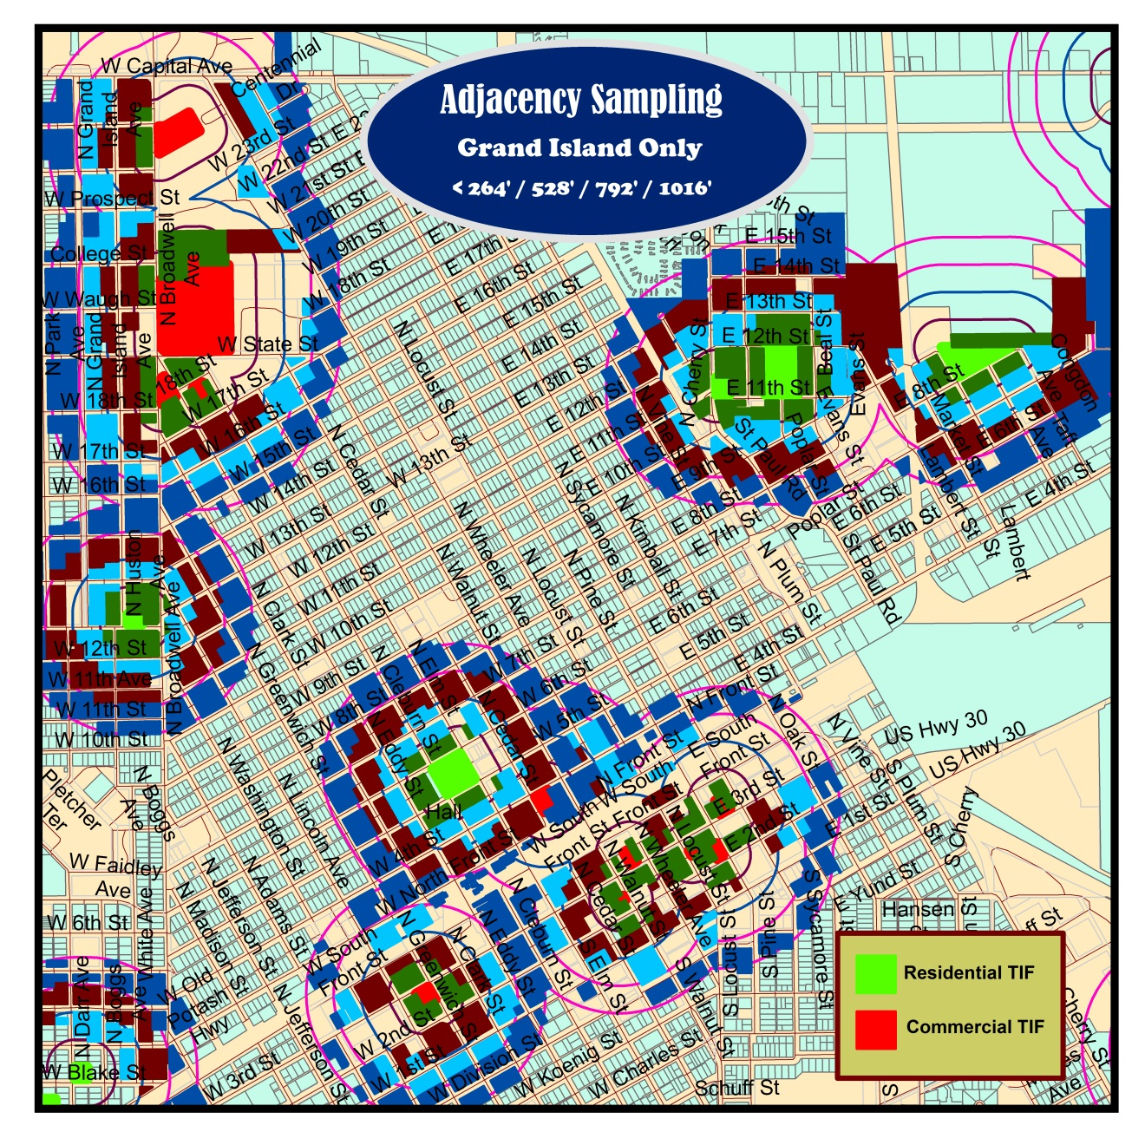

Figure 11

***NON-TIF PARCELS WITHIN 264’ COMPARED TO 264’-528’***

***Residential TIF / Residential Parcels***

Figure 12

***Residential TIF / Commercial Parcels***

Figure 13

***Commercial TIF / Residential Parcels***

Figure 14

***Commercial TIF / Commercial Parcels***

Figure 15

1. Negative slope (-122,710); Positive slope all years (+2,645,778); Positive slope minus last two years (+768,435). Non-TIF parcels (+61,652,203). Cumulative valuations attributable to improvements only increased dramatically the last two years in the database provided; land values, too, but less dramatically.
2. The downturn in 2016 TIF parcels comes from one parcel (2017 Broadwell Ave N), that lost all its improvements valuation in those final years, from $3,000,000+ to $0, perhaps from being razed, as their appears to be nothing on that parcel now.
3. Not all towns outside Grand Island were sampled.