City Council  Linna Dee Donaldson,  Michelle Fitzke  Chuck Haase  Julie Hehnke  Jeremy Jones  Vaughn Minton, President  Mitch Nickerson  Mike Paulick  Roger Steele  Mark Stelk | 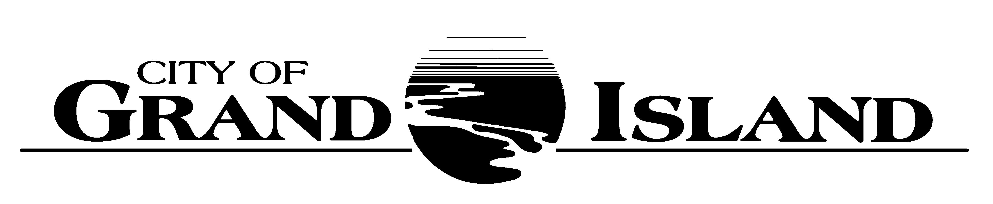  City Council Meeting Agenda  Council Chambers  City Hall  100 East First Street | Mayor  Jeremy L. Jensen  City Administrator  Marlan Ferguson  City Clerk  RaNae Edwards
Regular Meeting of April 24, 2018
7:00 p.m.

CALL TO ORDER

INVOCATION – Father Robert Lewis, St. Stephen’s Episcopal Church, 422 West 2nd Street

PLEDGE OF ALLEGIANCE

ROLL CALL

A - SUBMITTAL OF REQUESTS FOR FUTURE AGENDA ITEMS

Individuals who have appropriate items for City Council consideration should complete the Request for Future Agenda Items form located at the Information Booth. If the issue can be handled administratively without Council action, notification will be provided. If the item is scheduled for a meeting or study session, notification of the date will be given.

B - RESERVE TIME TO SPEAK ON AGENDA ITEMS

This is an opportunity for individuals wishing to provide input on any of tonight's agenda items to reserve time to speak. Please come forward, state your name and address, and the Agenda topic on which you will be speaking.

C – PRESENTATIONS AND PROCLAMATIONS

None Scheduled.

E – PUBLIC HEARINGS

A public hearing is a formal process intended to solicit public comment. A public hearing is structured, in part, to meet legal requirements. After a brief presentation on the item, any public comments will be heard. Questions and discussion from the Council will take place under the respective action items.

E-1. Public Hearing on Request from La Mexicana, Inc. dba La Mexicana, 3333 Ramada Road, Suite B for a Class “I” Liquor License.

E-2. Public Hearing on Acquisition of Utility Easement located at West Park Plaza (West Park Plaza Mobile Home Park, LLC).

E-3. Public Hearing on Acquisition of Utility Easement located East of Capital Avenue & E. Highway 30 Intersection (Richard & Kim Landell).

E-4. Public Hearing on Development of 2018-2019 Annual Action Plan for CDBG Activities.

F – ORDINANCES

None Scheduled.

G – CONSENT AGENDA

G-1. Approving Minutes of April 10, 2018 City Council Regular Meeting.

G-2. Approving Minutes of April 17, 2018 City Council Study Session.

G-3. Receipt of Official Documents – Pawnbroker’s Official Bonds for G.I. Loan Shop, 1004 West 2nd Street and Express Pawn, 645 South Locust Street.

G-4. #2018-106 - Approving Request from La Mexicana, Inc. dba La Mexicana, 3333 Ramada Road, Suite B for a Class “I” Liquor License and Liquor Manager Designation for Veronica Alvarez, 609 S. Stuhr Road.

G-5. #2018-107 - Approving Acquisition of Utility Easement located at West Park Plaza (West Park Plaza Mobile Home Park, LLC).

G-6. #2018-108 - Approving Acquisition of Utility Easement located East of Capital Avenue & E. Highway 30 Intersection (Richard & Kim Landell).

G-7. #2018-109 - Approving Award of Proposal for Sludge Dewatering Polymer.

G-8. #2018-110 - Approving Nebraska Unified Certification Program for Disadvantaged Business Enterprises Agreement in Connection with the City’s Transit Program.

G-9. #2018-111 - Approving Change Order No. 2 for Sanitary Sewer Collection System Rehabilitation – Various Locations; Project No. 2017-S-2A.

G-10. #2018-112 - Approving Amendment No. 2 with HDR Engineering, Inc. for Wastewater Treatment Plant Laboratory, Operations Control Center, and Administrative Building Renovation Consulting Services for Project No. 2017-WWTP-2.

G-11. #2018-113 - Approving Legal Description Correction Concerning Acquisition of Public Utility Easement for the North Interceptor Phase II; Sanitary Sewer Project No. 2013-S-4 (Longleaf, LLC).

G-12. #2018-114 - Approving Renewal of Agreement for Enterprise Asset Management System for the Public Works Department.

G-13. #2018-115 – Approving Development of 2018-2019 Annual Action Plan for CDBG Activities.

H – REQUESTS AND REFERRALS

None Scheduled.

I – RESOLUTIONS

I-1. #2018-116 - Consideration of Approving Downtown Business Improvement District Boundaries and Initial Board.

I-2. #2018-117 - Approving FY 2018-2019 Annual Budget for Fonner Park Business Improvement District and setting Date for Board of Equalization.

I-3. #2018-118 - Approving FY 2018-2019 Annual Budget for South Locust Business Improvement District and setting Date for Board of Equalization.

J – PAYMENT OF CLAIMS

J-1. Approving Payment of Claims for the Period of April 11, 2018 through April 24, 2018.

The City Council may vote to go into Closed Session on any agenda item as allowed by state law.

A continuously current agenda is maintained in the office of the City Clerk. Inquiries and correspondence concerning the City Council Agenda may be addressed to:

RaNae Edwards, City Clerk Telephone
P.O. Box 1968 (308) 385-5444 Ext. 111
Grand Island, NE 68802-1968
www.grand-island.com

