City Council  Linna Dee Donaldson,  Michelle Fitzke  Chuck Haase  Julie Hehnke  Jeremy Jones  Vaughn Minton, President  Mitch Nickerson  Mike Paulick  Roger Steele  Mark Stelk | 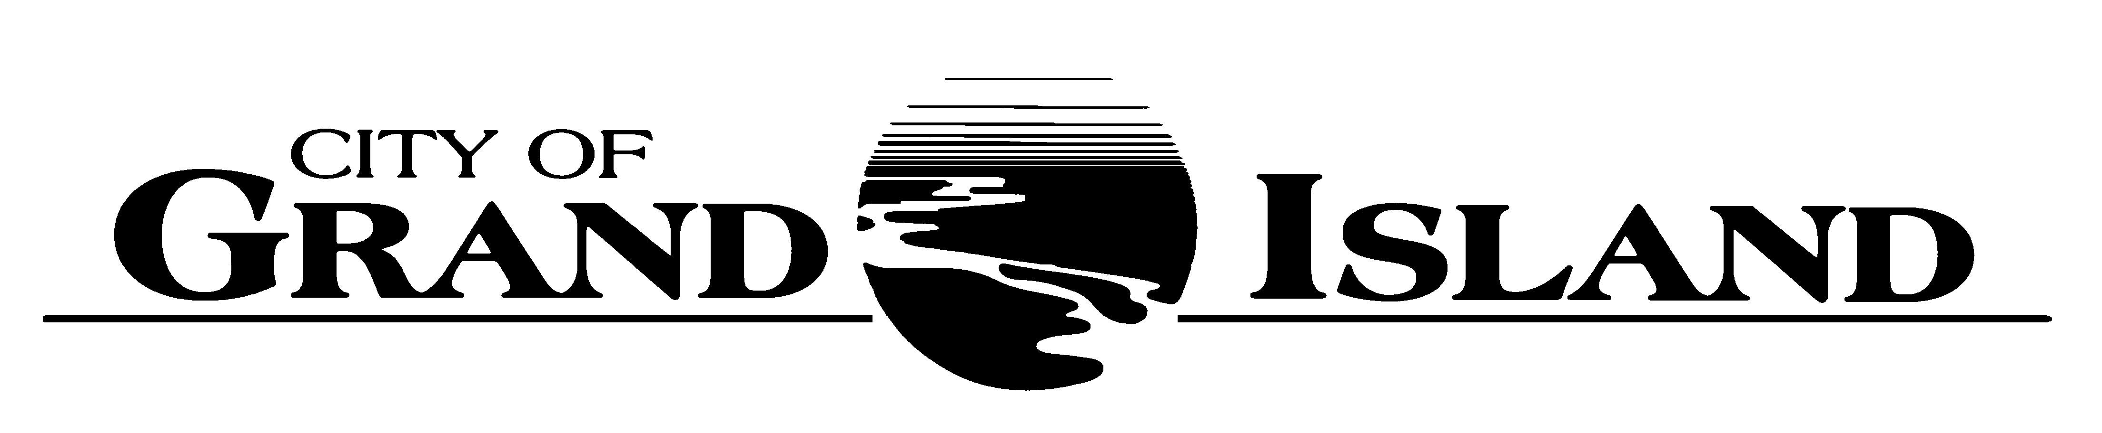  City Council Meeting Agenda  Council Chambers  City Hall  100 East First Street | Mayor  Jeremy L. Jensen  City Administrator  Marlan Ferguson  City Clerk  RaNae Edwards
Regular Meeting of May 8, 2018
7:00 p.m.

CALL TO ORDER

INVOCATION – Pastor Tim Kilstrom, Spirit of Life Church, 2304 Macron Street

PLEDGE OF ALLEGIANCE

ROLL CALL

A - SUBMITTAL OF REQUESTS FOR FUTURE AGENDA ITEMS

Individuals who have appropriate items for City Council consideration should complete the Request for Future Agenda Items form located at the Information Booth. If the issue can be handled administratively without Council action, notification will be provided. If the item is scheduled for a meeting or study session, notification of the date will be given.

B - RESERVE TIME TO SPEAK ON AGENDA ITEMS

This is an opportunity for individuals wishing to provide input on any of tonight's agenda items to reserve time to speak. Please come forward, state your name and address, and the Agenda topic on which you will be speaking.

C – PRESENTATIONS AND PROCLAMATIONS

None Scheduled.

E – PUBLIC HEARINGS

A public hearing is a formal process intended to solicit public comment. A public hearing is structured, in part, to meet legal requirements. After a brief presentation on the item, any public comments will be heard. Questions and discussion from the Council will take place under the respective action items.

E-1. Public Hearing on Request from Night Moods, LLC. dba The Upper Deck, 2110 West 2nd Street for a Class “C” Liquor License.

E-2. Public Hearing on Request from Westside Bowling, LLC dba Westside Lanes, 112 Kaufman Avenue for a Class “C” Liquor License.

E-3. Public Hearing on Request from Hy-Vee Restaurant, 115 Wilmar Avenue for a Catering Designation to their Class “I-21349” Liquor License.

E-4. Public Hearing on Acquisition of Public Right-of-Way at 4020 West 13th Street (Pedersen).

E-5. Public Hearing on Acquisition of Permanent Easement in Imperial Village Sixth Subdivision (GI School District 2).

E-6. Public Hearing on Acquisition of Public Right-of-Way, Subdivision Agreement Amendment and Temporary Easement at 1311 N North Road (Little B’s Corporation).

E-7. Public Hearing on Acquisition of Public Right-of-Way at 3993 West 13th Street (Leiser).

E-8. Public Hearing on Acquisition of Drainage Easement for 13th Street Paving Improvements; Project No. 2018-P-1 (Leiser).

F – ORDINANCES

F-1. #9685 - Consideration of Sale of Property Located at 2011 N Sycamore Street to River Pointe, LLC.

G – CONSENT AGENDA

G-1. Approving Minutes of April 24, 2018 City Council Regular Meeting.

G-2. Approving Steve Lamken to the Civil Service Commission.

G-3. Approving Request from Michael Weskamp, 1007 East 2nd Street, York, Nebraska for Liquor Manager Designation for Wal-Mart #3395, 3501 South Locust Street.

G-4. #2018-119 - Approving Request from Night Moods, LLC. dba The Upper Deck, 2110 West 2nd Street for a Class “C” Liquor License and Liquor Manager Designation for Grover Camp, 415 West 14th Street.

G-5. #2018-120 - Approving Request from Westside Bowling, LLC dba Westside Lanes, 112 Kaufman Avenue for a Class “C” Liquor License and Liquor Manager Designation for Jerry Pomplun, 43571 Riverbend Road, Oconto, NE.

G-6. #2018-121 - Approving Request from Hy-Vee Restaurant, 115 Wilmar Avenue for a Catering Designation to their Class “I-21349” Liquor License.

G-7. #2018-122 - Approving Temporary Construction Easement for 13th Street Paving Improvements; Project No. 2018-P-1 (Pedersen).

G-8. #2018-123 - Approving Acquisition of Public Right-of-Way at 4020 West 13th Street (Pedersen).

G-9. #2018-124 - Approving Temporary Construction Easement for Lift Station No. 11 Relocation – 2018; Project No. 2018-S-1.

G-10. #2018-125 - Approving Acquisition of Permanent Easement in Imperial Village Sixth Subdivision (GI School District 2).

G-11. #2018-126 - Approving Discontinuation of Street Improvement District No. 1265; Jay Street – Capital Avenue to Dack Avenue.

G-12. #2018-127 - Approving Acquisition of Public Right-of-Way, Subdivision Agreement Amendment and Temporary Easement at 1311 N North Road (Little B’s Corporation).

G-13. #2018-128 - Approving Purchase of Two (2) Utility Vehicles for the Wastewater Division of the Public Works Department.

G-14. #2018-129 - Approving Amendment No. 2 to Asphalt Resurfacing Inter-local Agreement with Hall County for Improvements to Shady Bend Road; Capital Avenue to Airport Road.

G-15. #2018-130 - Approving Temporary Construction Easement for 13th Street Paving Improvements; Project No. 2018-P-1 (Leiser).

G-16. #2018-131 - Approving Acquisition of Public Right-of-Way at 3993 West 13th Street (Leiser).

G-17. #2018-132 - Approving Acquisition of Drainage Easement for 13th Street Paving Improvements; Project No. 2018-P-1 (Leiser).

G-18. #2018-133 - Approving Addendum to the Labor Contract between the City of Grand Island and the IBEW Local 1597 Utilities Department Bargaining Unit.

H – REQUESTS AND REFERRALS

None Scheduled.

I – RESOLUTIONS

I-1. #2018-134 - Approving Agreement with Five Points Bank for Banking Services.

J – PAYMENT OF CLAIMS

J-1. Approving Payment of Claims for the Period of April 25, 2018 through May 8, 2018.

The City Council may vote to go into Closed Session on any agenda item as allowed by state law.

A continuously current agenda is maintained in the office of the City Clerk. Inquiries and correspondence concerning the City Council Agenda may be addressed to:

RaNae Edwards, City Clerk Telephone
P.O. Box 1968 (308) 385-5444 Ext. 111
Grand Island, NE 68802-1968
www.grand-island.com

