City Council  Linna Dee Donaldson,  Michelle Fitzke  Chuck Haase  Julie Hehnke  Jeremy Jones  Vaughn Minton, President  Mitch Nickerson  Mike Paulick  Roger Steele  Mark Stelk | 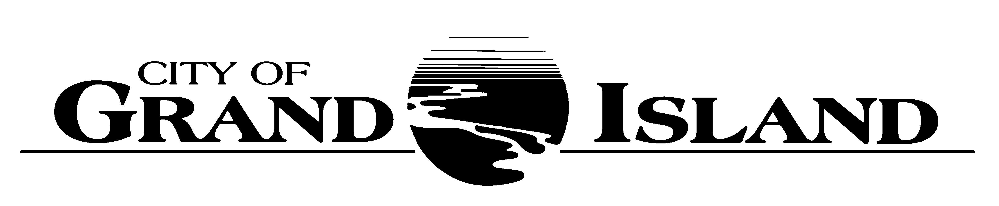  City Council Meeting Agenda  Council Chambers  City Hall  100 East First Street | Mayor  Jeremy L. Jensen  City Administrator  Marlan Ferguson  City Clerk  RaNae Edwards
Regular Meeting of August 14, 2018
7:00 p.m.

CALL TO ORDER

INVOCATION – Pastor Donald Adams, Evangelical Free Church, 2609 South Blaine Street

PLEDGE OF ALLEGIANCE

ROLL CALL

A - SUBMITTAL OF REQUESTS FOR FUTURE AGENDA ITEMS

Individuals who have appropriate items for City Council consideration should complete the Request for Future Agenda Items form located at the Information Booth. If the issue can be handled administratively without Council action, notification will be provided. If the item is scheduled for a meeting or study session, notification of the date will be given.

B - RESERVE TIME TO SPEAK ON AGENDA ITEMS

This is an opportunity for individuals wishing to provide input on any of tonight's agenda items to reserve time to speak. Please come forward, state your name and address, and the Agenda topic on which you will be speaking.

E – PUBLIC HEARINGS

A public hearing is a formal process intended to solicit public comment. A public hearing is structured, in part, to meet legal requirements. After a brief presentation on the item, any public comments will be heard. Questions and discussion from the Council will take place under the respective action items.

E-1. Public Hearing on Acquisition of Utility Easement located at 2405 S. North Road (Chief Industries).

E-2. Public Hearing on Acquisition of Utility Easement located at 3134 U.S. Highway 34 (Central Community College).

E-3. Public Hearing on Acquisition of Public Utility/Access Easements in Desert Rose Subdivision (3235 S Locust St- Community Redevelopment Authority for the City of Grand Island, Nebraska).

E-4. Public Hearing on Acquisition of Public Right-of-Way in Desert Rose Subdivision (3235 S Locust St- Community Redevelopment Authority for the City of Grand Island, Nebraska).

E-5. Public Hearing on Establishing Railside Business Improvement District.

F – ORDINANCES

F-1. #9698 - Consideration of Vacation of Utility Easements - Lot 2, CBC Subdivision - 2405 S. North Road - Chief Industries.

F-2. #9699 - Consideration of Vacation of Utility Easement - 3134 West U.S. Highway 34 - Central Community College.

F-3. #9700 - Consideration of Establishing Railside Business Improvement District.

G – CONSENT AGENDA

G-1. Approving Minutes of July 24, 2018 City Council Regular Meeting.

G-2. Approving Minutes of July 30, 2018 City Council Joint Health Meeting.

G-3. Approving Minutes of August 7, 2018 City Council Study Session.

G-4. Approving Request of Fonner Park Exposition and Events Center, Inc. (Heartland Events Center) for Ratification of Nomination and Election of Board of Directors.

G-5. Approving Re-Appointment of Doug Jensen to the Animal Advisory Board.

G-6. #2018-225 - Approving Preliminary and Final Plat and Subdivision Agreement for Industrial Foundation Subdivision.

G-7. #2018-226 - Approving Final Plat and Subdivision Agreement for Jensen Subdivision.

G-8. #2018-227 - Approving Final Plat and Subdivision Agreement for Woodland Park 17th Subdivision.

G-9. #2018-228 - Approving Acquisition of Utility Easement located at 2405 S. North Road (Chief Industries).

G-10. #2018-229 - Approving Acquisition of Utility Easement located at 3134 U.S. Highway 34 (Central Community College).

G-11. #2018-230 - Approving Bid Award - Four Drum Puller/Tensioner Trailer - Utilities Department, Line Division.

G-12. #2018-231 - Approving Change Order #1 with REOD, LLC for the Elevated Water Storage Tower NACE Coating Inspection Services.

G-13. #2018-232 - Approving Change Order #2 with Landmark Structures for the Composite Elevated Storage Tank Construction.

G-14. #2018-233 - Approving Bid Award for WAS Tank Blower Replacement; Project No. 2018-WWTP-1.

G-15. #2018-234 - Approving Acquisition of Public Utility/Access Easements in Desert Rose Subdivision (3235 S Locust St- Community Redevelopment Authority for the City of Grand Island, Nebraska).

G-16. #2018-235 - Approving Acquisition of Public Right-of-Way in Desert Rose Subdivision (3235 S Locust St- Community Redevelopment Authority for the City of Grand Island, Nebraska).

G-17. #2018-236 - Approving State Bid Award for One (1) 2018 F550 Crew Cab 4x2 Service Truck for the Wastewater Division of the Public Works Department.

G-18. #2018-237 - Approving Certificate of Final Completion for Chip Seal Project No. 2018-CS-1.

G-19. #2018-238 - Approving Purchase of Dell Laptop Computers and Docking Stations for Police Fleet.

G-20. #2018-239 - Approving Annual Agreement for Financial Software Licensing and Support.

H – REQUESTS AND REFERRALS

H-1. Consideration of Forwarding Blighted and Substandard Area #27 to the Hall County Regional Planning Commission (Keystone Properties).

I – RESOLUTIONS

I-1. #2018-240 - Consideration of Approving Update to Resolution No. 2015-120; Designated Truck Routes within the City of Grand Island.

I-2. #2018-196 - Consideration of Approving Proposed Ballot Language for 1/2 Cent Increase to Sales Tax.

I-3. #2018-197 - Consideration of Approving an Interlocal Agreement with the CRA.

J – PAYMENT OF CLAIMS

J-1. Approving Payment of Claims for the Period of July 25, 2018 through August 14, 2018.

S – SPECIAL ITEMS

S-1. Discussion Concerning Proposed Fiscal Year 2018-2019 Community Redevelopment Authority (CRA) Budget.

X – OTHER ITEMS

X-1. Strategy Session with Respect to Labor Negotiations with IBEW No. 1597 Service/Clerical and Finance.

The City Council may vote to go into Closed Session on any agenda item as allowed by state law.

A continuously current agenda is maintained in the office of the City Clerk. Inquiries and correspondence concerning the City Council Agenda may be addressed to:

RaNae Edwards, City Clerk Telephone
P.O. Box 1968 (308) 385-5444 Ext. 111
Grand Island, NE 68802-1968
www.grand-island.com

