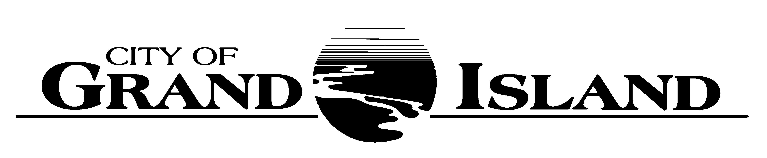

CITY COUNCIL STUDY SESSION

Tuesday, January 15, 2019
7:00 p.m.
City Hall
Council Chambers

AGENDA

- Call to Order
- Friends of the Grand Island Parks Presentation.
- Tax Increment Financing (TIF) Presentation.
- Adjournment

______________________________
RaNae Edwards
City Clerk

Public comment is provided for at the conclusion of the presentations. Members of the public may voice opinions on all Agenda items. When recognized by the Mayor, please approach the Council and give your name and address. Please remember that there is a three minute limit for any member of the public, unless extended by the governing body.

A continuously current agenda is maintained in the office of the City Clerk. Inquiries and correspondence concerning the City Council Agenda may be addressed to:

RaNae Edwards, City Clerk
P.O. Box 1968
Grand Island, Nebraska 68802-1968
(308)385-5444, extension 111

