City Council  Jason Conley  Michelle Fitzke  Bethany Guzinski  Chuck Haase  Maggie Mendoza  Vaughn Minton  Mitch Nickerson  Mike Paulick, President  Justin Scott  Mark Stelk | 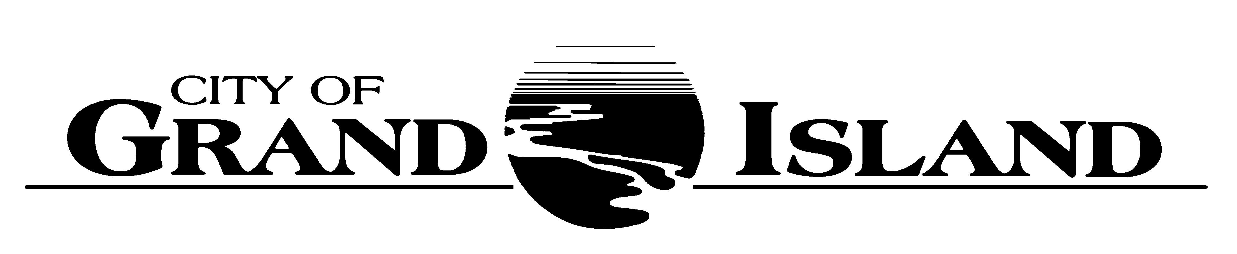  City Council Meeting Agenda  Council Chambers  City Hall  100 East First Street | Mayor  Roger G. Steele  City Administrator  Jerry Janulewicz  City Clerk  RaNae Edwards

Regular Meeting of March 23, 2021
7:00 p.m.

CALL TO ORDER

PLEDGE OF ALLEGIANCE

ROLL CALL

A - SUBMITTAL OF REQUESTS FOR FUTURE AGENDA ITEMS

Individuals who have appropriate items for City Council consideration should complete the Request for Future Agenda Items form located at the Information Booth. If the issue can be handled administratively without Council action, notification will be provided. If the item is scheduled for a meeting or study session, notification of the date will be given.

B - RESERVE TIME TO SPEAK ON AGENDA ITEMS

This is an opportunity for individuals wishing to provide input on any of tonight's agenda items to reserve time to speak. Please come forward, state your name and address, and the Agenda topic on which you will be speaking.

C – PRESENTATIONS AND PROCLAMATIONS

None Scheduled.

E – PUBLIC HEARINGS

A public hearing is a formal process intended to solicit public comment. A public hearing is structured, in part, to meet legal requirements. After a brief presentation on the item, any public comments will be heard. Questions and discussion from the Council will take place under the respective action items.

E-1. Public Hearing on Request from Amy J. Schutte dba Bella Design & Décor, 110 East 3rd Street for an Addition to their Class “C-123032” Liquor License.

E-2. Public Hearing on Request from Luisa Lovato dba Ritmos Night Club, 316 East 2nd Street for a Change of Location for Class “I-108549” Liquor License to 611 East 4th Street.

E-3. Public Hearing on Request from City of Grand Island dba Jackrabbit Run Golf Course, 2800 N. Shady Bend Road for a Class “C” Liquor License.

E-4. Public Hearing on Request from Phil Mader for a Conditional Use Permit for Adding a Water Well/Electric Service and Two Accessory Buildings to Property located at 551 Midaro Drive.

E-5. Public Hearing on Acquisition of Drainage Easement in Crane Valley Ninth Subdivision- North of Faidley Avenue, West of Diers Avenue (Parcel No. 400416182).

E-6. Public Hearing on 2020-2021 Community Development Annual Action Plan.

F – ORDINANCES

F-1. #9819 – Consideration of Amending Chapter 24-3 of the Grand Island City Code Relative to Vehicles in Parks, Hike/Bike Trails, and Detention Cells.

G – CONSENT AGENDA

G-1. Approving Minutes of March 9, 2021 City Council Regular Meeting.

G-2. Approving Appointment of James Truell to the Community Redevelopment Authority.

G-3. Approving Appointment of Councilmember Maggie Mendoza to the Building Code Advisory Board and the South Locust Street Business Improvement District.

G-4. #2021-55 - Approving Surety Bond for Councilmember Maggie Mendoza.

G-5. #2021-56 - Approving Request from Amy J. Schutte dba Bella Design & Décor, 110 East 3rd Street for an Addition to their Class “C-123032” Liquor License.

G-6. #2021-57 - Approving Request from Luisa Lovato dba Ritmos Night Club, 316 East 2nd Street for a Change of Location for Class “I-108549” Liquor License to 611 East 4th Street.

G-7. #2021-58 - Approving Request from City of Grand Island dba Jackrabbit Run Golf Course, 2800 N. Shady Bend Road for a Class “C” Liquor License and Liquor Manager Designation for Tomme McManus, 411 S. Madison Street.

G-8. #2021-59 - Approving Final Plat and Subdivision Agreement for Taylor Subdivision.

G-9. #2021-60 - Approving Bid Award for Veteran's Home Cemetery Maintenance - City Parks and Recreation Department.

G-10. #2021-61 - Approving Amended License Agreements for Father Flanagan’s Boys’ Home, Aurora Cooperative Elevator Company, and Hall County Airport Authority Relative to Entrance Signs.

G-11. #2021-62 - Approving Bid Award for the 2021 Asphalt Resurfacing Project No. 2021-AC-1.

G-12. #2021-63 - Approving Bid Award for Chip Seal Project No. 2021-CS-1.

G-13. #2021-64 - Approving Bid Award for Furnishing Components for EIMCO® Type C3D-Fully Trough Skimmer Clarifier Mechanism; Project No. 2021-WWTP-1.

G-14. #2021-65 - Approving Bid Award for Bridge Joint Repairs 2020-2021.

G-15. #2021-66 - Approving Inter-local Agreement with Hall County for Improvements to Sections of Bismark Road and Wildwood Road.

G-16. #2021-67 - Approving Temporary Construction Easement at 3962 Norseman Avenue (Conditioned Air Mechanical) for North Road- 13th Street to Highway 2 Roadway Improvements; Project No. 2019-P-5.

G-17. #2021-68 - Approving Acquisition of Drainage Easement in Crane Valley Ninth Subdivision- North of Faidley Avenue, West of Diers Avenue (Parcel No. 400416182).

G-18. #2021-69 - Approving 2020-2021 Community Development Block Grant Annual Action Plan.

G-19. #2021-70 - Approving 2019 CDBG Consolidated Annual Performance and Evaluation Review.

G-20. #2021-71 – Approving Multiyear Agreement with National 4-H for Championship Event at Heartland Public Shooting Park.

G-21. #2021-72 - Approving Capital Equipment Lease Program for Jackrabbit Run Golf Course.

H – REQUEST AND REFERRALS

H-1. Consideration of Approving Request from Phil Mader for a Conditional Use Permit for Adding a Water Well/Electric Service and Two Accessory Buildings to Property located at 551 Midaro Drive.

I – RESOLUTIONS

None Scheduled..

J – PAYMENT OF CLAIMS

J-1. Approving Payment of Claims for the Period of March 10, 2021 through March 23, 2021.

The City Council may vote to go into Closed Session on any agenda item as allowed by state law.

A continuously current agenda is maintained in the office of the City Clerk. Inquiries and correspondence concerning the City Council Agenda may be addressed to:

RaNae Edwards, City Clerk Telephone
P.O. Box 1968 (308) 385-5444 Ext. 111
Grand Island, NE 68802-1968
www.grand-island.com

