City Council  Jason Conley  Michelle Fitzke  Bethany Guzinski  Chuck Haase  Maggie Mendoza  Vaughn Minton  Mitch Nickerson  Mike Paulick, President  Justin Scott  Mark Stelk | 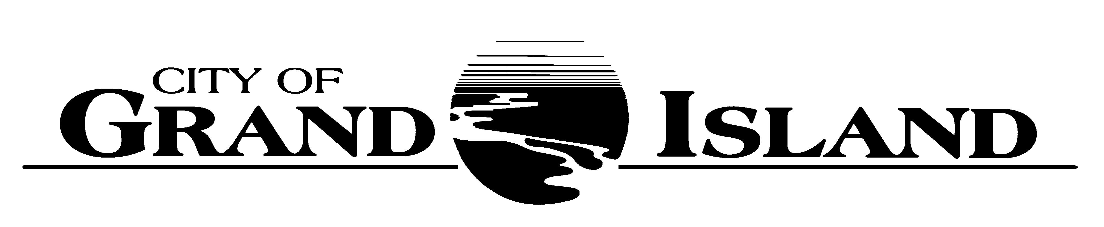  City Council Meeting Agenda  Council Chambers  City Hall  100 East First Street | Mayor  Roger G. Steele  City Administrator  Jerry Janulewicz  City Clerk  RaNae Edwards

Regular Meeting of July 13, 2021
7:00 p.m.

CALL TO ORDER

INVOCATION – Pastor Sheri Lodel, Calvary Lutheran Church, 1304 N. Custer Avenue

PLEDGE OF ALLEGIANCE

ROLL CALL

A - SUBMITTAL OF REQUESTS FOR FUTURE AGENDA ITEMS

Individuals who have appropriate items for City Council consideration should complete the Request for Future Agenda Items form located at the Information Booth. If the issue can be handled administratively without Council action, notification will be provided. If the item is scheduled for a meeting or study session, notification of the date will be given.

B - RESERVE TIME TO SPEAK ON AGENDA ITEMS

This is an opportunity for individuals wishing to provide input on any of tonight's agenda items to reserve time to speak. Please come forward, state your name and address, and the Agenda topic on which you will be speaking.

C – PRESENTATIONS AND PROCLAMATIONS

None Scheduled.

E – PUBLIC HEARINGS

A public hearing is a formal process intended to solicit public comment. A public hearing is structured, in part, to meet legal requirements. After a brief presentation on the item, any public comments will be heard. Questions and discussion from the Council will take place under the respective action items.

E-1. Public Hearing on Request from Wine Beer & Spirits, LLC dba Wine Beer & Spirits, 1111 Allen Drive for a Class "C" Liquor License.

E-2. Public Hearing on Acquisition of Utility Easement - 3321 West Schimmer Drive (Bosselman Energy, Inc.).

E-3. Public Hearing on Acquisition of Drainage Easement in Prairie Commons Fourth Subdivision- 3490 Ewoldt Street (Tabitha Grand Island, Inc.).

F – ORDINANCES

F-1. #9836 - Consideration of Vacation of Two Utility Easement Tracts at 803, 829 and 831 Bronze Road - Husker Storage.

F-2. #9837 - Consideration of Vacation of Public Drainage Easement in Prairie Commons Fourth Subdivision; 3490 Ewoldt Street (Tabitha Grand Island, Inc.).

F-3. #9838 - Consideration of Vacation of Public Utility Easement in King’s Crossing Subdivision; 3416 S Locust Street (Bosselman Pump & Pantry, Inc.).

G – CONSENT AGENDA

G-1. Approving Minutes of June 22, 2021 City Council Regular Meeting.

G-2. #2021-155 - Approving Request from Wine Beer & Spirits, LLC dba Wine Beer & Spirits, 1111 Allen Drive for a Class "C" Liquor License and Liquor Manager Designation for Beau Starkel.

G-3. #2021-156 - Approving Acquisition of Utility Easement - 3321 West Schimmer Drive (Bosselman Energy, Inc.).

G-4. #2021-157 - Approving Bid Award for the Sale of Fly Ash from the Platte Generating Station.

G-5. #2021-158 - Approving Generating Station Distributive Control System Service Agreement.

G-6. #2021-159 - Approving Engineering Services for the 2021 Wastewater Treatment Plant Operations On-Call.

G-7. #2021-160 - Approving Change Order No. 1 for Sanitary Sewer District No. 544; Ellington Pointe and Westwood Park Subdivisions.

G-8. #2021-161 - Approving Amendment No. 2 to Engineering Consulting Services for Sanitary Sewer District No. 544; Ellington Pointe and Westwood Park Subdivisions.

G-9. #2021-162 - Approving Lease Agreement Renewal for Transit Services Office Facility.

G-10. #2021-163 - Approving Sub-Lease Agreement Renewal with Senior Citizen Industries, Inc. for Occupancy of Transit Services Office Facility.

G-11. #2021-164 - Approving Acquisition of Drainage Easement in Prairie Commons Fourth Subdivision- 3490 Ewoldt Street (Tabitha Grand Island, Inc.).

G-12. #2021-165 - Approving Change Order No. 3 for the 2020 Asphalt Resurfacing Project No. 2020-AC-1.

G-13. #2021-166 - Approving CDBG Sub-Recipient Agreement with Railside Downtown BID.

G-14. #2021-167 - Approving CDBG Sub-Recipient Agreement with YWCA.

G-15. #2021-168 - Approving Authorized Signatures for Police and Fire Pension Plans.

G-16. #2021-169 - Approving Contract with US Cellular for Cellular Services.

H – REQUEST AND REFERRALS

None Scheduled.

I – RESOLUTIONS

None Scheduled.

J – PAYMENT OF CLAIMS

J-1. Approving Payment of Claims for the Period of June 23, 2021 through July 13, 2021.

The City Council may vote to go into Closed Session on any agenda item as allowed by state law.

A continuously current agenda is maintained in the office of the City Clerk. Inquiries and correspondence concerning the City Council Agenda may be addressed to:

RaNae Edwards, City Clerk Telephone
P.O. Box 1968 (308) 385-5444 Ext. 111
Grand Island, NE 68802-1968
www.grand-island.com

