City Council  Jason Conley  Michelle Fitzke  Bethany Guzinski  Chuck Haase  Maggie Mendoza  Vaughn Minton  Mitch Nickerson  Mike Paulick, President  Justin Scott  Mark Stelk | 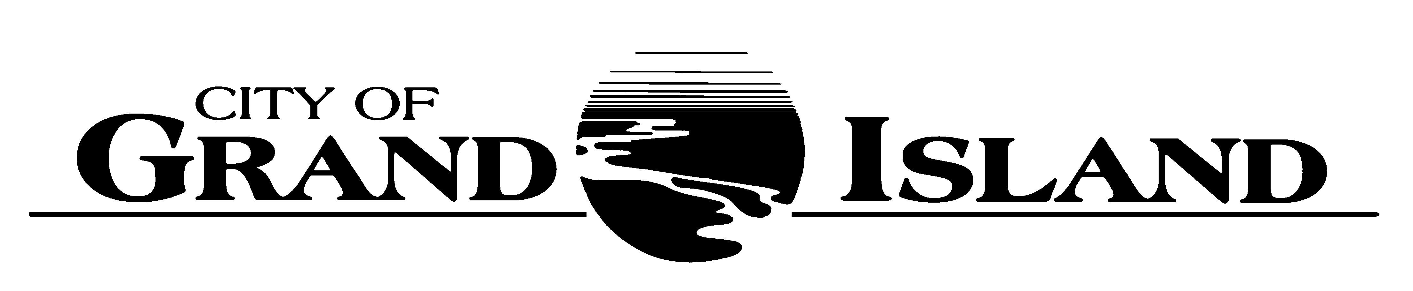  City Council Meeting Agenda  Council Chambers  City Hall  100 East First Street | Mayor  Roger G. Steele  City Administrator  Jerry Janulewicz  City Clerk  RaNae Edwards

Regular Meeting of August 24, 2021
7:00 p.m.

CALL TO ORDER

INVOCATION – Pastor Steven Peeler, Messiah Lutheran Church, 708 North Locust Street

PLEDGE OF ALLEGIANCE

ROLL CALL

A - SUBMITTAL OF REQUESTS FOR FUTURE AGENDA ITEMS

Individuals who have appropriate items for City Council consideration should complete the Request for Future Agenda Items form located at the Information Booth. If the issue can be handled administratively without Council action, notification will be provided. If the item is scheduled for a meeting or study session, notification of the date will be given.

B - RESERVE TIME TO SPEAK ON AGENDA ITEMS

This is an opportunity for individuals wishing to provide input on any of tonight's agenda items to reserve time to speak. Please come forward, state your name and address, and the Agenda topic on which you will be speaking.

C – PRESENTATIONS AND PROCLAMATIONS

C-1. Community Redevelopment Authority (CRA) Budget Presentation.

E – PUBLIC HEARINGS

A public hearing is a formal process intended to solicit public comment. A public hearing is structured, in part, to meet legal requirements. After a brief presentation on the item, any public comments will be heard. Questions and discussion from the Council will take place under the respective action items.

E-1. Public Hearing on Proposed Blighted and Substandard Area 33 for approximately 210 Acres located West of Prairieview Street North of Husker Highway (Innate Development, LLC).

E-2. Public Hearing on Amending the FY 2020-2021 Budget Relative to Enterprise Fund.

E-3. Public Hearing on City General Property and CRA Tax Requests.

E-4. Public Hearing on FY 2021-2022 Annual Budget for Parking District #2 (Ramp).

F – ORDINANCES

F-1. #9840 - Consideration of Changes to Chapter 15 of the Grand Island City Code relative to Electricity.

F-2. #9841 - Consideration of Changes to Chapter 22 of the Grand Island City Code Relative to Parking and Storing RV’s in Residential Areas.

F-3. #9842 - Consideration of Approving Salary Ordinance.

F-4. #9843 - Consideration of Approving Amending the FY 2020-2021 Budget Relative to Enterprise Fund.

G – CONSENT AGENDA

G-1. Approving Minutes of August 10, 2021 City Council Regular Meeting.

G-2. Approving Minutes of August 10, 2021 Study Session.

G-3. Approving Re-Appointments of Deb Trosper, John Schultz, Robin Hendricksen, and Susan Bullington and Appointment of Lisa Thayer to the Zoning Board of Adjustment.

G-4. #2021-202 - Approving Bid Award - Cooling Tower Repair at Platte Generating Station - Fall 2021.

G-5. #2021-203 - Approving the Purchase of Liquid Ortho-Polyphosphate for Corrosion Control.

G-6. #2021-204 - Approving Bid Award - Water Main Project 2021-W-1 - Oak and Kimball Streets and Koenig to Division.

G-7. #2021-205 - Approving Amendment to the Transmission Planning Services Agreement with GDS Associates, Inc.

G-8. #2021-206 - Approving Amendment No. 1 to Engineering Consulting Agreement for Capital Avenue- Moores Creek Drainway to North Road Roadway Improvements; Project No. 2020-P-1.

G-9. #2021-207 - Approving Bid Award for Grand Island City Cemetery Road Conversion to Burial Spaces.

G-10. #2021-208 - Approving Change Order #1 - JBS Trail Construction - Parks & Recreation Department.

G-11. #2021-209 - Approving Change Order #1 - Pickleball Court Design - Parks & Recreation Department.

H – REQUEST AND REFERRALS

None Scheduled.

I – RESOLUTIONS

I-1. #2021-210 - Consideration of Approving Proposed Blighted and Substandard Area 33 for approximately 210 Acres located West of Prairieview Street North of Husker Highway (Innate Development, LLC).

I-2. #2021-211 - Consideration of Approving Interlocal Agreement with Hall County and the Hall County Airport Authority Regarding Airport Sanitary Sewer Project.

I-3. #2021-212 - Consideration of Approving FY 2021-2022 Annual Budget for Railside Business Improvement District and Setting Date for Board of Equalization.

I-4. #2021-213 - Consideration of Approving FY 2021-2022 Annual Budget for Fonner Park Business Improvement District and Setting Date for Board of Equalization.

I-5. #2021-214 - Consideration of Approving FY 2021-2022 Annual Budget for South Locust Street Business Improvement District and Setting Date of Board of Equalization.

I-6. #2021-215 - Consideration of Approving FY 2020-2021 Benefits for Vehicle Off-Street Parking District #3 and Setting Date of Board of Equalization.

I-7. #2021-216 - Consideration of Approving City General Property and CRA Tax Requests.

I-8. #2021-217 - Consideration of Approving FY 2021-2022 Annual Budget for Parking District #2 (Ramp).

J – PAYMENT OF CLAIMS

J-1. Approving Payment of Claims for the Period of August 11, 2021 through August 24, 2021.

The City Council may vote to go into Closed Session on any agenda item as allowed by state law.

A continuously current agenda is maintained in the office of the City Clerk. Inquiries and correspondence concerning the City Council Agenda may be addressed to:

RaNae Edwards, City Clerk Telephone
P.O. Box 1968 (308) 385-5444 Ext. 111
Grand Island, NE 68802-1968
www.grand-island.com

