City Council  Jason Conley  Michelle Fitzke  Bethany Guzinski  Chuck Haase  Maggie Mendoza  Vaughn Minton  Mitch Nickerson  Mike Paulick, President  Justin Scott  Mark Stelk | 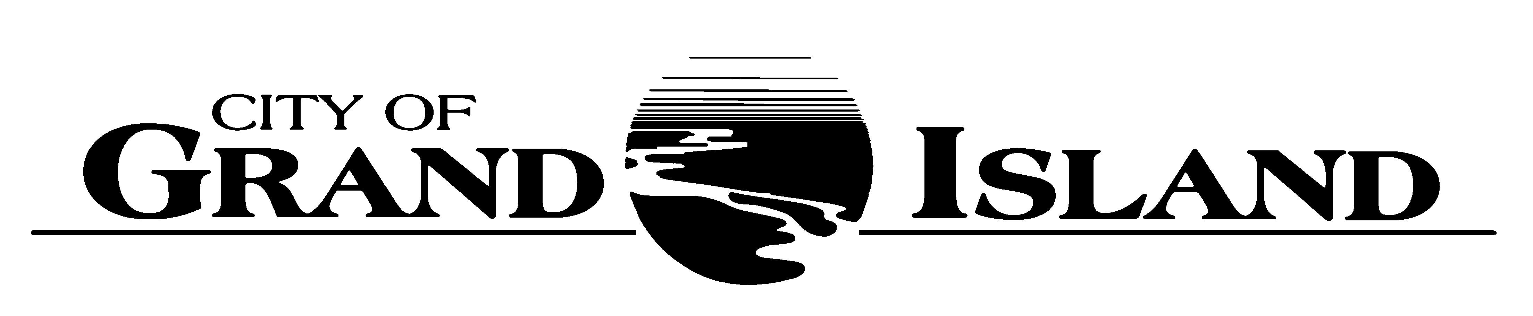  City Council Meeting Agenda  Council Chambers  City Hall  100 East First Street | Mayor  Roger G. Steele  City Administrator  Jerry Janulewicz  City Clerk  RaNae Edwards

Special Meeting of September 7, 2021
7:00 p.m.

CALL TO ORDER

PLEDGE OF ALLEGIANCE

ROLL CALL

A - SUBMITTAL OF REQUESTS FOR FUTURE AGENDA ITEMS

Individuals who have appropriate items for City Council consideration should complete the Request for Future Agenda Items form located at the Information Booth. If the issue can be handled administratively without Council action, notification will be provided. If the item is scheduled for a meeting or study session, notification of the date will be given.

B - RESERVE TIME TO SPEAK ON AGENDA ITEMS

This is an opportunity for individuals wishing to provide input on any of tonight's agenda items to reserve time to speak. Please come forward, state your name and address, and the Agenda topic on which you will be speaking.

C – PRESENTATIONS AND PROCLAMATIONS

None Scheduled.

E – PUBLIC HEARINGS

A public hearing is a formal process intended to solicit public comment. A public hearing is structured, in part, to meet legal requirements. After a brief presentation on the item, any public comments will be heard. Questions and discussion from the Council will take place under the respective action items.

E-1. Public Hearing on FY 2021-2022 Annual Single City Budget and the Annual Appropriations Bill.

F – ORDINANCES

None Scheduled.

G – CONSENT AGENDA

None Scheduled.

H – REQUEST AND REFERRALS

None Scheduled.

I – RESOLUTIONS

None Scheduled.

J – PAYMENT OF CLAIMS

None Scheduled.

The City Council may vote to go into Closed Session on any agenda item as allowed by state law.

A continuously current agenda is maintained in the office of the City Clerk. Inquiries and correspondence concerning the City Council Agenda may be addressed to:

RaNae Edwards, City Clerk Telephone
P.O. Box 1968 (308) 385-5444 Ext. 111
Grand Island, NE 68802-1968
www.grand-island.com

