City Council  Jason Conley  Michelle Fitzke  Bethany Guzinski  Chuck Haase  Maggie Mendoza  Vaughn Minton  Mitch Nickerson  Mike Paulick, President  Justin Scott  Mark Stelk | 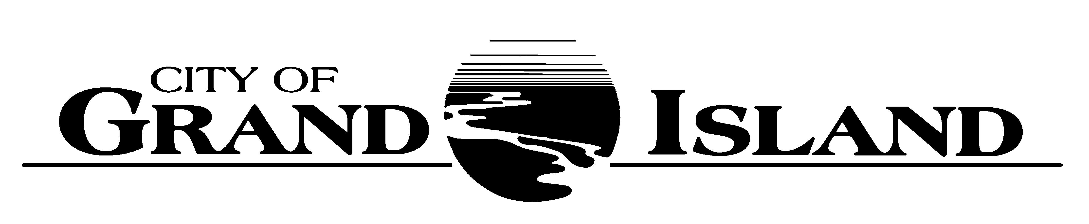  City Council Meeting Agenda  Council Chambers  City Hall  100 East First Street | Mayor  Roger G. Steele  City Administrator  Jerry Janulewicz  City Clerk  RaNae Edwards

Regular Meeting of December 14, 2021
7:00 p.m.

CALL TO ORDER

INOVATION – Pastor Scott Jones, Third City Christian Church, 4100 West 13th Street

PLEDGE OF ALLEGIANCE

ROLL CALL

A - SUBMITTAL OF REQUESTS FOR FUTURE AGENDA ITEMS

Individuals who have appropriate items for City Council consideration should complete the Request for Future Agenda Items form located at the Information Booth. If the issue can be handled administratively without Council action, notification will be provided. If the item is scheduled for a meeting or study session, notification of the date will be given.

B - RESERVE TIME TO SPEAK ON AGENDA ITEMS

This is an opportunity for individuals wishing to provide input on any of tonight's agenda items to reserve time to speak. Please come forward, state your name and address, and the Agenda topic on which you will be speaking.

C – PRESENTATIONS AND PROCLAMATIONS

None Scheduled.

S - SPECIAL ITEMS

S-1. Election of City Council President.

E – PUBLIC HEARINGS

A public hearing is a formal process intended to solicit public comment. A public hearing is structured, in part, to meet legal requirements. After a brief presentation on the item, any public comments will be heard. Questions and discussion from the Council will take place under the respective action items.

E-1. Public Hearing on Acquisition of Utility Easement - 1910 West 9th Street (Crossroads Center).

E-2. Public Hearing on Acquisition of Utility Easement - 1602 W. 2nd St (Raymond O'Connor).

E-3. Public Hearing on Acquisition of Utility Easement - 3225 W. Wildwood Drive (42 Grand Island, LP).

E-4. Public Hearing on Acquisition of Permanent Sanitary Sewer and Lift Station Easements for Central Nebraska Regional Airport Sanitary Sewer Collection System Rehabilitation; Project No. 2017-S-4 (Hall County, Hall County Airport, and City of Grand Island).

E-5. Public Hearing on the Annual Report by Grand Island Area Economic Development Corp./Citizens Advisory Review Committee on the EDC Program Plan.

F – ORDINANCES

F-1. #9865 - Consideration of Amending Chapter 35 of the Grand Island City Code Relative to Groundwater Control Area Boundaries.

G – CONSENT AGENDA

G-1. Approving Minutes of November 23, 2021 City Council Regular Meeting.

G-2. #2021-339 - Approving Acquisition of Utility Easement - 1910 West 9th Street (Crossroads Center).

G-3. #2021-340 - Approving Acquisition of Utility Easement - 1602 W. 2nd St (Raymond O'Connor).

G-4. #2021-341 - Approving Acquisition of Utility Easement - 3225 W. Wildwood Dr (42 Grand Island, LP).

G-5. #2021-342 - Approving Bottom Ash System Upgrades at Platte Generating Station.

G-6. #2021-343 - Approving New South Central Area Law Enforcement Area (SCALES) Interlocal Agreement for Police Services.

G-7. #2021-344 - Approving Acquisition of Permanent Sanitary Sewer and Lift Station Easements for Central Nebraska Regional Airport Sanitary Sewer Collection System Rehabilitation; Project No. 2017-S-4 (Hall County, Hall County Airport, and City of Grand Island).

G-8. #2021-345 - Approving 2021 Public Transit Vehicle Provider.

G-9. #2021-346 - Renewing Approval of Sole Source Designation for Flyght Equipment and Repairs at the Wastewater Treatment Plant.

G-10. #2021-347 - Approving Amendment No. 2 to for Transfer Station Operations and Facility Improvements.

G-11. #2021-348 - Approving Caterpillar D8T Low Ground Pressure Waste Handler Arrangement Dozer Comprehensive Maintenance for the Solid Waste Division of the Public Works Department.

G-12. #2021-349 - Approving Change Order No. 3 for Old Potash Highway Roadway Improvements; Project No. 2019-P-1.

G-13. #2021-350 - Approving Purchase of Trojan Items for UV System at the Wastewater Treatment Plant.

G-14. #2021-351 - Approving Opioid Litigation Settlement.

G-15. #2021-352 - Approving Purchase of Three (3) 60” Mowers for Use in the Cemetery Division.

G-16. #2021-353 - Approving Purchase of Two (2) Bobcat Universal Units for Use in the Park Division.

G-17. #2021-354 - Approving Renewal of State Patrol Building Lease at Heartland Public Shooting Park.

G-18. #2021-355 - Approving Submission of the 2020 Consolidated Annual Performance Evaluation and Review Report to HUD.

G-19. #2021-356 - Approving Pioneer Consortium Fiduciary Agent Change.

H – REQUEST AND REFERRALS

None Scheduled.

I – RESOLUTIONS

I-1. #2021-357 - Consideration of Approving the Annual Report by Grand Island Area Economic Development Corp./Citizens Advisory Review Committee on the EDC Program Plan.

I-2. #2021-358 - Consideration of Approving Funding for the Grand Island Area Economic Development Program Plan.

J – PAYMENT OF CLAIMS

J-1. Approving Payment of Claims for the Period of November 24, 2021 through December 14, 2021.

The City Council may vote to go into Closed Session on any agenda item as allowed by state law.

A continuously current agenda is maintained in the office of the City Clerk. Inquiries and correspondence concerning the City Council Agenda may be addressed to:

RaNae Edwards, City Clerk Telephone
P.O. Box 1968 (308) 385-5444 Ext. 111
Grand Island, NE 68802-1968
www.grand-island.com

