City Council  Jason Conley  Michelle Fitzke  Bethany Guzinski  Chuck Haase  Maggie Mendoza  Vaughn Minton, President  Mitch Nickerson  Mike Paulick  Justin Scott  Mark Stelk | 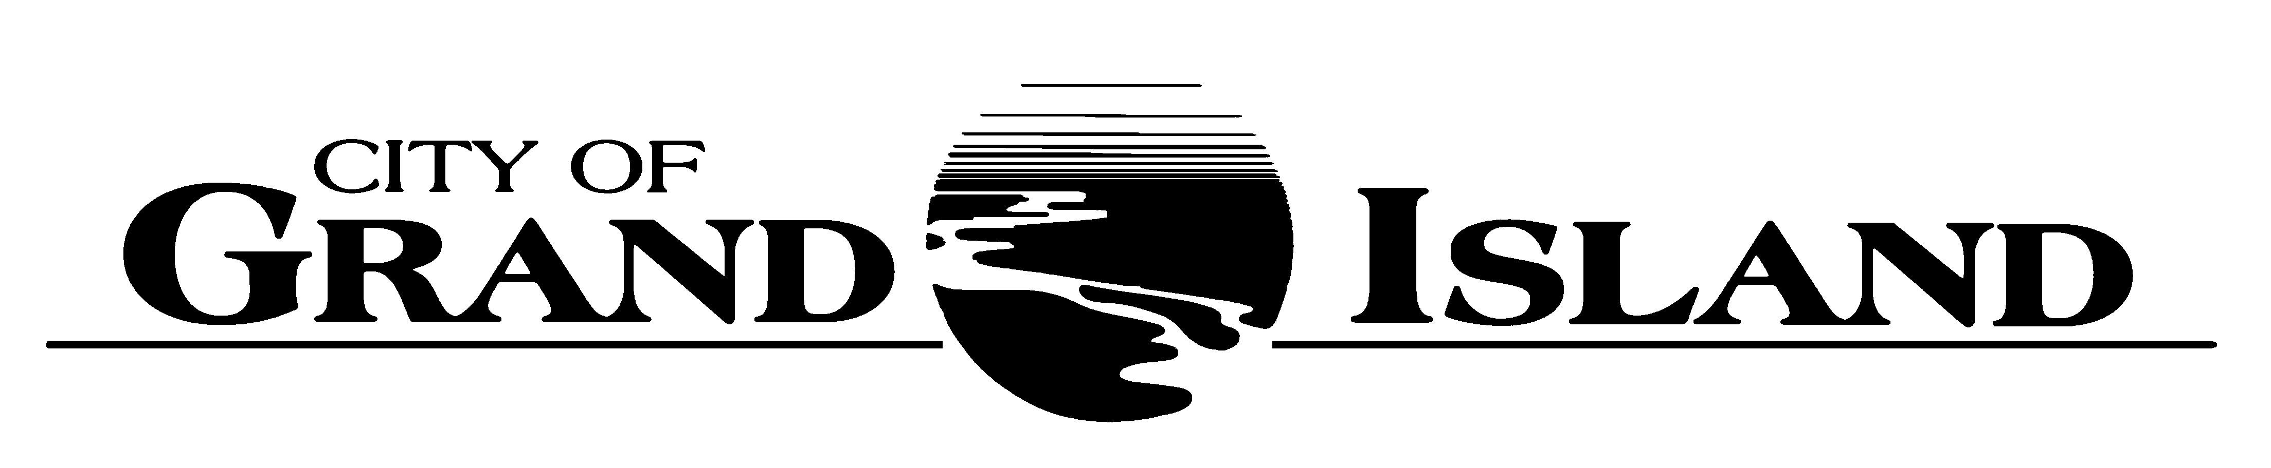  City Council Meeting Agenda  Council Chambers  City Hall  100 East First Street | Mayor  Roger G. Steele  City Administrator  Jerry Janulewicz  City Clerk  RaNae Edwards

Regular Meeting of January 11, 2022
7:00 p.m.

CALL TO ORDER

INOVATION – Pastor Kelly Karges, Trinity United Methodist Church, 511 North Elm Street

PLEDGE OF ALLEGIANCE

ROLL CALL

A - SUBMITTAL OF REQUESTS FOR FUTURE AGENDA ITEMS

Individuals who have appropriate items for City Council consideration should complete the Request for Future Agenda Items form located at the Information Booth. If the issue can be handled administratively without Council action, notification will be provided. If the item is scheduled for a meeting or study session, notification of the date will be given.

B - RESERVE TIME TO SPEAK ON AGENDA ITEMS

This is an opportunity for individuals wishing to provide input on any of tonight's agenda items to reserve time to speak. Please come forward, state your name and address, and the Agenda topic on which you will be speaking.

C – PRESENTATIONS AND PROCLAMATIONS

None Scheduled.

E – PUBLIC HEARINGS

A public hearing is a formal process intended to solicit public comment. A public hearing is structured, in part, to meet legal requirements. After a brief presentation on the item, any public comments will be heard. Questions and discussion from the Council will take place under the respective action items.

E-1. Public Hearing on Acquisition of Utility Easement - 1601 S. Locust Street (Bosselman Real Estate, LLC).

E-2. Public Hearing on Redevelopment Plan for CRA No. 6 for Property located North of State Street and West of Wheeler Avenue (Mesner Development Co.).

E-3. Public Hearing on Acquisition of Public Drainage Easement for Capital Avenue- Moores Creek Drainway to North Road Roadway Improvements; Project No. 2020-P-1.

E-4. Public Hearing on Acquisition of Public Right-of-Way for Capital Avenue- Moores Creek Drainway to North Road Roadway Improvements; Project No. 2020-P-1.

F – ORDINANCES

None Scheduled.

G – CONSENT AGENDA

G-1. Approving Minutes of December 28, 2021 City Council Regular Meeting.

G-2. #2022-1 - Approving Updated East Central 911 Interlocal Agreement.

G-3. #2022-2 - Approving Contract with Motorola CallWorks for 911 System Support.

G-4. #2022-3 - Approving Acquisition of Utility Easement - 1601 S. Locust Street (Bosselman Real Estate, LLC).

G-5. #2022-4 - Approving Bid Award - Tree Removal Project 2022-TR-1.

G-6. #2022-5 - Approving the Certificate of Compliance with the Nebraska Department of Transportation for Maintenance Agreement No. 12; Calendar Year 2021.

G-7. #2022-6 - Approving Bid Award for Asphalt Hot-Mix 2022.

G-8. #2022-7 - Approving Bid Award for Concrete Ready-Mix for 2022.

G-9. #2022-8 - Approving On-Board Mobile Video Surveillance System for the Transit Division of the Public Works Department.

G-10. #2022-9 - Approving Amendment No. 1 to Engineering Consulting Services for Lift Station No. 28 Equalization Tank; Project No. 2022-S-3.

G-11. #2022-10 - Approving Acquisition of Public Drainage Easement for Capital Avenue- Moores Creek Drainway to North Road Roadway Improvements; Project No. 2020-P-1.

G-12. #2022-11 - Approving Acquisition of Public Right-of-Way for Capital Avenue- Moores Creek Drainway to North Road Roadway Improvements; Project No. 2020-P-1.

G-13. #2022-12 - Approving Temporary Construction Easement for Capital Avenue- Moores Creek Drainway to North Road Roadway Improvements; Project No. 2020-P-1.

G-14. #2022-13 - Approving Fundraising Agreement for the Construction of a New Playground at Ryder Park.

G-15. #2022-14 - Approving Re-Construction of Heartland Public Shooting Park Rifle/Pistol Baffle System.

G-16. #2022-15 - Approving New Playground Equipment to be Installed at Stolley Park.

G-17. #2022-16- Approving Consent for Rental Use of the Grand Generation Center.

G-18. #2022 -17 - Approving Emergency Coal Purchase.

H – REQUEST AND REFERRALS

None Scheduled.

I – RESOLUTIONS

I-1. #2022-18 - Consideration of Approving Amendment to the Redevelopment Plan for CRA No. 6 for Property located North of State Street and West of Wheeler Avenue (Mesner Development Co.).

J – PAYMENT OF CLAIMS

J-1. Approving Payment of Claims for the Period of December 29, 2021 through January 11, 2022.

The City Council may vote to go into Closed Session on any agenda item as allowed by state law.

A continuously current agenda is maintained in the office of the City Clerk. Inquiries and correspondence concerning the City Council Agenda may be addressed to:

RaNae Edwards, City Clerk Telephone
P.O. Box 1968 (308) 385-5444 Ext. 111
Grand Island, NE 68802-1968
www.grand-island.com

