City Council  Jason Conley  Michelle Fitzke  Bethany Guzinski  Chuck Haase  Maggie Mendoza  Vaughn Minton, President  Mitch Nickerson  Mike Paulick  Justin Scott  Mark Stelk | 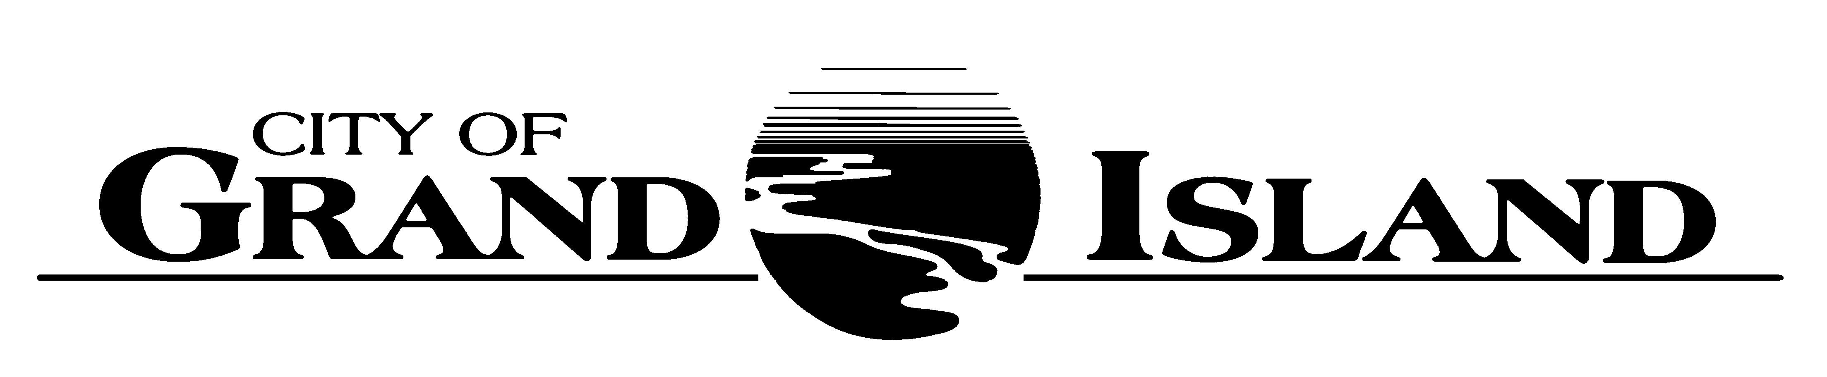  City Council Meeting Agenda  Council Chambers  City Hall  100 East First Street | Mayor  Roger G. Steele  City Administrator  Jerry Janulewicz  City Clerk  RaNae Edwards

Regular Meeting of April 26, 2022
7:00 p.m.

CALL TO ORDER

INOVATION – Pastor Ray Stone, First Faith United Methodist Church, 4190 West Capital Avenue

PLEDGE OF ALLEGIANCE

ROLL CALL

A - SUBMITTAL OF REQUESTS FOR FUTURE AGENDA ITEMS

Individuals who have appropriate items for City Council consideration should complete the Request for Future Agenda Items form located at the Information Booth. If the issue can be handled administratively without Council action, notification will be provided. If the item is scheduled for a meeting or study session, notification of the date will be given.

B - RESERVE TIME TO SPEAK ON AGENDA ITEMS

This is an opportunity for individuals wishing to provide input on any of tonight's agenda items to reserve time to speak. Please come forward, state your name and address, and the Agenda topic on which you will be speaking.

C – PRESENTATIONS AND PROCLAMATIONS

C-1. Presentation of Tree Board Report.

C-2. Presentation Regarding the Hall County Veteran’s Warriors Memorial.

E – PUBLIC HEARINGS

A public hearing is a formal process intended to solicit public comment. A public hearing is structured, in part, to meet legal requirements. After a brief presentation on the item, any public comments will be heard. Questions and discussion from the Council will take place under the respective action items.

E-1. Public Hearing on Acquisition of Utility Easement - 3732 W. Husker Highway (Innate Development 2, LLC)
.
E-2. Public Hearing on Acquisition of Utility Easement - 5620 Quandt Rd Well #103 (Jared Leiser).

E-3. Public Hearing on Electric Utility Integrated Resource Plan.

F – ORDINANCES

F-1. #9879 - Consideration of Vacation of Public Utility Easement in Lot 2 of Pedcor Subdivision- (City of Grand Island).

F-2. #9880 - Consideration of Approving Salary Ordinance.

G – CONSENT AGENDA

G-1. Approving Minutes of April 12, 2022 City Council Regular Meeting.

G-2. Receipt of Official Documents – Pawnbroker’s Official Bonds for G.I. Loan Shop, 1004 West 2nd Street and Express Pawn, 645 South Locust Street.

G-3. Approving Appointment of Tom Barnes to the Zoning Board of Adjustment Board.

G-4. Approving Appointment of Gail Yenny to the Animal Advisory Board.

G-5. #2022-106 - Approving Final Plat and Subdivision Agreement for Copper Creek Estates 21st Subdivision.

G-6. #2022-107 - Approving Final Plat and Subdivision Agreement for Sargent Subdivision.

G-7. #2022-108 - Approving Final Plat and Subdivision Agreement for Eynetich Subdivision.

G-8. #2022-109 - Approving Amendment to McCoy Meadows Subdivision Agreement.

G-9. #2022-110 - Approving Acquisition of Utility Easement - 3732 W. Husker Highway (Innate Development 2, LLC).

G-10. #2022-111 - Approving Acquisition of Utility Easement - 5620 Quandt Rd Well #103 (Jared Leiser).

G-11. #2022-112 - Approving PGS Coal Combustion Residual (CCR) Groundwater Services Task 19 with HDR.

G-12. #2022-113 - Approving Electric Utility Integrated Resource Plan.

G-13. #2022-114 - Approving Renewal of Coal Market Services with Western Fuels Association.

G-14. #2022-115 - Approving Termination Agreement with Prairie Hills Wind, LLC.

G-15. #2022-116 - Approving Purchase of Motorola CommandCentral Analytics Software under 5-year Contract for Police Department.

G-16. #2022-117 - Approving Purchase of Braun Type I Ambulance.

G-17. #2022-118 - Approving Bid Award for Moores Creek Storm Sewer Improvements; Project No. 2021-D-2(B).

G-18. #2022-119 - Approving Bid Award for Diffuser Replacement; Project No. 2022-WWTP-2.

G-19. #2022-120 - Approving Change Order #1 for Stolley Park Wading Pool Demo.

G-20. #2022-121 - Approving Bid Award for Construction of Stolley Park Splash Pad.

G-21. #2022-122 - Approving Change Order #1 for Island Oasis Water Slides Project.

G-22. #2022-123 - Approving Change Order #2 for Heartland Public Shooting Park Baffle Project.

H – REQUEST AND REFERRALS

None Scheduled.

I – RESOLUTIONS

None Scheduled.

J – PAYMENT OF CLAIMS

J-1. Approving Payment of Claims for the Period of April 13, 2022 through April 26, 2022.

The City Council may vote to go into Closed Session on any agenda item as allowed by state law.

A continuously current agenda is maintained in the office of the City Clerk. Inquiries and correspondence concerning the City Council Agenda may be addressed to:

RaNae Edwards, City Clerk Telephone
P.O. Box 1968 (308) 385-5444 Ext. 111
Grand Island, NE 68802-1968
www.grand-island.com

