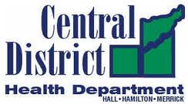

CDHD JOINT MEETING
Law Enforcement Training Center
111 Public Safety Drive
Grand Island NE
Monday, July 25, 2022 - 6:00 p.m. - 7:00 p.m.
AGENDA (Masks highly recommended)

- Welcome: Ron Peterson 6:00 - 6:05

- Roll Call 6:05 – 6:10

- Pandemic – Protecting our most at risk population 6:10 - 6:30
- Our elderly population
- Those least likely to get health care

- Year in Review: Teresa Anderson 6:30 – 6:45

- Budget Overview: Teresa Anderson 6:45 - 6:55

- Closing and questions 6:55 - 7:00

If you are feeling sick, please stay home and get tested

