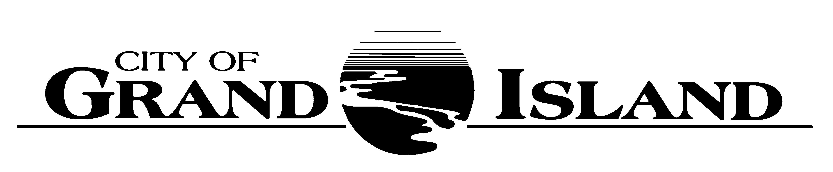

ZONING BOARD OF ADJUSTMENT
Tuesday, September 27, 2022
1:30 p.m.
Conference Room #1
City Hall

AGENDA

- Roll Call

- Approval of Minutes
June 28, 2022

3. Public Hearing 2022-1:
Request from Danny and Alicia Houssler for a Variance from the Regulations Regarding Setback Requirements located at #31 Kuesters Lake.

- Introduction of Official Documents by the City Clerk
- Presentation by the Building Inspector
- Presentation by Applicant
- Submission of Objections
- Discussion and Decision of the Board

5. Adjournment

______________________________________
RaNae Edwards, City Clerk

A continuously current agenda is maintained in the office of the City Clerk. Inquiries and correspondence concerning the Board of Adjustment Agenda may be addressed to:

RaNae Edwards, City Clerk
P.O. Box 1968
Grand Island, Nebraska 68802-1968
(308)385-5444, Extension 111

