City Council  Jason Conley  Michelle Fitzke  Bethany Guzinski  Chuck Haase  Maggie Mendoza  Vaughn Minton, President  Mitch Nickerson  Mike Paulick  Justin Scott  Mark Stelk | 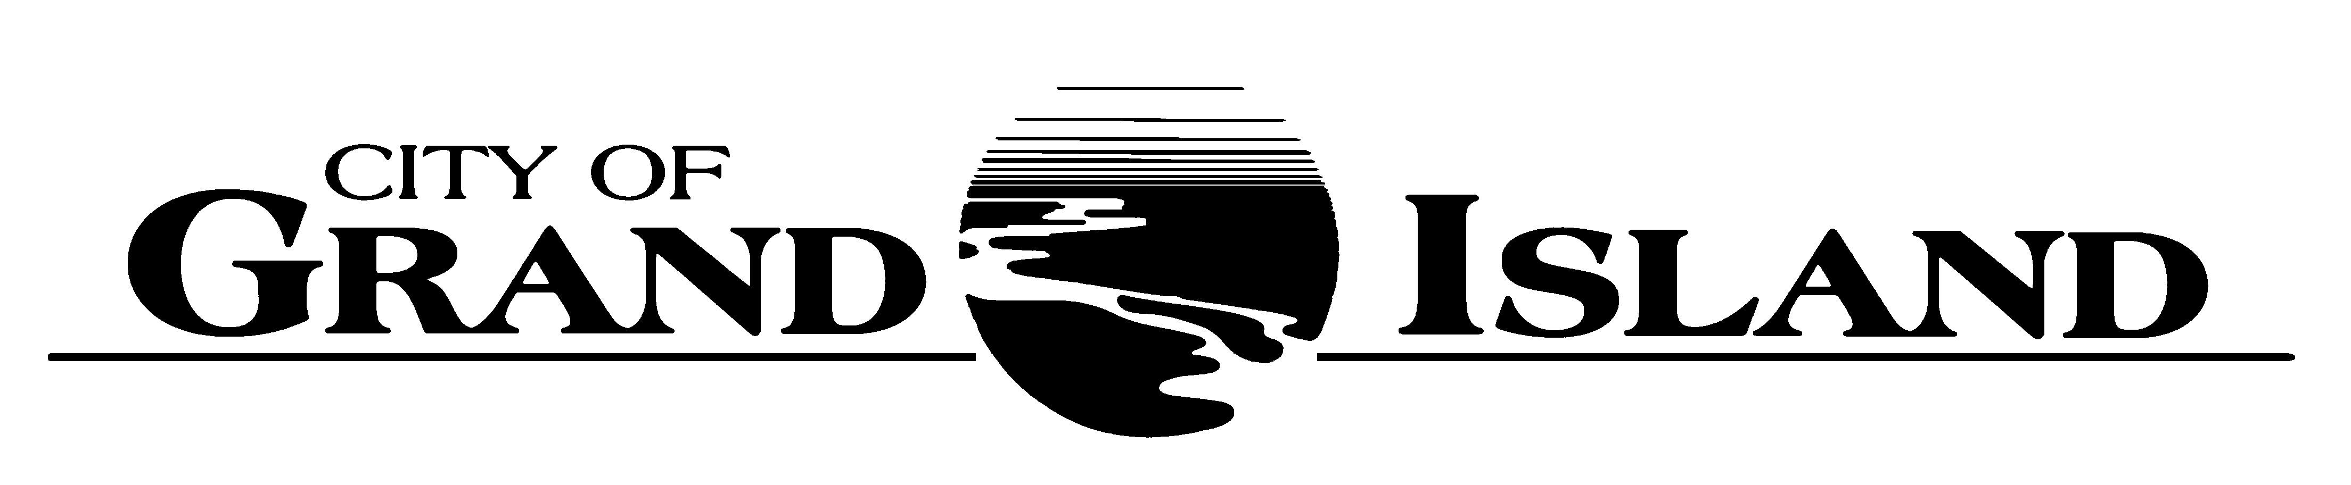  City Council Meeting Agenda  Council Chambers  City Hall  100 East First Street | Mayor  Roger G. Steele  City Administrator  Jerry Janulewicz  City Clerk  RaNae Edwards

Regular Meeting of October 11, 2022
7:00 p.m.

CALL TO ORDER

INOVATION – Pastor Dan Bremer, Grace Lutheran Church, 545 East Memorial Drive

PLEDGE OF ALLEGIANCE

ROLL CALL

A - SUBMITTAL OF REQUESTS FOR FUTURE AGENDA ITEMS

Individuals who have appropriate items for City Council consideration should complete the Request for Future Agenda Items form located at the Information Booth. If the issue can be handled administratively without Council action, notification will be provided. If the item is scheduled for a meeting or study session, notification of the date will be given.

B - RESERVE TIME TO SPEAK ON AGENDA ITEMS

This is an opportunity for individuals wishing to provide input on any of tonight's agenda items to reserve time to speak. Please come forward, state your name and address, and the Agenda topic on which you will be speaking.

C – PRESENTATIONS AND PROCLAMATIONS

None Scheduled.

E – PUBLIC HEARINGS

A public hearing is a formal process intended to solicit public comment. A public hearing is structured, in part, to meet legal requirements. After a brief presentation on the item, any public comments will be heard. Questions and discussion from the Council will take place under the respective action items.

E-1. Public Hearing on Zoning Change to Property located at 3600 Husker Highway from R2 Low Density Residential to CD Commercial Development (Innate Development 2, LLC).

E-2. Public Hearing on Redevelopment Plan for CRA No. 33 for Redevelopment for Property Located North of Husker Highway and West of Prairie View Street Subdivision (Innate Development LLC).

E-3. Public Hearing on Redevelopment Plan for CRA No. 1 for Redevelopment for Property Located at 124 West 3rd Street (Living Waters LLC).

F – ORDINANCES

F-1. #9902 - Consideration of Approving Zoning Change to Property located at 3600 Husker Highway from R2 Low Density Residential to CD Commercial Development (Innate Development 2, LLC).

f-2. #9903 – Consideration of Approving Salary Ordinance.

G – CONSENT AGENDA

G-1. Approving Minutes of September 27, 2022 City Council Regular Meeting.

G-2. #2022-278 - Approving Final Plat and Subdivision Agreement for Legacy 34 Second Subdivision.

G-3. #2022-279 - Approving Purchase of One (1) 2023 D7 Tracked Dozer with Waste Handler Arrangement for the Solid Waste Division of the Public Works Department.

G-4. #2022-280 - Approving Bid Award for Circle Drive Drainage Improvements; Project No. 2022-D-1.

G-5. #2022-281 - Approving Bid Award for North Road- Westgate Road to Old Potash Highway Roadway Improvements; Project No. 2019-P-12.

G-6. #2022-282 - Approving Change Order No. 1 for Lift Station No. 17 Improvements; Project No. 2021-S-9.

G-7. #2022-283 - Approving Award of Landfill Grade Software for the Solid Waste Division of the Public Works Department.

G-8. #2022-284 - Approving Purchase of New Front-End Loader for the Wastewater Division of the Public Works Department.

G-9. #2022-285 - Approving Concurrence of Bid Award to The Diamond Engineering Company for Five Points Intersection Improvements.

G-10. #2022-286 - Approving Program Agreement with NDOT for Broadwell Avenue Grade Separation.

G-11. #2022-287 - Approving Change Order No. 1 for Various Locations Drainage Projects; Brookline Drive and Henry Street/South Street Intersection; Project No. 2021-D-1.

G-12. #2022-288 - Approving Change Order No. 1 for North Road- Old Potash Highway to 13th Street Roadway Improvements; Project No. 2019-P-6.

G-13. #2022-289 - Approving Purchase of Power and Concentric Neutral Cable.

G-14. #2022-290 - Approving Bid Award for Electrical Underground Conduit Installation - Electrical Project 2023-UG-1.

G-15. #2022-291 - Approving Tri-City Drug Enforcement Team (TRIDENT) Civil Forfeiture Signature Authorization.

H – REQUEST AND REFERRALS

None Scheduled.

I – RESOLUTIONS

I-1. #2022-292 - Consideration of Approving the Redevelopment Plan for CRA No. 33 for Redevelopment for Property Located North of Husker Highway and West of Prairie View Street Subdivision (Innate Development LLC).

I-2. #2022-293 - Consideration of Approving the Redevelopment Plan for CRA No. 1 for Redevelopment for Property Located at 124 West 3rd Street (Living Waters LLC).

J – PAYMENT OF CLAIMS

J-1. Approving Payment of Claims for the Period of September 28, 2022 through October 11, 2022.

X – OTHER ITEMS

X-1. Strategy Session Regarding Labor Negotiations with AFSCME Labor Contract.

The City Council may vote to go into Closed Session on any agenda item as allowed by state law.

A continuously current agenda is maintained in the office of the City Clerk. Inquiries and correspondence concerning the City Council Agenda may be addressed to:

RaNae Edwards, City Clerk Telephone
P.O. Box 1968 (308) 385-5444 Ext. 111
Grand Island, NE 68802-1968
www.grand-island.com

