City Council  Jason Conley  Michelle Fitzke  Bethany Guzinski  Chuck Haase  Doug Lanfear  Maggie Mendoza  Mitch Nickerson  Mike Paulick, President  Jack Sheard  Mark Stelk | 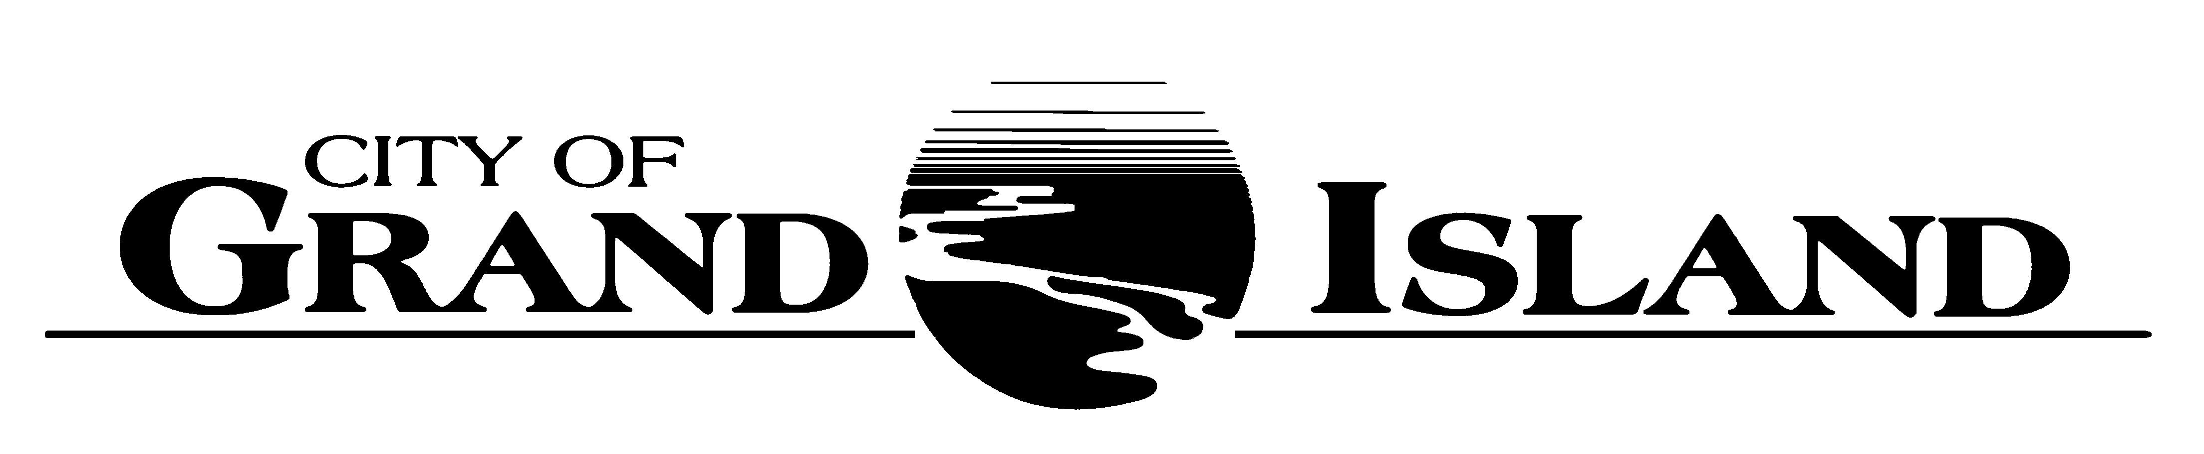  City Council Meeting Agenda  Council Chambers  City Hall  100 East First Street | Mayor  Roger G. Steele  City Administrator  City Clerk  RaNae Edwards

Regular Meeting of January 10, 2023
7:00 p.m.

CALL TO ORDER

INOVATION – Pastor Kelly Karges, Trinity United Methodist Church, 511 North Elm Street

PLEDGE OF ALLEGIANCE

ROLL CALL

A - SUBMITTAL OF REQUESTS FOR FUTURE AGENDA ITEMS

Individuals who have appropriate items for City Council consideration should complete the Request for Future Agenda Items form located at the Information Booth. If the issue can be handled administratively without Council action, notification will be provided. If the item is scheduled for a meeting or study session, notification of the date will be given.

B - RESERVE TIME TO SPEAK ON AGENDA ITEMS

This is an opportunity for individuals wishing to provide input on any of tonight's agenda items to reserve time to speak. Please come forward, state your name and address, and the Agenda topic on which you will be speaking.

C – PRESENTATIONS AND PROCLAMATIONS

C-1. Recognition of Police Chief Robert Falldorf for Service to the City of Grand Island.

E – PUBLIC HEARINGS

A public hearing is a formal process intended to solicit public comment. A public hearing is structured, in part, to meet legal requirements. After a brief presentation on the item, any public comments will be heard. Questions and discussion from the Council will take place under the respective action items.

E-1. Public Hearing on Request from Aloha Investments, LLC dba Afternooner’s, 3773 Sky Park Road, Suite 5 for a Class "C" Liquor License.

E-2. Public Hearing on Request from Grand Island Casino Resort, LLC dba Grand Island Casino Resort, 700 E Stolley Park Road, Suite 2 for a Class “I” Liquor License.

E-3. Public Hearing on Acquisition of Utility Easement - 2983 S. Stuhr Rd (Phillip Beckett, II).

E-4. Public Hearing on Acquisition of Public Right-of-Way in Lassonde Third Subdivision (Parcel No. 400059893- 2002 Nelson Ln).

F – ORDINANCES

F-1. #9913 - Consideration of Approving Amendment to Chapter 18 of the Grand Island City Code Relative to Uniform Mechanical Code.

F-2. #9914 - Consideration of Approving Amendment to Chapter 26 of the Grand Island City Code Relative to Uniform Plumbing Code.

G – CONSENT AGENDA

G-1. Approving Minutes of December 20, 2022 City Council Regular Meeting.

G-2. Approving Councilmembers Appointments to Boards and Commissions.

G-3. #2023-1 - Approving Request from Aloha Investments, LLC dba Afternooner’s, 3773 Sky Park Road, Suite 5 for a Class "C" Liquor License and Liquor Manager Designation for Kialani Hose, 1407 N. Cherry Street.

G-4. #2023-2 - Approving Request from Grand Island Casino Resort, LLC dba Grand Island Casino Resort, 700 E Stolley Park Road, Suite 2 for a Class “I” Liquor License and Liquor Manager Designation for Vincent Fiala, 3784 Lilac Lane.

G-5. #2023-3 - Approving Bid Award for Recruiting Firm for Search to Fill City Administrator and Public Works Director Positions.

G-6. #2023-4 - Approving Acquisition of Utility Easement - 2983 S. Stuhr Rd (Phillip Beckett, II).

G-7. #2023-5 - Approving Certificate of Final Completion WMP 2021-W-1 - Oak and Kimball from Koenig to Division.

G-8. #2023-6 - Approving Acquisition of Public Right-of-Way in Lassonde Third Subdivision (Parcel No. 400059893- 2002 Nelson Ln).

G-9. #2023-7 - Approving Bid Award for Crushed Rock for 2023.

G-10. #2023-8 - Approving Certificate of Final Completion and Scheduling the Board of Equalization for Sidewalk Repair at 239 South Plum Street.

G-11. #2023-9 - Approving Certificate of Final Completion for Diffuser Replacement; Project No. 2022-WWTP-2.

G-12. #2023-10 - Approving Transit Scheduling System with Foxster Opco, LLC, dba CTS Software.

G-13. #2023-11 - Approving Disadvantaged Business Enterprises Program for the City of Grand Island Transit Division of the Public Work Department.

G-14. #2023-12 - Approving Purchase of Trojan Technologies Items for UV System at the Wastewater Treatment Plant.

G-15. #2023-13 - Approving Amendment No. 1 for North Moores Creek Wetland Mitigation Bank.

H – REQUEST AND REFERRALS

None Scheduled.

I – RESOLUTIONS

I-1. #2023-14 - Consideration of Approving Proposal for the Inflation Reduction Act Generation Evaluation and Advisory.

I-2. #2023-15 - Consideration of Approving Compact for Apprehension of Narcotics Dealers and Offenders (CANDO) Interlocal Agreement.

J – PAYMENT OF CLAIMS

J-1. Approving Payment of Claims for the Period of December 21, 2022 through January 10, 2023.

The City Council may vote to go into Closed Session on any agenda item as allowed by state law.

A continuously current agenda is maintained in the office of the City Clerk. Inquiries and correspondence concerning the City Council Agenda may be addressed to:

RaNae Edwards, City Clerk Telephone
P.O. Box 1968 (308) 385-5444 Ext. 111
Grand Island, NE 68802-1968
www.grand-island.com

