City Council  Jason Conley  Michelle Fitzke  Bethany Guzinski  Chuck Haase  Doug Lanfear  Maggie Mendoza  Mitch Nickerson  Mike Paulick, President  Jack Sheard  Mark Stelk | 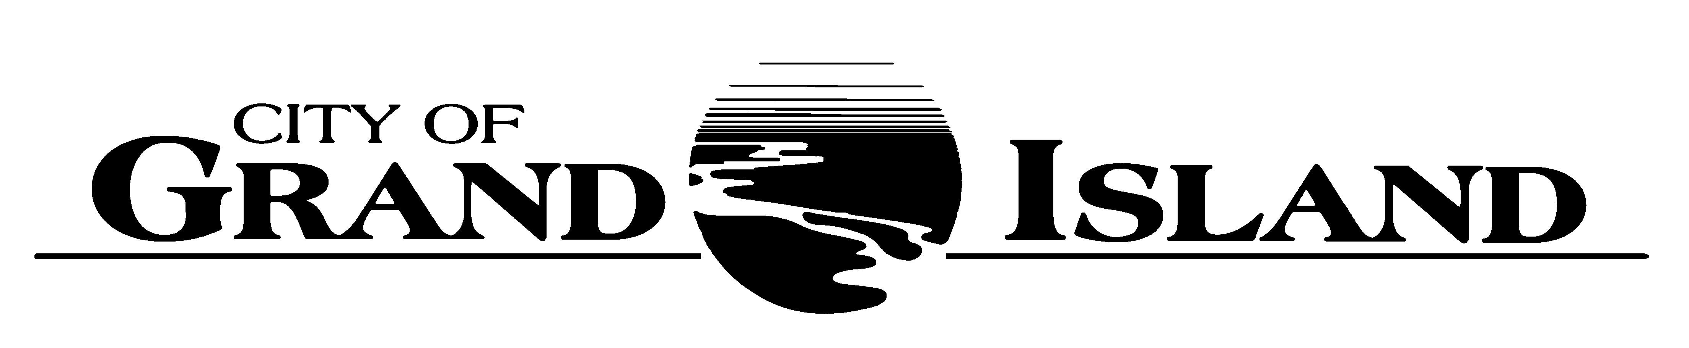  City Council Meeting Agenda  Council Chambers  City Hall  100 East First Street | Mayor  Roger G. Steele  City Administrator  City Clerk  RaNae Edwards

Regular Meeting of January 24, 2023
7:00 p.m.

CALL TO ORDER

INOVATION – Father Don Buhrman, St. Leo’s Catholic Church, 2410 South Blaine Street

PLEDGE OF ALLEGIANCE

ROLL CALL

A - SUBMITTAL OF REQUESTS FOR FUTURE AGENDA ITEMS

Individuals who have appropriate items for City Council consideration should complete the Request for Future Agenda Items form located at the Information Booth. If the issue can be handled administratively without Council action, notification will be provided. If the item is scheduled for a meeting or study session, notification of the date will be given.

B - RESERVE TIME TO SPEAK ON AGENDA ITEMS

This is an opportunity for individuals wishing to provide input on any of tonight's agenda items to reserve time to speak. Please come forward, state your name and address, and the Agenda topic on which you will be speaking.

C – PRESENTATIONS AND PROCLAMATIONS

C-1. Presentation and Discussion Regarding Allocation ARPA Funds.

E – PUBLIC HEARINGS

A public hearing is a formal process intended to solicit public comment. A public hearing is structured, in part, to meet legal requirements. After a brief presentation on the item, any public comments will be heard. Questions and discussion from the Council will take place under the respective action items.

E-1. Public Hearing on Request from Duysen Enterprises, LLC dba The Upper Deck, 2110 West 2nd Street for a Class "C" Liquor License.

F – ORDINANCES

F-1. #9915 - Consideration of Vacation of Public Right-of-Way in Section 12-11-10; North of State Street, East of North Road (Parcel No. 400523168).

G – CONSENT AGENDA

G-1. Approving Minutes of January 10, 2023 City Council Regular Meeting.

G-2. Approving Councilmembers Appointments to Boards and Commissions.

G-3. #2023-16 - Approving Budget Software Annual Renewal.

G-4. #2023-17 - Approving Final Plat and Subdivision Agreement for Ben R Davis Subdivision.

G-5. #2023-18 - Approving Final Plat and Subdivision Agreement for The Orchard Third Subdivision.

G-6. #2023-19 - Approving the Certificate of Compliance with the Nebraska Department of Transportation for Maintenance Agreement No. 12; Calendar Year 2022.

G-7. #2023-20 - Approving Maintenance Agreement No. 12 Renewal with the Nebraska Department of Transportation for Calendar Year 2023.

G-8. #2023-21 - Approving Bid Award for 18th Street - Moores Creek Draiwnay to Diers Avenue; Project No. 2022-P-8.

G-9. #2023-22 - Approving Bid Award for Custer Avenue - 13th Street to State Street Roadway Rehabilitation; Project No. 2022-P-5.

G-10 #2023-23 - Approving Change Order #1 for PGS Bottom Ash System Upgrade.

G-11. #2023-24 - Approving Purchase of Ryder Park Playground.

G-12. #2023-25 - Approving Purchase of Bucket Truck for Parks Operations.

G-13. #2023-26 - Approving Preliminary Design of West Connector Trail Extension.

G-14. #2023-27 - Approving CDBG Sub-recipient Agreement with Central Nebraska Community Action Partnership.

G-15. #2023-28 - Approving Application for the Grand Island Fire Department to Apply for FY22 Assistance to Firefighters Grant to Purchase 70 P25 Compliant Radios.

H – REQUEST AND REFERRALS

None Scheduled.

I – RESOLUTIONS

I-1. #2023-29 – Consideration of Request from Duysen Enterprises, LLC dba The Upper Deck, 2110 West 2nd Street for a Class “C” Liquor License and Liquor Manager Designation for Aaron Duysen, 1507 West 1st Street.

I-2. #2023-30 - Consideration of Approving Letter of Support for Essential Air Service (EAS) to the Department of Transportation (DOT).

I-3. #2023-31 - Consideration of Approving City Council Study Session Schedule for 2023.

I-4. #2023-32 – Consideration of Approving Police Portable Radio Purchase Proposal.

J – PAYMENT OF CLAIMS

J-1. Approving Payment of Claims for the Period of January 11, 2023 through January 24, 2023.

The City Council may vote to go into Closed Session on any agenda item as allowed by state law.

A continuously current agenda is maintained in the office of the City Clerk. Inquiries and correspondence concerning the City Council Agenda may be addressed to:

RaNae Edwards, City Clerk Telephone
P.O. Box 1968 (308) 385-5444 Ext. 111
Grand Island, NE 68802-1968
www.grand-island.com

