City Council  Jason Conley  Michelle Fitzke  Bethany Guzinski  Chuck Haase  Doug Lanfear  Maggie Mendoza  Mitch Nickerson  Mike Paulick, President  Jack Sheard  Mark Stelk | 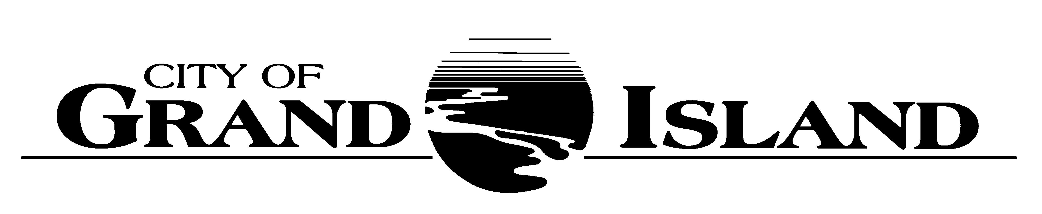  City Council Meeting Agenda  Council Chambers  City Hall  100 East First Street | Mayor  Roger G. Steele  City Administrator  City Clerk  RaNae Edwards

Regular Meeting of February 28, 2023
7:00 p.m.

CALL TO ORDER

INOVATION – Pastor Jeremy Reagen, Solid Rock Baptist Church, 3221 West 13th Street

PLEDGE OF ALLEGIANCE

ROLL CALL

A - SUBMITTAL OF REQUESTS FOR FUTURE AGENDA ITEMS

Individuals who have appropriate items for City Council consideration should complete the Request for Future Agenda Items form located at the Information Booth. If the issue can be handled administratively without Council action, notification will be provided. If the item is scheduled for a meeting or study session, notification of the date will be given.

B - RESERVE TIME TO SPEAK ON AGENDA ITEMS

This is an opportunity for individuals wishing to provide input on any of tonight's agenda items to reserve time to speak. Please come forward, state your name and address, and the Agenda topic on which you will be speaking.

C – PRESENTATIONS AND PROCLAMATIONS

C-1. Recognition of Grand Island Senior High Boys Bowling Team for Class A State Championship.

C-2. Presentation by Central Community College for Infrastructure Funding.

E – PUBLIC HEARINGS

A public hearing is a formal process intended to solicit public comment. A public hearing is structured, in part, to meet legal requirements. After a brief presentation on the item, any public comments will be heard. Questions and discussion from the Council will take place under the respective action items.

E-1. Public Hearing on Request from Simple Kitchen, LLC dba Chocolate Bar, 116 West 3rd Street for a Class "CK" Liquor License.

E-2. Public Hearing on Request from Wish Nebraska, Inc. for a Conditional Use Permit to allow for an 88’ Monopole located at 1515 East 4th Street.

E-3. Public Hearing on Acquisition of Public Right-of-Way for Claude Road; Faidley Avenue to State Street; Project No. 2022-P-4 (Sagewood Phase II, LLC- 1921 Sagewood Avenue).

F – ORDINANCES

F-1. #9917 - Consideration of Amending Grand Island City Code Section 31-25.1 Relative to Development Signs.

F-2. #9918 - Consideration of Approving Salary Ordinance.

G – CONSENT AGENDA

G-1. Approving Minutes of February 14, 2023 City Council Regular Meeting.

G-2. #2023-37 - Approving Request from Simple Kitchen, LLC dba Chocolate Bar, 116 West 3rd Street for a Class "CK" Liquor License and Liquor Manager Designation for Angela Dowd, 2140 2nd Avenue, Boelus, NE.

G-3. #2023-38 - Approving Amendment to the Farmers National Company Manager Agreement to add Acquired Land in 2022.

G-4. #2023-39 - Approving Bid Award for Asphalt Hot-Mix 2023.

G-5. #2023-40 - Approving Bid Award for Concrete Ready-Mix for 2023.

G-6. #2023-41 - Bid Award for Annual Pavement Markings 2023.

G-7. #2023-42 - Approving Bid Award for Curb Ramp Project No. 2023-CR-1.

G-8. #2023-43 - Approving Bid Award for the 2023 Asphalt Resurfacing Project No. 2023-AC-1.

G-9. #2023-44 - Approving Bid Award for Concrete Pavement and Storm Sewer Repairs for 2023.

G-10. #2023-45 - Approving Purchase of One (1) New F150, Four-Wheel Drive Pick-up for the Streets Division of the Public Works Department.

G-11. #2023-46 - Approving Acquisition of Public Right-of-Way for Claude Road; Faidley Avenue to State Street; Project No. 2022-P-4 (Sagewood Phase II, LLC- 1921 Sagewood Avenue).

G-12. #2023-47 - Approving Temporary Construction Easement for Claude Road; Faidley Avenue to State Street; Project No. 2022-P-4 (Sagewood Phase II, LLC- 19121 Sagewood Avenue).

G-13. #2023-48 - Approving Purchase of a New 14’ Vee Box Bulk Salt Spreader for the Streets Division of the Public Works Department.

G-14. #2023-49 - Approving Award of Professional Engineering Consulting Services for Storm Water Modeling Project.

G-15. #2023-50 - Approving PGS Coal Combustion Residual (CCR) Groundwater Services - Task 21.

G-16. #2023-51 - Approving Emergency Procurement of Burdick Station CO2 Fire Suppression System.

G-17. #2023-52 - Approving Bid Award for Water Main Project 2023-W-1.

G-18. #2023-53 - Approving Change Order #1 for New Restroom Facilities for Ryder and George Parks.

G-19. #2023-54 - Approving RFP for a New Playground at Lincoln Park.

G-20. #2023-55 - Approving RFQ for Ryder Park Parking Lot Hard Surfacing.

G-21. #2023-56 - Approving Amendment to Executive Recruitment Services Contract Agreement with Government Professional Services, LLC.

G-22. #2023-57 - Approving Addition to the Fee Schedule for Joint Trenching Installations.

G-23. #2023-58 - Approving Addendum to the East Central 911 Interlocal Agreement.

H – REQUEST AND REFERRALS

H-1. Consideration of Approving the Request from Wish Nebraska, Inc. for a Conditional Use Permit to allow for an 88’ Monopole located at 1515 East 4th Street.

H-2. Consideration of Approving Grant Application to ICMA/Gates Foundation for Economic Mobility Opportunities.

I – RESOLUTIONS

None Scheduled.

J – PAYMENT OF CLAIMS

J-1. Approving Payment of Claims for the Period of February 15, 2023 through February 28, 2023.

The City Council may vote to go into Closed Session on any agenda item as allowed by state law.

A continuously current agenda is maintained in the office of the City Clerk. Inquiries and correspondence concerning the City Council Agenda may be addressed to:

RaNae Edwards, City Clerk Telephone
P.O. Box 1968 (308) 385-5444 Ext. 111
Grand Island, NE 68802-1968
www.grand-island.com

