City Council  Jason Conley  Michelle Fitzke  Bethany Guzinski  Chuck Haase  Doug Lanfear  Maggie Mendoza  Mitch Nickerson  Mike Paulick, President  Jack Sheard  Mark Stelk | 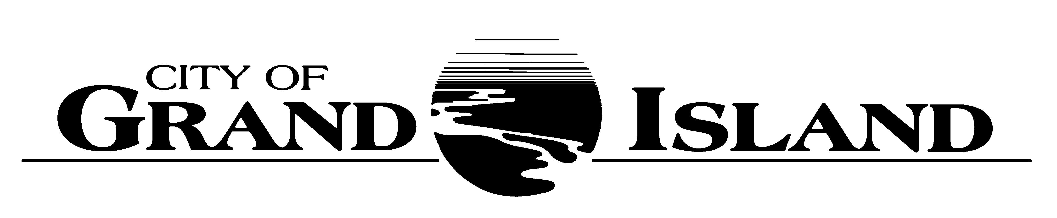  City Council Meeting Agenda  Council Chambers  City Hall  100 East First Street | Mayor  Roger G. Steele  City Administrator  City Clerk  RaNae Edwards

Regular Meeting of March 14, 2023
7:00 p.m.

CALL TO ORDER

INOVATION – Pastor Paul Canady, True North Church, 1804 West State Street

PLEDGE OF ALLEGIANCE

ROLL CALL

A - SUBMITTAL OF REQUESTS FOR FUTURE AGENDA ITEMS

Individuals who have appropriate items for City Council consideration should complete the Request for Future Agenda Items form located at the Information Booth. If the issue can be handled administratively without Council action, notification will be provided. If the item is scheduled for a meeting or study session, notification of the date will be given.

B - RESERVE TIME TO SPEAK ON AGENDA ITEMS

This is an opportunity for individuals wishing to provide input on any of tonight's agenda items to reserve time to speak. Please come forward, state your name and address, and the Agenda topic on which you will be speaking.

C – PRESENTATIONS AND PROCLAMATIONS

C-1. Recognition of the Central Catholic Ben Alberts Wrestling State Championship.

C-2. Recognition of Dave Chavez, Equipment Operator for the Streets Department for 45 Years of Service with the City of Grand Island.

C-3. Recognition of Fire Chief Cory Schmidt's Acceptance into the Executive Leaders Program.

E – PUBLIC HEARINGS

A public hearing is a formal process intended to solicit public comment. A public hearing is structured, in part, to meet legal requirements. After a brief presentation on the item, any public comments will be heard. Questions and discussion from the Council will take place under the respective action items.

E-1. Public Hearing on Zoning Change for Legacy 34 Third Sub. located W. of Prairie View St and N. of Husker Hwy from CD Commercial Dev & RD Residential Dev to Amended CD Commercial Dev & RD Residential Dev & B2 General Business.

F – ORDINANCES

F-1. #9919 - Consideration of Approving Zoning Change for Legacy 34 Third Sub. located W. of Prairie View St and N. of Husker Hwy from CD Commercial Dev & RD Residential Dev to Amended CD Commercial Dev & RD Residential Dev & B2 General Business.

F-2. #9920 - Consideration of Vacation of Utility Easement - 2819 N. Engleman Rd.

F-3. #9921 - Consideration of Vacation of Access Easements in Legacy 34 Second Subdivision; West of Prairieview Street, North of Husker Highway (Innate 3, LLC / Innate 4, LLC / Innate 5, LLC / Innate 6, LLC).

G – CONSENT AGENDA

G-1. Approving Minutes of February 28, 2023 City Council Regular Meeting.

G-2. Approving Request from Full Circle Venue LLC dba Full Circle Venue for a Change of Location from 3333 Ramada Road to 220 West 3rd Street – Liquor License C-088739.

G-3. Receipt of Official Document – Tort Claim filed by Petersen Farms Inc.

G-4. Receipt of Official Document – Tort Claim filed by Lancer Insurance Company on Behalf of its Insured Navigator Motorcoaches, Inc. and Navigator Motorcoaches, Inc.

G-5. #2022-59 - Approving Final Plat and Subdivision Agreement for Legacy 34 Third Subdivision.

G-6. #2023-60 - Approving Lease for Dedicated Parking Stall in the Public Parking Lot at West South Front Street and Walnut Street- Railside District.

G-7. #2023-61 - Approving Lease Agreement with Arnold and Linda Wenn for Property at 1204 W North Front Street for the Wastewater Division of the Public Works Department.

G-8. #2023-62 - Approving Change Order No. 3 for Central Nebraska Regional Airport Sanitary Sewer Collection System Rehabilitation; Project No. 2017-S-4.

G-9. #2023-63 - Approving Purchase of a 2023 Service Truck for Water Distribution Department.

G-10. #2023-64 - Appointment of City's Representative at the Nebraska Municipal Power Pool.

G-11. #2023-65 - Approving Engineering Services for Electric System Master Plan.

G-12. #2023-66 - Approving Purchase of Police Laptops and Docking Stations.

G-13. #2023-67 - Approving Purchase of 2023 Police Fleet Vehicles.

G-14. #2023-68 - Approving 2023-2024 Victims of Crime Act (VOCA) Grant Award for Police Department.

G-15. #2023-69 - Approving FY24 Community Project Funding Grant Request for P25 Radio System.

H – REQUEST AND REFERRALS

None Scheduled.

I – RESOLUTIONS

I-1. #2023-70 - Consideration of Approving Public Transit Service Agreement Budget Amendment for Fiscal Year 2023 and 2024.

I-2. #2023-71 - Consideration of Approving the Final Allocation of the ARPA Funds.

J – PAYMENT OF CLAIMS

J-1. Approving Payment of Claims for the Period of March 1, 2023 through March 14, 2023.

The City Council may vote to go into Closed Session on any agenda item as allowed by state law.

A continuously current agenda is maintained in the office of the City Clerk. Inquiries and correspondence concerning the City Council Agenda may be addressed to:

RaNae Edwards, City Clerk Telephone
P.O. Box 1968 (308) 385-5444 Ext. 111
Grand Island, NE 68802-1968
www.grand-island.com

