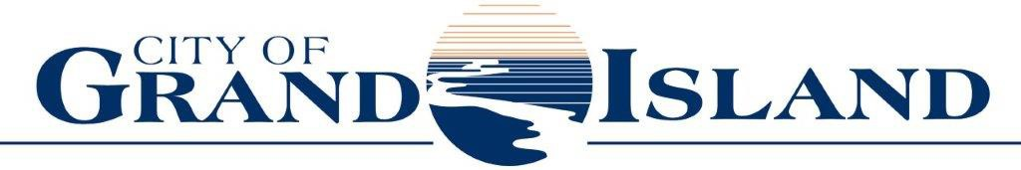
City Council Meeting Agenda Council Chambers
City Hall
100 East First Street
Study Session of June 20, 2023
7:00 PM

- CALL TO ORDER This is an open meeting of the Grand Island City Council. The City of Grand Island abides by the Open Meetings Act in conducting business. A copy of the Open Meetings Act is displayed in the back of this room as required by state law. The City Council may vote to go into Closed Session on any agenda item as allowed by state law.
- PLEDGE OF ALLEGIANCE
- ROLL CALL
- SUBMITTAL OF REQUESTS FOR FUTURE AGENDA ITEMS Individuals who have appropriate items for City Council consideration should complete the Request for Future Agenda Items form located at the Information Booth. If the issue can be handled administratively without Council action, notification will be provided. If the item is scheduled for a meeting or study session, notification of the date will be given.
- RESERVE TIME TO SPEAK ON AGENDA ITEMS This is an opportunity for individuals wishing to provide input on any of tonight's agenda items wishing to reserve time to speak if you did not sign up to speak on an agenda item. Please come forward, state your name and the Agenda topic on which you will be speaking.
- ITEMS FOR DISCUSSION
  - State Fair Presentation
  - Revisions to City Code Chapter 5 Relating to Chickens
  - Council Goal Setting
- ADJOURN

