Purpose of the Blight and Substandard Study
The purpose of completing this Blight and Substandard study is to examine existing conditions within and contiguous to the City of Grand Island. The City of Grand Island has identified a targeted area for consideration of future redevelopment. Portions of the Study Area are currently within the corporate limits of the city and remaining portion is part of a County Industrial Park which is outside of the corporate limits. The area currently within the County Industrial Park will be examined as to its influence on the adjacent areas.

The City of Grand Island, when considering conditions of Blight and Substandard, will be looking at those issues and definitions provided for in the Nebraska Community Redevelopment Law as found in Chapter 18 of the Revised Nebraska State Statutes, as follows:

“The governing body of a , to the greatest extent it deems to be feasible in carrying out the provisions of Sections 18-2101 to 18-2144, shall afford maximum opportunity, consistent with sound needs of the as a whole, to the rehabilitation or redevelopment of the community redevelopment area by private enterprises. The governing body of a shall give consideration to this objective in exercising its powers under sections 18-2101 to 18-2144, including the formulation of a workable program, the approval of community redevelopment plans consistent with the general plan for the development of the , the exercise of its zoning powers, the enforcement of other laws, codes, and regulations relating to the use and occupancy of buildings and improvements, the disposition of any property acquired, and providing of necessary public improvements”.

The Nebraska Revised Statutes §18-2105 continues by granting authority to the governing body for formulation of a workable program. The statute reads,
“The governing body of a or an authority at its direction for the purposes of the Community Development Law may formulate for the entire municipality a workable program for utilizing appropriate private and public resources to eliminate or prevent the development or spread of urban blight, to encourage needed urban rehabilitation, to provide for the redevelopment of substandard and blighted areas, or to undertake such of the aforesaid activities or other feasible municipal activities as may be suitably employed to achieve the objectives of such workable program. Such workable program may include, without limitation, provision for the prevention of the spread of blight into areas of the municipality which are free from blight through diligent enforcement of housing, zoning, and occupancy controls and standards; the rehabilitation or conservation of substandard and blighted areas or portions thereof by replanning, removing congestion, providing parks, playgrounds, and other public improvements by encouraging voluntary rehabilitation and by compelling the repair and rehabilitation of deteriorated or deteriorating structures; and the clearance and redevelopment of substandard and blighted areas or portions thereof.”

Blight and Substandard are defined as the following:
“Substandard areas means an area in which there is a predominance of buildings or improvements, whether nonresidential or residential in character, which, by reason of dilapidation, deterioration, age or obsolescence, inadequate provision for ventilation, light, air, sanitation, or open spaces, high density of population and overcrowding, or the existence of conditions which endanger life or property by fire and other causes, or any combination of such factors, is conducive to ill health, transmission of disease, infant mortality, juvenile delinquency, and crime, (which cannot be remedied through construction of prisons), and is detrimental to the public health, safety, morals, or welfare;”

“Blighted area means an area, which (a) by reason of the presence of a substantial number of deteriorated or deteriorating structures, existence of defective or inadequate street layout, faulty lot layout in relation to size, adequacy, accessibility, or usefulness, insanitary or unsafe conditions, deterioration of site or other improvements, diversity of ownership, tax or special assessment delinquency exceeding the fair value of the land, defective or unusual conditions of title, improper subdivision or obsolete platting, or the existence of conditions which endanger life or property by fire and other causes, or any combination of such factors, substantially impairs or arrests the sound growth of the community, retards the provision of housing accommodations, or constitutes an economic or social liability and is detrimental to the public health, safety, morals, or welfare in its present condition and use and (b) in which there is at least one of the following conditions: (i) Unemployment in the designated area is at least one hundred twenty percent of the state or national average; (ii) the average age of the residential or commercial units in the area is at least forty years; (iii) more than half of the plotted and subdivided property in an area is unimproved land that has been within the city for forty years and has remained unimproved during that time; (iv) the per capita income of the area is lower than the average per capita income of the city or in which the area is designated; or (v) the area has had either stable or decreasing population based on the last two decennial censuses. In no event shall a city of the metropolitan, primary, or first class designate more than thirty-five percent of the city as blighted, a city of the second class shall not designate an area larger than fifty percent of the city as blighted, and a shall not designate an area larger than one hundred percent of the as blighted;”

This Blight and Substandard Study is intended to give the Grand Island Community Redevelopment Authority and Grand Island City Council the basis for identifying and declaring Blighted and Substandard conditions existing within the City’s jurisdiction. Through this process, the City is attempting to address economic and/or social liabilities which are harmful to the well-being of the entire community.

The study area can be seen in Figure 1 of this report. The Redevelopment Plan portion of this report will contain, in accordance with the law, definite local objectives regarding appropriate land uses, improved traffic, public transportation, public utilities and other public improvements, and the proposed land uses and building requirements in the redevelopment area and shall include:
- The boundaries defining the blighted and substandard areas in question (including existing uses and conditions of the property within the area), and
- A list of the conditions present which qualify the area as blighted and substandard.

Existing Land Uses
The term “Land Use” refers to the developed uses in place within a building or on a specific parcel of land. The number and type of uses are constantly changing within a community, and produce a number of impacts that either benefit or detract from the community. Because of this, the short and long-term success and sustainability of the community is directly contingent upon available resources utilized in the best manner given the constraints the City faces during the course of the planning period. Existing patterns of land use are often fixed in older communities and neighborhoods, while development in newer areas is often reflective of current development practices.

Existing Land Use Analysis within Study Area
As part of the planning process, a survey was conducted through both in-field observations, as well as data collection online using the Hall County Assessors website. This survey noted the use of each parcel of land within the study area. These data from the survey are analyzed in the following paragraphs.

Table 1 includes the existing land uses for the entire study area. The table contains the total acres determined per land use from the survey; next is the percentage of those areas compared to the total developed land; and finally, the third set of data compare the all land uses to the total area within the Study Area.

Nearly 28% of the Study Area’s developed land is in Industrial uses and another 27% is in Commercial uses. The next largest land area is the land used for streets and rights-of-way which was approximately 20% of the total area. Overall, approximately 75% of the land area in this Study area is non-residential in nature. Overall residential land uses total approximately 18%.

TABLE 1: EXISTING LAND USE, GRAND ISLAND - 2011
Source: 2011 Grand Island Blight Study, Olsson Associates and Marvin Planning Consultants

Figure 1

Existing Land Use Map

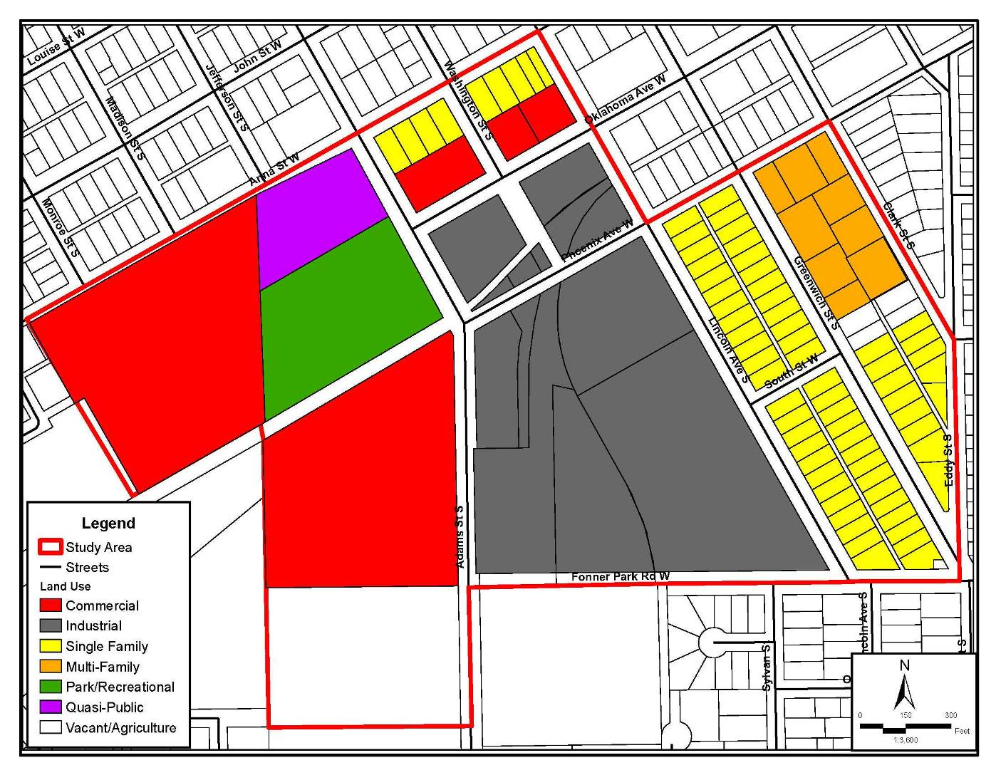

Source: Olsson Associates and Marvin Planning Consultants, 2011

Blight and Substandard Eligibility Study
The City of Grand Island has selected a specific target area within an established part of the community for evaluation. The area is indicated in Figure 2 of this report. The existing uses in this area include single-family residential, multi-family residential, commercial, parks/recreation, quasi-public, commercial, and industrial.

Through the redevelopment process the City of Grand Island can guide future development throughout the area. The use of the Community Redevelopment Act by the City of Grand Island is intended to redevelop and improve the area. Using the Community Redevelopment Act, the City of Grand Island can assist in the elimination of negative conditions and implement different programs/projects identified for the City.

The following is the description of the designated area within Grand Island.

Study Area
POINT OF BEGINNING IS THE INTERSECTION OF THE CENTERLINES OF ANNA STREET AND LINCOLN AVENUE S; THENCE SOUTHEASTERLY ALONG SAID CENTERLINE OF LINCOLN AVENUE S TO THE INTERSECTION OF THE CENTERLINES OF LINCOLN AVENUE S AND PHOENIX AVENUE W; THENCE NORTHEASTERLY ALONG SAID CENTERLINE OF PHOENIX AVENUE W TO THE INTERSECTION OF THE CENTERLINES OF PHOENIX AVENUE W AND CLARK STREET S; THENCE, SOUTH EASTERLY ALONG SAID CENTERLINE OF CLARK STREET S TO THE INTERSECTION OF THE CENTERLINES OF CLARK STREET S AND EDDY STREET S; THENCE, SOUTH ALONG THE CENTERLINE OF EDDY STREET S TO THE INTERSECTION OF THE CENTERLINS OF EDDY STREET S AND FONNER PARK ROAD W; THENCE, WEST ALONG THE CENTERLINE OF FONNER PARK ROAD W TO THE INTERSECTION OF THE CENTERLINES OF FONNER PARK ROAD W AND ADAMS STREET S; THENCE, SOUTH ALONG THE CENTERLINE OF ADAMS STREET S TO THE EXTENDED SOUTH PROPERTY LINE OF THE TRACT DESCRIBED IN FILE: 07-2412 OF THE HALL COUNTY REGISTER OF DEEDS; THENCE, WEST ALONG SAID SOUTH PROPERTY LINE TO THE WEST PROPERTY LINE OF SAID PROPERTY; THENCE NORTH ALONG THE WEST PROPERTY LINE OF SAID PROPERTY TO THE NORTHWEST CORNER OF A PORTION OF LOT 21 AS DESCRIBED IN ITEMS 1 AND 2 OF INSTRUMENT NUMBER 200314398; THENCE NORTHEASTERLY TO THE SOUTHEAST CORNER OF WASH TWP PT SE 1/4 NW 1/4 21-11-9 (ALSO KNOWN AS PARCEL NUMBER 400206935 ON THE HALL COUNTY ASSESSORS SITE); THENCE, NORTHWESTERLY ALONG THE WESTERN PROPERTY LINE OF SAID PROPERTY TO THE INTERSECTION OF THE EXTENDED WESTERN PROPERTY LINE AND THE CENTERLIN OF ANNA STREET W; THENCE, NORTHEASTERLY ALONG SAID CENTERLINE TO THE POINT OF BEGINNING.

Corporate Limits
The Corporate Limits is the entire study area excepting:
- THE PARCEL REFERRED TO WASH TWP PT SE 1/4 NW 1/4 21-11-9 (ALSO REFERRED AS PARCEL NUMBER 400206935 ON THE HALL COUNTY ASSESSORS SITE) 10.92 AC
- WASH TWP PT SW 1/4 NE 1/4 21-11-9 (ALSO REFERRED AS PARCEL NUMBER 400206811 ON THE HALL COUNTY ASSESSORS SITE) 10.33 AC
- WASHINGTON TWP B. & Y. SUB LT 1 (ALSO REFERRED AS PARCEL NUMBER 400209616 ON THE HALL COUNTY ASSESSORS SITE) 132,422 SF
- WASH TWP S OF RR PT NE 1/4 21-11-9 (ALSO REFERRED AS PARCEL NUMBER 400206862 ON THE HALL COUNTY ASSESSORS SITE) .44 AC
- WASH TWP PT NE 1/4 PT FORMER BLKS 7-8-9-10 SOUTH PARK 21-11-9 PT VAC WASHINGTON ST (ALSO REFERRED AS PARCEL NUMBER 400206846 ON THE HALL COUNTY ASSESSORS SITE) 5.69 AC
- A PIECE OF LAND REFERRED TO AS PARCEL 64
- WASH TWP 21-11-9 W 1/2 OF VACATED WASHINGTON STREET (ALSO REFERRED AS PARCEL NUMBER 400371391 ON THE HALL COUNTY ASSESSORS SITE) .076 AC
- WASH TWP PT SW 1/4 NE 1/4 21-11-9 (ALSO REFERRED AS PARCEL NUMBER 400289172 ON THE HALL COUNTY ASSESSORS SITE) .15 AC

Figure 2
Study Area Map
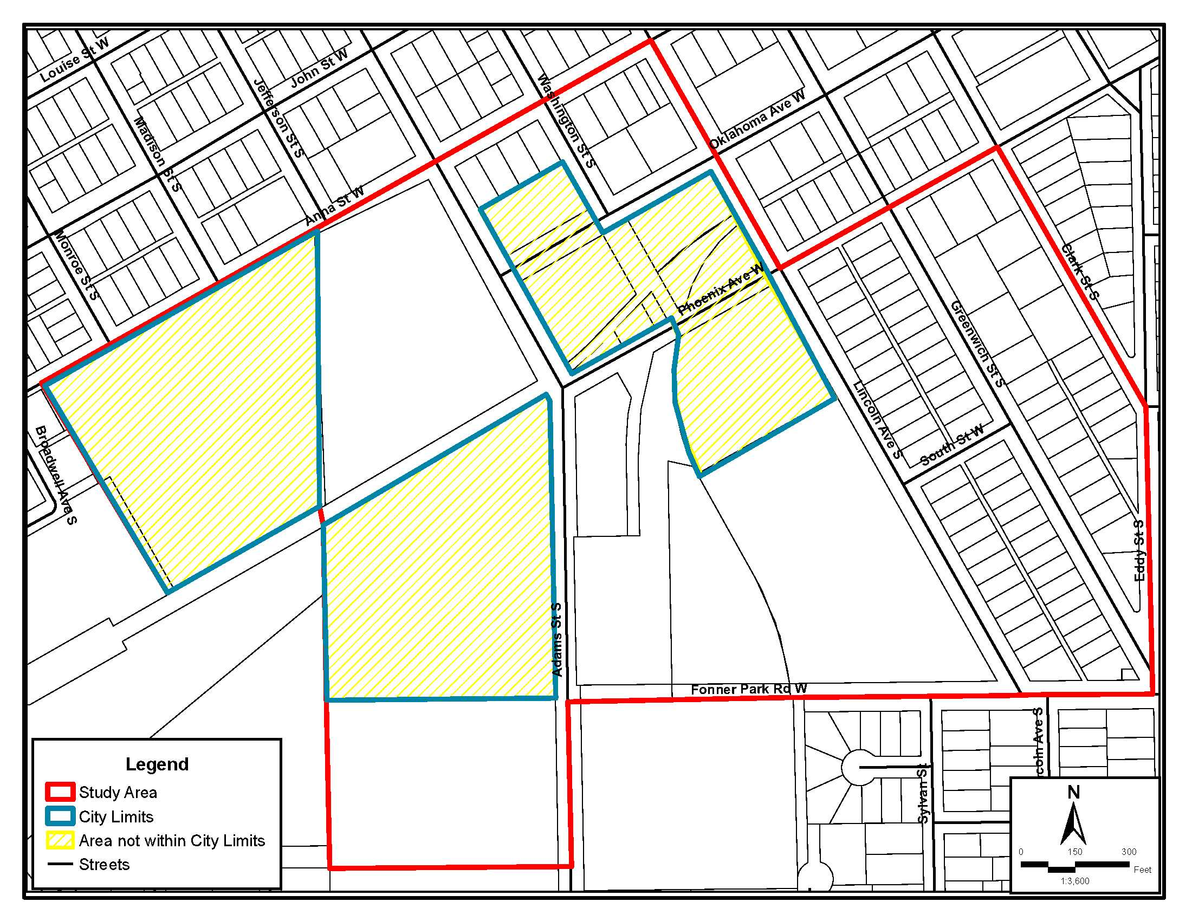

Source: Olsson Associates and Marvin Planning Consultants, 2011
Findings of Blight and Substandard Conditions Eligibility Study
This section of the Eligibility Report examines the conditions found in the study area. The Findings Section will review the conditions based upon the Statutory definitions and then will explain the reasons contributing to the findings.

Contributing Factors
There are a number of conditions that were examined and evaluated in the field and online. There are a number of these conditions that will be reviewed in detail, through the next several pages, while some of the Statutory conditions are present, other are not.

Specifics will be discussed from two angles, within the corporate limits and outside the corporate limits and contributing.

Structural Conditions
Where structural conditions were evaluated, structures were either rated as: No problems, Adequate, Deteriorating, or Dilapidated. The following are the definitions of these terms:

No Problem/ Adequate Conditions
- No structural or aesthetic problems were visible, or
- Slight damage to porches, steps, roofs etc. is present on the structure,
- Slight wearing away of mortar between bricks, stones, or concrete blocks,
- Small cracks in walls or chimneys,
- Cracked windows,
- Lack of paint, and
- Slight wear on steps, doors, and door and window sills and frames.

Deteriorating Conditions
- Holes, open cracks, rotted, loose, or missing materials in parts of the foundation, walls, or roof (up to 1/4 of wall or roof),
- Shaky, broken, or missing steps or railings,
- Numerous missing and cracked window panes,
- Some rotted or loose windows or doors (no longer wind- or water-proof), and
- Missing bricks, or cracks, in chimney or makeshift (uninsulated) chimney.

Dilapidated Conditions
- Holes, open cracks, or rotted, loose or missing material (siding, shingles, brick, concrete, tiles, plaster, floorboards) over large areas of foundation,
- Substantial sagging of roof, floors, or walls,
- Extensive damage by fire, flood or storm, and
- Inadequate original construction such as makeshift walls, roofs made of scrap materials, foundations or floors lacking, or converted barns, sheds, and other structures not adequate for housing.
These are criteria used to determine the quality of each structure in the Study Area.

Corporate Limits
In a recent conditions survey, the structures within the corporate limits were rated. Within the corporate limits portion of the study area there are a total of 106 primary structures. Accessory structures were not rated due to the limited number of them visible from the City rights-of-way (the field survey process does not include venturing onto private property). From the limited number of visible accessory structures, the overall conditions typically matched the primary structures.

After reviewing the overall conditions of the structures in the corporate limits portion include:
- 64 (63.4%) structures rated as adequate
- 24 (23.7%) structures rated as deteriorating
- 13 (12.9%) structures rated as dilapidated

Overall, 36.6% of the structures in this portion of the area are in a state of disrepair. One specific site within the corporate limits contains 8 dilapidated structures and is immediately across the street from an older residential neighborhood. Even though there is not a majority of the structures considered deteriorated or dilapidated, it is felt this represents a substantial number, considering that they are concentrated in two primary areas of the neighborhood. The data are available for inspection; however, for purposes of this study, Figure 3 only shows the data on a block level as opposed to structure. However, if there were several structures deemed to be deteriorating or dilapidated then the entire block was downgraded.

For purposes of this study there is approximately 36.8% of the block area within the corporate limits of the Study Area that has deteriorating or dilapidated structures. The remaining 63.2% was considered as “Adequate”.

Due to the state of disrepair of a number of properties in the area, the conditions represent conditions which are Dangerous to conditions of life or property due to fire or other causes.

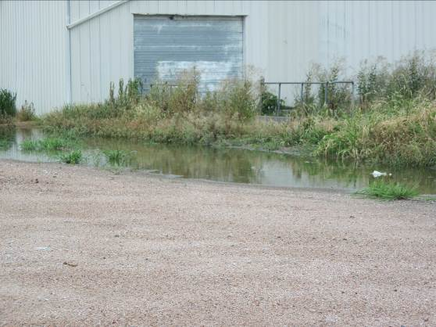
County Industrial Park area
The conditions survey identified 18 structures within the county industrial park limits. Within this area the overall conditions of the structures include:
- 7 (38.8%) structures rated as adequate
- 4 (22.4%) structures rated as deteriorating
- 7 (38.8%) structures rated as dilapidated

Overall, 60.2% of the structures in this portion of the study area are in a state of disrepair. Even though these structures are not currently within the corporate limits of Grand Island; they are in close enough proximity to be a contributing factor to those located within the city limits. One major part of this area contains 7 of the 18 structures that are considered to be deteriorating or dilapidated.

For purposes of this study 52.3% of the area within the county industrial tracts of the Study Area is considered to contain deteriorating or dilapidated structures.

Due to the state of disrepair of a number of properties in the area, the conditions represent conditions which are Dangerous to conditions of life or property due to fire or other causes and are a major contributing factor to the entire study area.
Figure 3
Structural Conditions
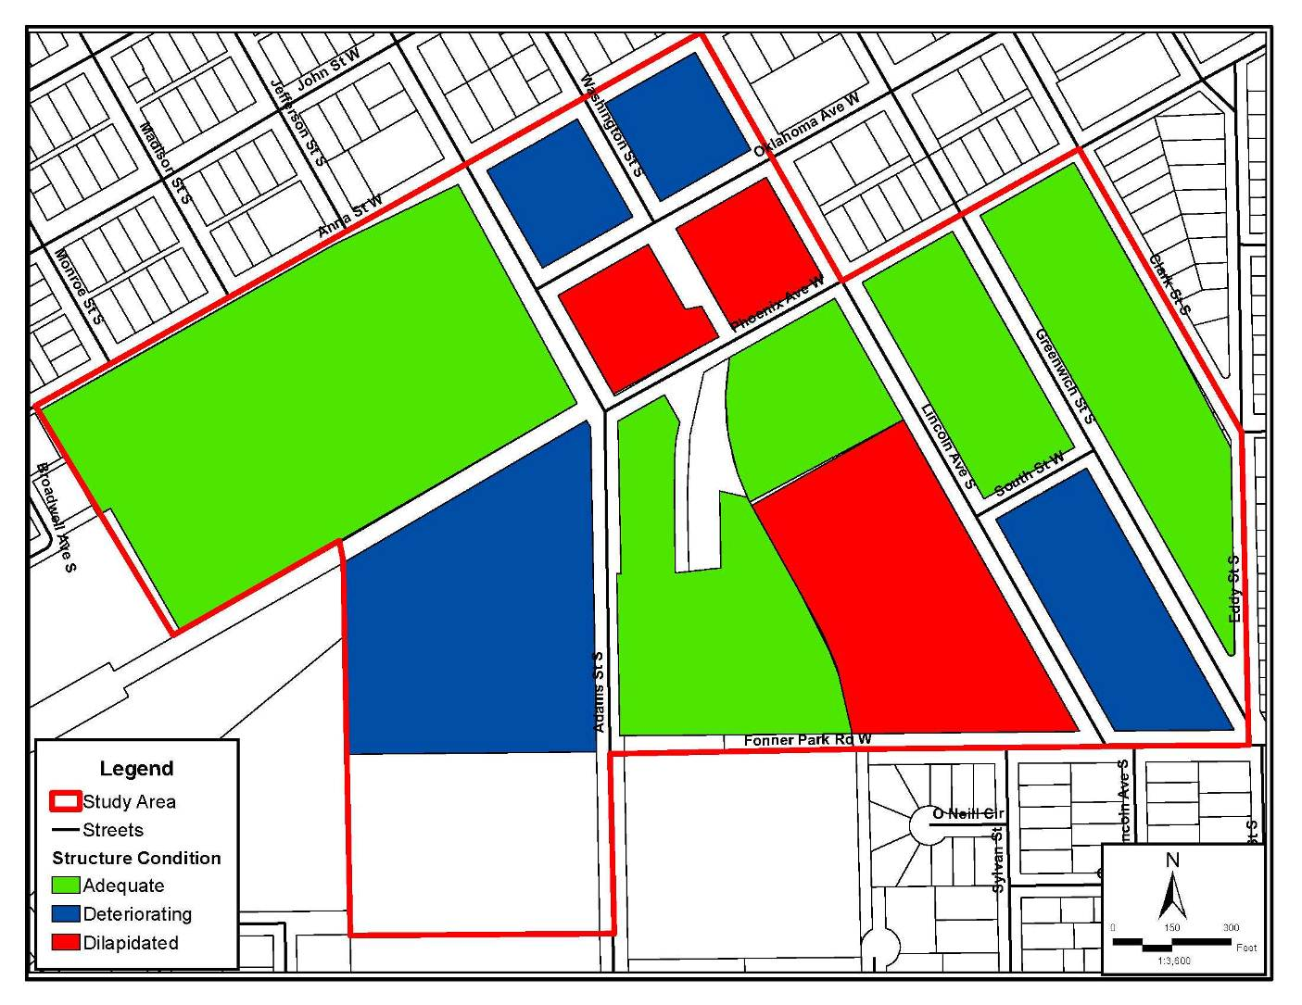
Source: Olsson Associates and Marvin Planning Consultants, 2011

Age of Structure
Besides structural conditions of the buildings in the Study Area, age of these structures is another contributing factor to the blighted and substandard conditions in the area. Statutes allow for a predominance of structures that are 40 years of age or older to be a contributing factor regardless of their condition. The following paragraphs document the structural age of the Study Area and again it is broke down into the corporate limits and the county industrial park areas.

Corporate Limits
Within the corporate limits portion of the study area there is a total of 101 primary structures. After research structural age on the Hall County Assessor’s and Treasurer’s websites, the following breakdown was determined:
- 5 ( 5.0%) structures were determined to be less than 40 years of age
- 96 (95.0%) structures were determined to be 40 years of age or older

Overall, 95.0% of the structures in this portion of the area are 40 years old or older thus qualifying it as substantial. See Figure 4 for the locations of the structures.

Due to the age of the structures in the corporate limits, age of structures would be a direct contributing factor.

Figure 4
Structural Age Map
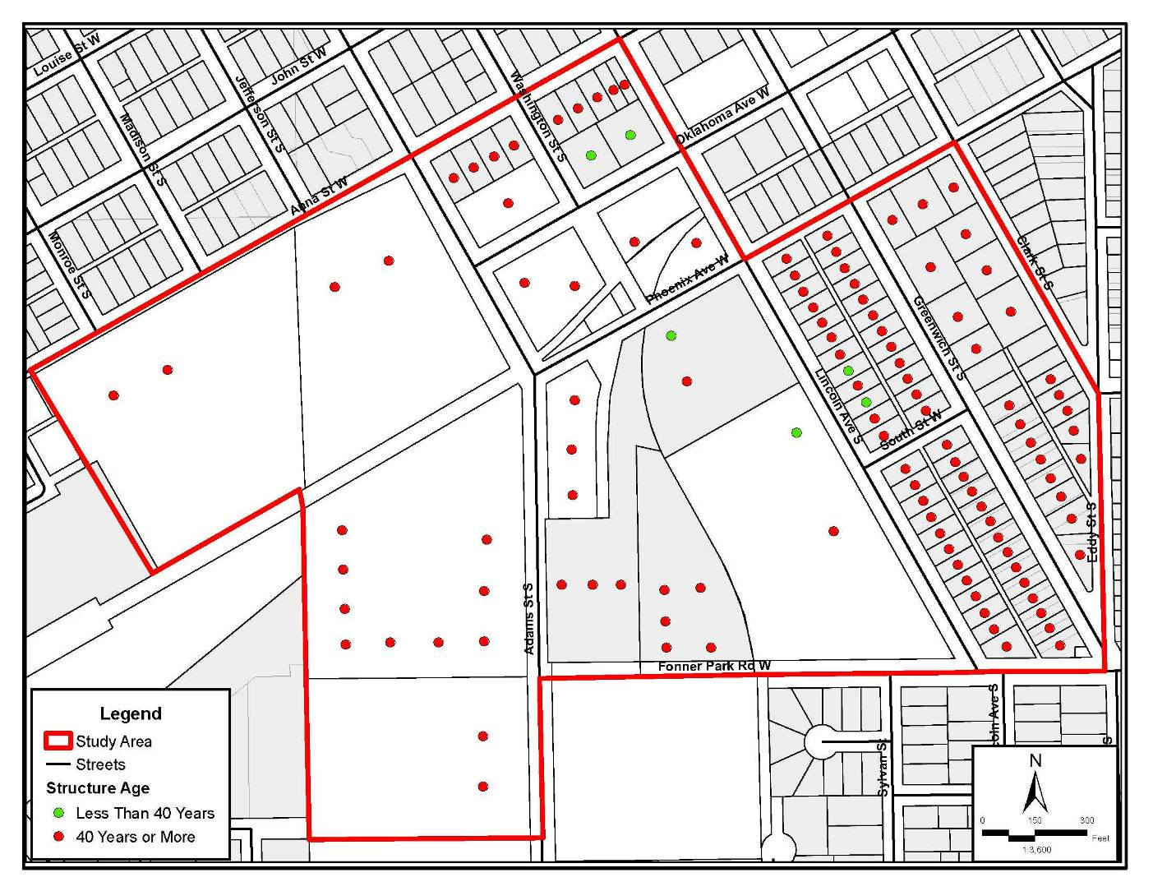
Source: Olsson Associates and Marvin Planning Consultants, 2011

County Industrial Park area
The conditions survey identified 18 structures within the county industrial park limits. Within this area the overall structural ages include:
- 1 ( 0.8%) structures were determined to be less than 40 years of age
- 17 (99.2%) structures were determined to be 40 years of age or older

Overall, over 99% of the structures in this portion of the area are 40 years old or older thus qualifying it as substantial. Even though this area is not within the corporate limits of Grand Island, the structural age of this area does have an impact on the adjacent properties. See Figure 4 for the locations of the structures.

Due to the age of the structures within the county industrial park, age of structures would be a direct contributing factor.

Sidewalk Conditions
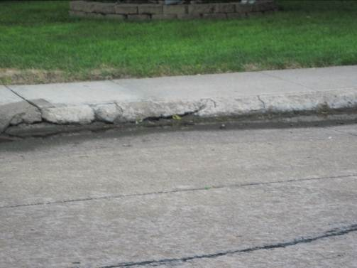
The sidewalk conditions were analyzed in the Study Area including both the incorporated areas and the unincorporated portions of the area. The sidewalks were rated on four categories; adequate, deteriorating, dilapidating, and missing completely. The following is the breakdown by corporate limits and county industrial park.
Corporate Limits
Within the corporate limits portion of the study area there is approximately 12,633 lineal feet of sidewalk. After reviewing the conditions in the field, the following is how the sidewalk conditions breakdown within the corporate limits:
- 4,369 (34.6%) lineal feet of adequate sidewalk
- 2,537 (20.1%) lineal feet of deteriorating sidewalk
- 5,727 (45.3%) lineal feet of no sidewalk.
- There was no sidewalk deemed to be dilapidated.

Overall, 65% of the sidewalks are in either a deteriorating state or completely missing. Missing sidewalk is as bad as dilapidated or deteriorating sidewalk since there is no safe place to walk other than across someone else’s property or in the street. See Figure 5 for the locations of these sidewalks.

Due to the large amount of deteriorating and missing sidewalk, the sidewalk conditions would be a direct contributing factor.

County Industrial Park area
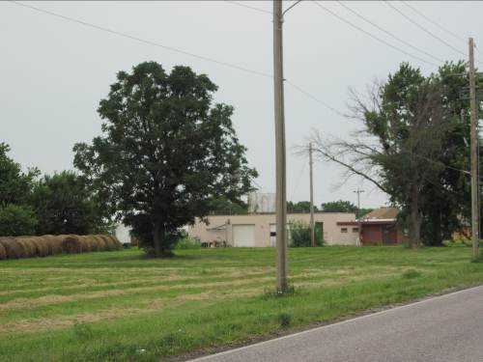
The conditions survey identified approximately 4,744 lineal feet of sidewalk or sidewalk potential within the county industrial park limits. Within this area the sidewalk conditions were as follows:
- 416 (8.8%) lineal feet were determined to be adequate
- 1,484 (31.3%) lineal feet were determined to be in a deteriorating condition
- 2,844 (59.9%) lineal feet had no sidewalk at all
- Again, no dilapidated sidewalk was identified in the field work.

Overall, 90% of the lineal feet in this area were either missing sidewalk or the sidewalk was in a deteriorated state. Again, the most critical portion of this review is the amount of missing sidewalk. Within the county industrial park there are several large tracts of land with heavily traveled streets. Some of these parcels are adjacent to a city trail which has limited connectivity to it from these areas. See Figure 5 for the locations of these conditions.

Due to the large amount of missing or deteriorating sidewalk within the county industrial park, sidewalk conditions would be a direct contributing factor and is a contributing factor to adjacent areas within the corporate limits.
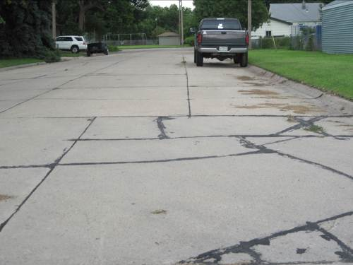
Street Conditions
The street conditions were analyzed in the Study Area including both the incorporated areas and the unincorporated portions of the area. The streets were also rated on four categories; adequate, deteriorating, dilapidating, and missing completely. The following is the breakdown by corporate limits and county industrial park.

Based upon a state statute that requires anytime a city annexes part of a street or road they are required to annex the entire street or road, the analysis assumes that unless a street or road is entirely within the county industrial park it is in the corporate limits. Due to this assumption, of the total 13,139 lineal feet of streets in the study area, all but 270 lineal feet are within the corporate limits.
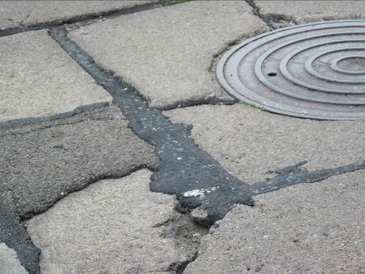
Corporate Limits
Within the corporate limits portion of the study area there is approximately 12,899 lineal feet of street. After reviewing the conditions in the field, the following is how the street conditions breakdown within the corporate limits:
- 1,929 (15.0%) lineal feet of adequate street
- 10,608 (82.2%) lineal feet of deteriorating street
- 362 (2.8%) lineal feet of gravel streets.
- There was no street deemed to be dilapidated.

Overall, 85% of the streets are in either a deteriorating state or was paved with gravel, thus an obsolete material for an urban area. See Figure 6 for the locations of these streets.

Due to the large amount of deteriorating and missing sidewalk, the sidewalk conditions would be a direct contributing factor.

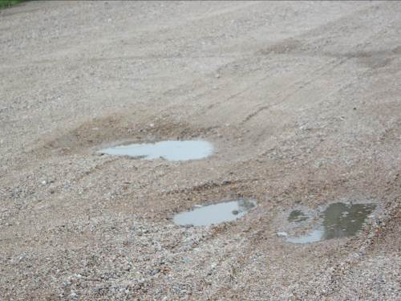
County Industrial Park area
The conditions survey identified approximately 270 lineal feet of street within the county industrial park limits. Within this area the sidewalk conditions were as follows:
- 270 (100.0%) lineal feet was gravel.
- There were no other conditions.

Overall, 100% of the lineal feet in this area were constructed of gravel. In addition, as shown in the photograph at the right, this portion of street had considerable pot holes throughout. See Figure 5 for the locations of these conditions.

Due to the fact that there is one street section that is all gravel within the county industrial park and the condition of that street is in poor condition, street conditions would be a direct contributing factor and is a contributing factor to adjacent areas within the corporate limits.

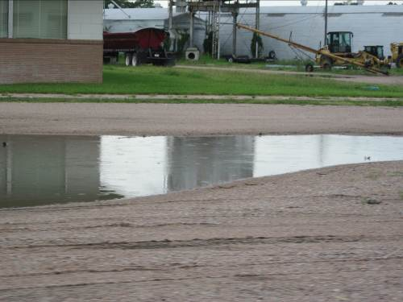
Drainage Conditions
Grand Island has a long history of drainage issue due to the extreme flatness of the area, as well as the high water table. Topography and soils can have a major impact on how a given portion of the city drains. The area designated in this Study Area is nearly flat or has an extremely small slope.

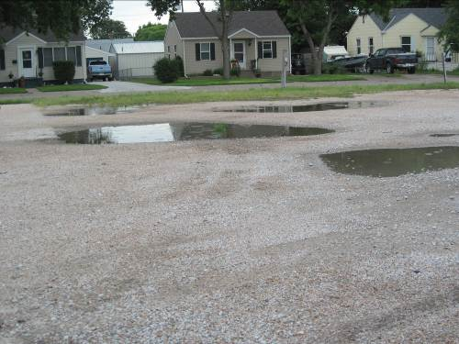
The field survey examined the entire area for potential drainage problems. One field survey was completed a couple of days after a rain event and the second trip was the day after a rain event. During both field visits there was standing water throughout the entire area. Water was standing in large potholes, in drainage ditches, along areas that were supposed to drain the water away.

Standing water from poor drainage can be a catalyst for Health issues like West Nile due to the potential mosquito breeding that can occur.

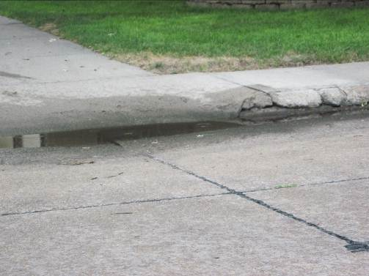
Drainage also can be tied directly to the next issue that was analyzed during the field investigations, curb and gutter conditions.

Curb and Gutter
Curb and Gutters have a number of direct and indirect roles in neighborhoods. Their primary functions is to be a barrier that collects and directs water, drainage. On a secondary level, they can help define where the streets start and stop, and they act as a physical barrier between pedestrian and vehicular traffic.

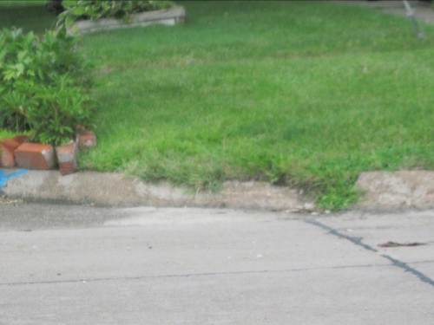
Curb and gutter for the Study Area will be examined similarily to streets and sidewalks. The curb and gutter will be graded as either adequate, deteriorating, dilapidated, or missing. In addition, curb and gutter will be examined based upon their location, within the incorporated area or within the county industrial park.

Corporate Limits
Within the corporate limits portion of the study area there is approximately 11,357 lineal feet of curb and gutter possible. After reviewing the conditions in the field, the following is how the curb and gutter conditions breakdown within the corporate limits:
- 6,432 (56.6%) lineal feet of adequate curb and gutter
- 2,756 (24.3%) lineal feet of deteriorating curb and gutter
- 2,169 (19.1%) lineal feet of no curb and gutter or rural section.
- There was no street deemed to be dilapidated.
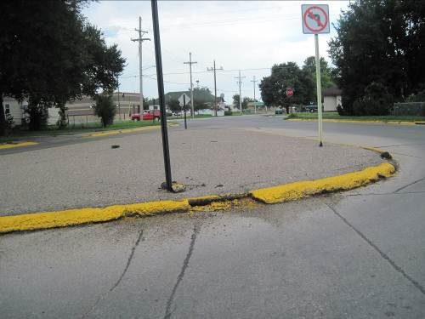
Nearly, 45% of the curb and gutters are in either a deteriorating state or are missing. See Figure 7 for the locations of these streets.

Due to the large amount of deteriorating and missing curb and gutter, the curb and gutter conditions would be a direct contributing factor.

County Industrial Park area
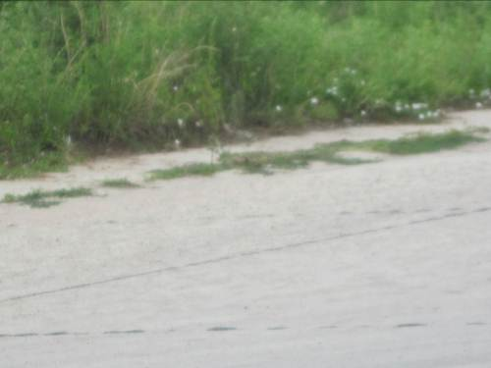
The conditions survey identified approximately 6,200 lineal feet of curb and gutter or possible locations within the county industrial park limits. Within this area the curb and gutter conditions were as follows:
- 416 (6.7%) lineal feet was adequate curb and gutter.
- 1,484 (23.9%) lineal feet was in a deteriorating condition.
- 4,299 (69.3%) had no curb and gutter or was rural section drainage.
- There was no curb and gutter deemed to be in a dilapidated condition.

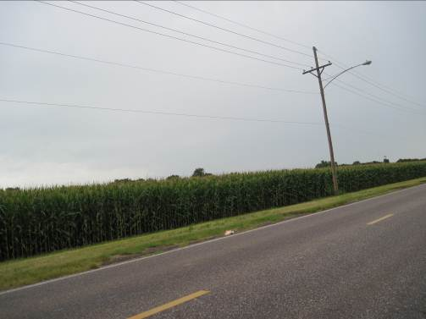
Overall, 92% of the lineal feet in this area were either deteriorating curb and gutter or there was no curb and gutter. See Figure 7 for the locations of these conditions.

Due to the fact that there is a great deal of deteriorating curb and gutter, as well as the fact there is a large portion of this area that does not have any curb and gutter this area would be contributing negatively to adjacent areas within the corporate limits.

Unsanitary / Unsafe conditions
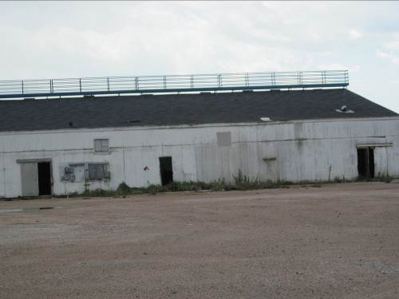
The primary issue surrounding Unsanitary/Unsafe conditions is centered on issues within the county industrial park portion of the Study Area. Even though these conditions are not completely present within the corporate limits, they are a major contributing factor on the properties within the corporate limits.

The first contributing factor is the standing water and drainage issues that are found throughout the entire Study Area. This water has the potential to be the breeding grounds for insects, especially mosquitoes and their potential to carry the West Nile Virus.

Secondly, the old Aurora COOP site contains several building that has limited use at present. It appears that a number of these structures may not be secure and the potential for individuals to sneak into the structures and injure themselves is an extreme possibility.

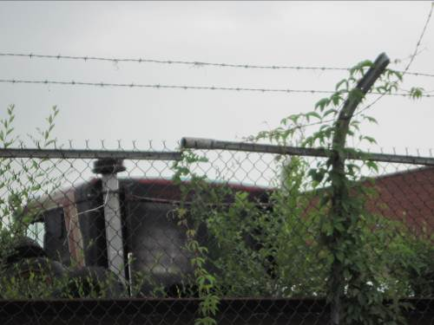
The final contributing factor found within the Study Area is the property along the south side of Oklahoma Avenue. The property not only contains run down structures but it also contains a large area of old machinery and other items. The property is also very weedy. The property is fenced off with a larger chain link fence; however, the fence itself is in disrepair and a potential unsafe condition. All of these conditions are along the Oklahoma Avenue side of the property.

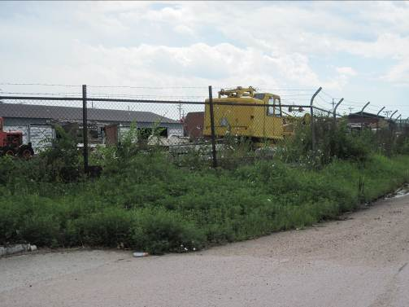
Based upon the field analysis, there are sufficient elements present for there to be unsanitary and unsafe conditions in the Study Area. These conditions are predominately found as being a contributing factor from properties in the county industrial park.

Deterioration of site or other improvements
Throughout the corporate limits of this Study Area, there is a large portion of sidewalk that is either deteriorating or missing. In addition, a large portion of the curb and gutter has been determined to be either deteriorating or missing.

Finally, the corporate limits also have a large amount of deteriorating streets. The streets have been patched over and over due to large amounts of cracking that has been occurring in the pavement.

These are major considerations in determining if the area has deteriorated sites or improvements.

There are a number of properties in the county industrial park that lend themselves to this category. Again the old Aurora COOP site contains several structures that have a negative impact on adjacent properties within the corporate limits. In addition, several of the larger ponding locations are located on this property.

The site along the south side of Oklahoma Avenue has a security fence that is in disrepair. In addition there are a large number of overgrown weeds and volunteer trees growing along the Oklahoma Avenue property line.

Based upon the field analysis, there are sufficient elements present to meet the definition of deterioration of site and other improvements in the Study Area. These conditions include conditions found to be contributing from properties in the county industrial park.

Dangerous conditions to life or property due to fire or other causes
A number of the structures within the Study Area deteriorating and appear to be getting worse. The continued deterioration from this point forward will place some of these properties at risk for fire.

In addition, there are a couple of properties that if they go untouched in the future could present a danger to life if someone were to sneak onto the property. This property needs to have a repaired security fence put into place in order to minimize the threat.

Based upon the field analysis, there are sufficient elements present to meet the definition of dangerous conditions within the Study Area. These conditions are predominately found as being a contributing factor from properties in the county industrial park.

Combination of factors which are impairing and/or arresting sound growth
There is one critical element within this Study Area that is presently impairing and/or arresting sound growth, the remaining parcels that are located within the county industrial park. Currently, there is so few properties left within the county industrial park that the benefits that this economic development tool offers is extremely minimized. Therefore, any future development within this portion of the Study Area will likely be minimal thus slowing the ability of the entire area to redevelop.

Based upon the field analysis, there are sufficient elements present to meet the definition of impairing/arresting sound growth within the Study Area. These conditions are predominately found as being a contributing factor from properties in the county industrial park.

Blighting Summary
These conditions are contributing to the blighted conditions of the study area.
- Substantial number of deteriorating structures
  - 30.8% of the structures identified within the corporate limits, of the Study Area, were deemed to be in a state of deterioration or dilapidation
  - 63.6% of the structures in the adjacent county industrial park where deemed to be in a state of deterioration or dilapidation.
  - The deteriorating and dilapidated structures within the county industrial park are a contributing factor on the properties within the corporate limits.
- Unsanitary / Unsafe conditions
  - The presence of standing water through the corporate limits and the county industrial park is a contributing factor due to the potential breeding grounds for insects such as mosquitoes.
  - In addition one property within the county industrial park has a large amount of junk and debris. In addition the facility also has a chain link fence that is falling apart.
- Deterioration of site or other improvements
  - A large amount of sidewalk either in a deteriorated state or missing from properties in the corporate limits
  - A large amount of sidewalk either in a deteriorated state or missing within the county industrial park area
  - The existence of two gravel streets within the study area
  - The condition of the streets within the corporate limits and the county industrial park
  - Deteriorating curb and gutter and missing curb and gutter in both the corporate limits and county industrial park.
- Dangerous conditions to life or property due to fire or other causes
  - The number of deteriorating structures, especially within the county industrial park portion of the Study Area.
  - The condition of the property on the south side of Oklahoma Avenue
  - The condition of the security fence along the south side of Oklahoma Avenue
- Combination of factors which are impairing and/or arresting sound growth
  - The continued existence of the county industrial park
- Average age of structures is over 40 years of age
  - Within the corporate limits of the Study Area 97.8% of the structures meet the criteria of 40 years of age or older.
  - Within the county industrial park portion of the Study Area. 90.9% of the structures meet the criteria of 40 years of age or older.

The other criteria for Blight were not present in the area, these included:
- Defective/Inadequate street layouts,
- Faulty lot layout,
- Defective or unusual condition of title,
- Economic or social liability detrimental to health, safety and welfare,
- Conditions provision of housing accommodations,
- One-half of unimproved property is over 40 years old,
- Inadequate provisions for ventilation, light, air, open spaces or sanitation, and
- Diversity of ownership.
- Improper Subdivision or obsolete platting

These issues were either not present or were limited enough as to have little impact on the overall condition of the study area.

Substandard Conditions

Average age of the residential or commercial units in the area is at least forty years
Besides structural conditions of the buildings in the Study Area, age of these structures is another contributing factor to the substandard conditions in the area. Statutes allow for a predominance of structures that are 40 years of age or older to be a contributing factor regardless of their condition. The following paragraphs document the structural age of the Study Area and again it is broke down into the corporate limits and the county industrial park areas.

Corporate Limits
Within the corporate limits portion of the study area there is a total of 91 primary structures. After research structural age on the Hall County Assessor’s and Treasurer’s websites, the following breakdown was determined:
- 2 (2.2%) structures were determined to be less than 40 years of age
- 89 (97.8%) structures were determined to be 40 years of age or older

Overall, 97.8% of the structures in this portion of the area are 40 years old or older thus qualifying it as substantial. See Figure 4 for the locations of the structures.

Due to the age of the structures in the corporate limits, age of structures would be a direct contributing factor.

County Industrial Park area
The conditions survey identified 22 structures within the county industrial park limits. Within this area the overall structural ages include:
- 2 (9.1%) structures were determined to be less than 40 years of age
- 20 (90.9%) structures were determined to be 40 years of age or older

Overall, 90% of the structures in this portion of the area are 40 years old or older thus qualifying it as substantial. Even though this area is not within the corporate limits of Grand Island, the structural age of this area does have an impact on the adjacent properties. See Figure 4 for the locations of the structures.

Due to the age of the structures within the county industrial park, age of structures would be a direct contributing factor.

Substandard Summary
Nebraska State Statute requires that at least one of five substandard factors be present in a community. This Study Area in Grand Island has one of the five. The other criteria for Substandard were not present or the data was not readily accessible in the area, these included:
- Unemployment in the designated area is at least one hundred twenty percent of the state or national average;
- more than half of the plotted and subdivided property in an area is unimproved land that has been within the city for forty years and has remained unimproved during that time;
- the per capita income of the area is lower than the average per capita income of the city or in which the area is designated
- the area has had either stable or decreasing population based on the last two decennial censuses.

Findings for Grand Island
Study Area #8 has several items contributing to the Blight and Substandard Conditions. These conditions include:

Blighted Conditions
- Substantial number of deteriorating structures,
- Unsanitary / Unsafe conditions,
- Deterioration of site or other improvements,
- Dangerous conditions to life or property due to fire or other causes,
- Combination of factors which are impairing and/or arresting sound growth,
- Average age of structures is over 40 years of age.

Substandard Conditions
- Average age of the residential or commercial units in the area is at least forty years

Issues which were not researched due to a lack of data were:
- Tax/special assessment delinquency greater than fair value of land,
- Tax delinquency,
- Underemployment that equals 120% state or national average,
- Per capita income less than city wide average, and
- High Density or population and overcrowding.
- Unemployment in the designated area is at least one hundred twenty percent of the state or national average;
- more than half of the plotted and subdivided property in an area is unimproved land that has been within the city for forty years and has re mained unimproved during that time;
- the per capita income of the area is lower than the average per capita income of the city or in which the area is designated

Figure 5:
Sidewalk Conditions
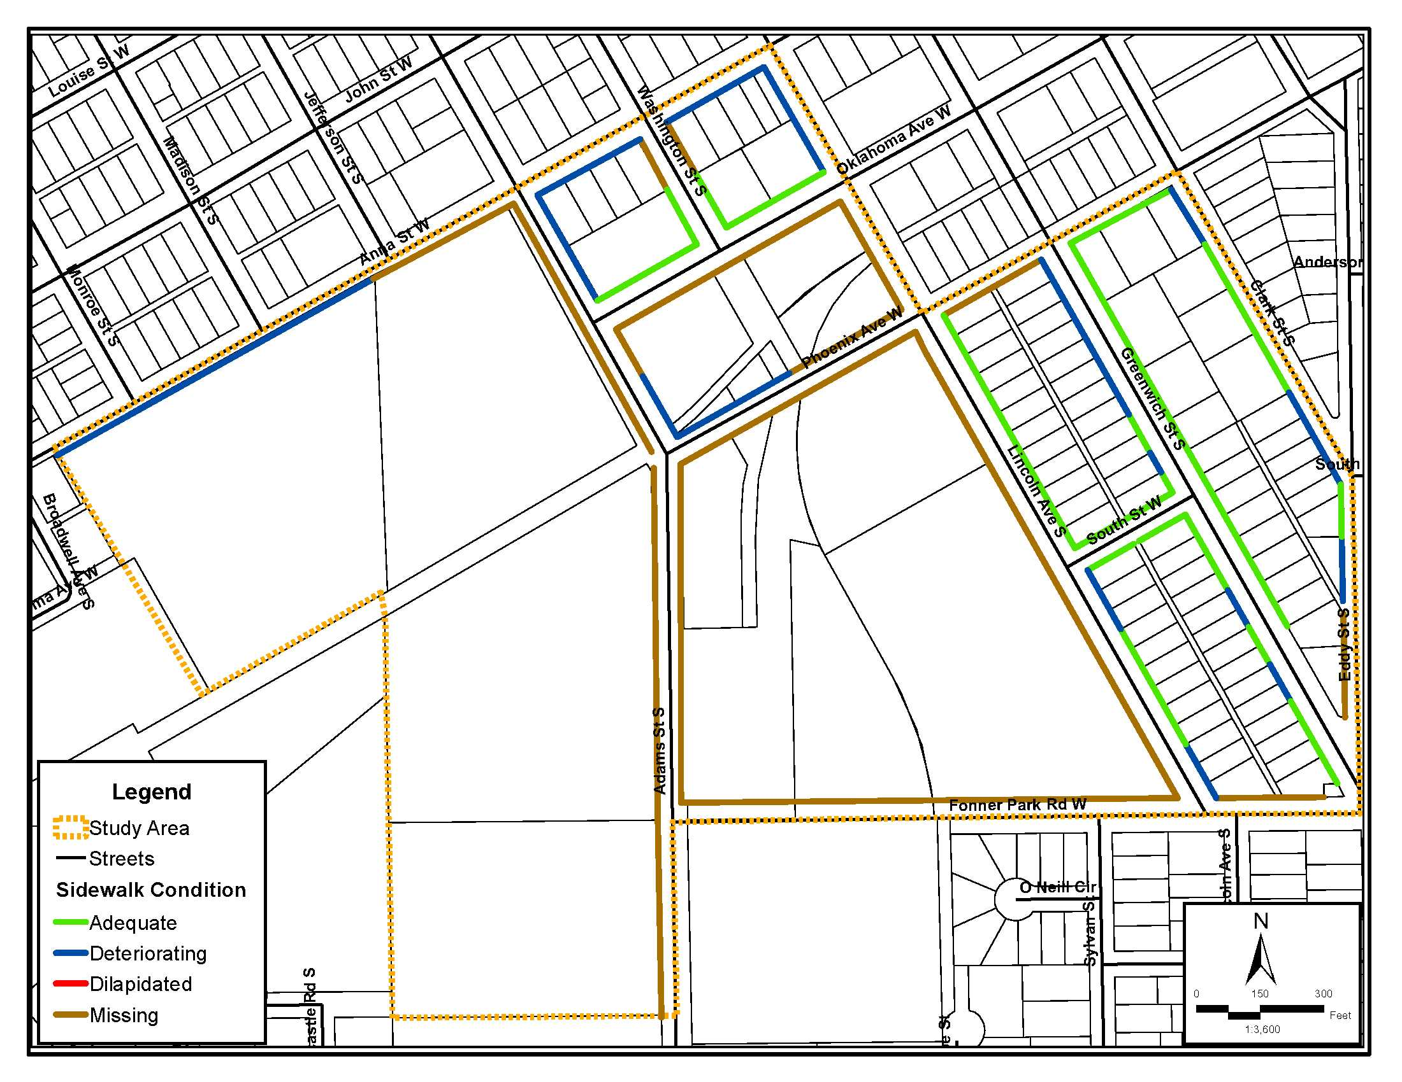
Source: Olsson Associates and Marvin Planning Consultants, 2011
Figure 6:
Street Conditions
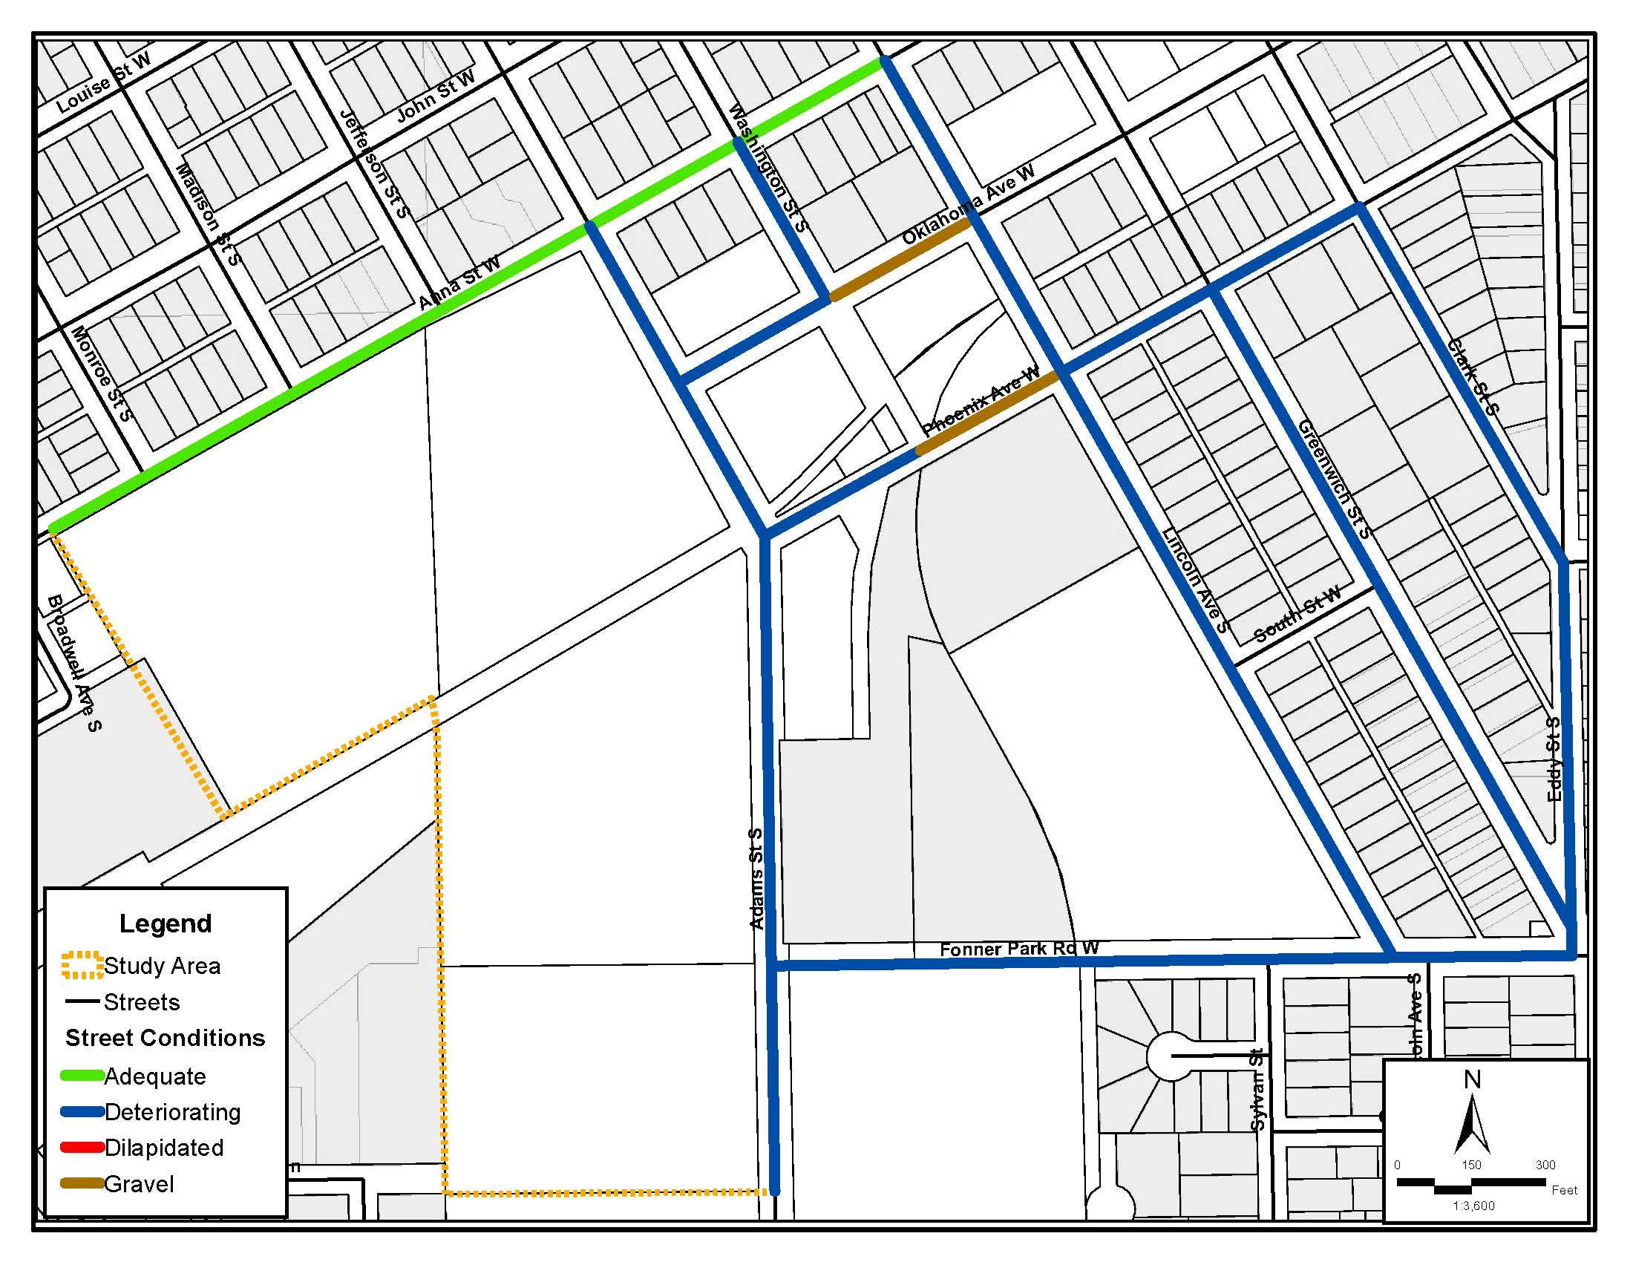
Source: Olsson Associates and Marvin Planning Consultants, 2011
Figure 7:
Curb and Gutter Conditions
Source: Olsson Associates and Marvin Planning Consultants, 2011

Conclusion
Based upon the issues and conditions indicated from the survey of this area, there are sufficient criteria present to declare Area #8 of Grand Island as Blighted and Substandard as provided for in the Nebraska Revised Statutes. The conditions found throughout the entire area constitute a designation of blighted and substandard.

In addition, the area within the county industrial park is not only a contributing factor to the area within the corporate limits but if this area had its industrial park designation removed, the area would be able to stand on its own as Blighted and Substandard.

The eventual use of Tax Increment Financing would be of great benefit to the entire area; provided the entire area is brought into the corporate limits of the community.

