**BLIGHT AND SUBSTANDARD AREA #11 DESIGNATION**

**For the Veterans Affairs CBOC site in Grand Island**

**City of Grand Island, Nebraska**

**Prepared by**

**RDG Planning & Design**

**Omaha, Nebraska**

**June, 2012**

This study considers the presence of blighted or substandard conditions in the study area located in the City of Grand Island, pursuant to the requirements of Section 18-2103 of the Nebraska Revised Statutes.

Geography of the Site

Beginning at the southeasterly corner of the intersection of Capital Avenue and Broadwell Avenues, thence, in an easterly direction, following the southerly line of Capital Avenue, a distance of 434.5 feet, more or less, to the southwesterly corner of the intersection of Capital Avenue and Wheeler Avenue; thence, in a southeasterly direction, following the southwesterly line of Wheeler Avenue, a distance of 965.76 feet to a point; thence, West, a distance of 124.0 feet to a point; thence, South a distance of 268.0 feet to a point; thence, in a southeasterly direction following the southwesterly line of Wheeler Avenue, a distance of 377.0 feet to a point; thence, in a northerly direction, following the westerly line of Broadwell avenue, a distance of 1460 feet, more or less, to the point of beginning, containing approximately 27 acres.

All in the City of Grand Island, County of Hall, State of Nebraska.

Figure 1 depicts the location of the site and supersedes the above description.

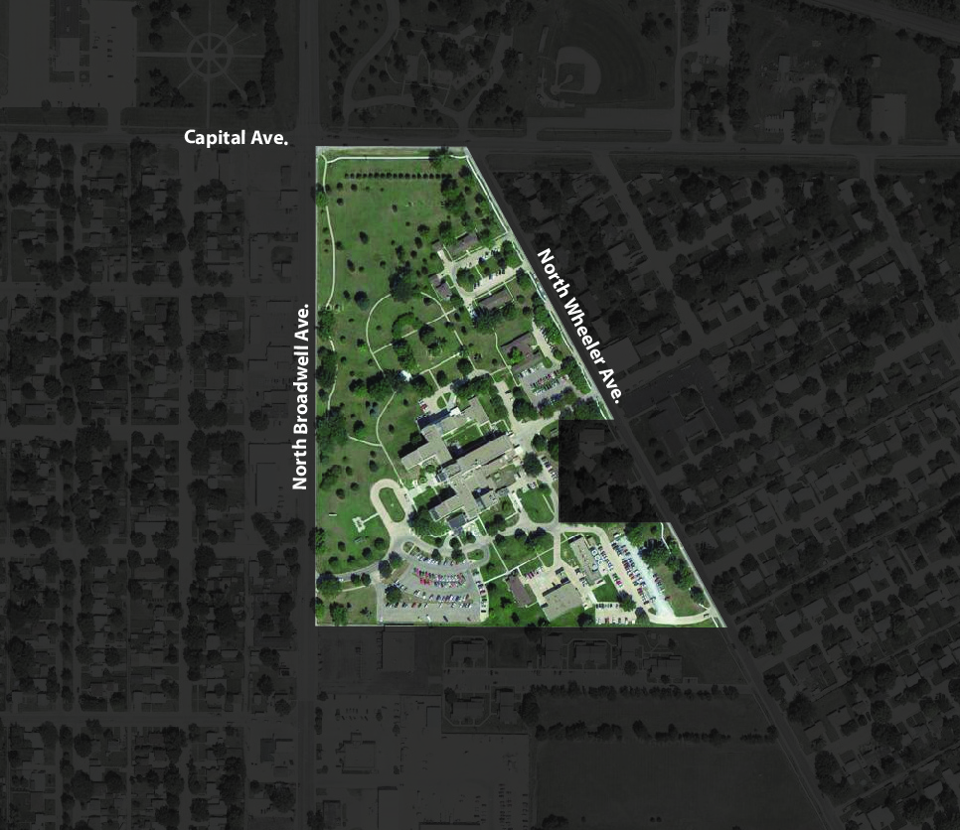

Figure 1: Study area for Veterans Affairs CBOC Site Blight Study.

**DESIGNATION OF BLIGHT**

In order to qualify as a blighted and substandard area in accordance with the requirements of Section 18-2103, a parcel or district must comply with certain objective and subjective evaluative criteria, set forth by state statute.

**Objective Criteria**

In order to qualify as “blighted,” a site must meet at least one of five objective, or numerical, criteria. These criteria include:

1. *Unemployment.* The qualifying criterion is an unemployment rate in the designated area that is at least 120% of the state or national average. 2000 Census block group data is the most recent decennial census data available to determine the site’s performance with respect to unemployment.

More recent data is provided by the ongoing American Community Survey (ACS), which generates community data from smaller, more frequent samples on an array of topics. Along with 2000 Census data, 2006-2010 “5-year estimates” from the ACS were used to determine whether the site met this criterion.

1. *Average age of residential or commercial units in the area.* The qualifying criterion is that structures in the proposed blighted area have an average age of at least 40 years.
2. *Per capita income.* The qualifying criterion is a per capita income figure for the area that is lower than the average per capita income of the municipality in which the area is located. Block group data from the 2010 Census is the most recent census data utilized to assess this condition. Five-year estimates, (2006-2010) from the ACS also assisted in accurately assessing this criteria.
3. *Population.* The qualifying criterion is that the area has had either a stable or decreasing population based on the last two decennial censuses. Census block group level data from 2000 and 2010 were examined to determine the presence of this condition.
4. *Unimproved land.* This criterion applies to blight designation of predominately vacant areas. Such an area qualifies as “blighted” if more than half of the plotted and subdivided property in the area has been within the city for 40 years and has remained unimproved during that time.

**Subjective Criteria**

In addition to meeting at least one of the objective requirements described above, a potentially blighted area must exhibit the presence of at least one of several subjective criteria. These subjective evaluative criteria include:

1. *Presence of a substantial number of deteriorated or deteriorating structures.*
2. *The existence of defective or inadequate street layout.*
3. *Faulty lot layout in relation to size, adequacy, accessibility, or usefulness.*
4. *Insanitary or unsafe conditions.*
5. *Deterioration of site or other improvements.*
6. *Diversity of ownership.*
7. *Tax or special delinquency exceeding the fair value of the land.*
8. *Defective or unusual conditions of title.*
9. *Improper subdivision or obsolete platting.*
10. *The existence of conditions which endanger life or property by fire and other causes.*
11. *Any combination of such factors that substantially impairs or arrests the sound growth of the community, retards the provision of housing accommodations, or constitutes economic or social liability and is detrimental to the public health, safety, morals, or welfare in its present conditions and use.*

**Documentation of Qualifying Conditions, Objective Criteria**

The data used to evaluate the redevelopment site’s blight status is primarily derived from the U.S. Bureau of the Census. To expedite the Census data collection process and provide more fine-grained information, the Census Bureau divides counties and places into several enumeration levels. These include tracts, which are subdivided into block groups and finally into individual blocks. Because the study area includes portions of a block group, examining data at the block level would provide the most accurate evaluation. However, in order to preserve the privacy of individuals, the Census Bureau does not report all types of data at the block level.

Additionally, some data from the 2010 Census is not yet available at the block group level. Some tract data is also not provided by the 2010 Census, such as “per-capita income” because the blight study area is unable to meet the population threshold for data accuracy. Five-year estimates, (2006-2010) from the American Community Survey are used as a result, providing the most accurate picture in assessing blight designation. Therefore, the population evaluation utilizes 2010 Census block data, while the other objective criteria are evaluated using a combination of 2010, and 2000 Census data, along with 5-year estimates from the American Community Survey.

Analysis of US Census and American Community Survey data indicates that the Veterans Affairs CBOC site meets the statutory requirements for the first level of evaluation for the presence of blighting condition, as required by Section 18-2103 (11). Table 1 illustrates the study area’s performance with respect to each of the objective criteria. The area currently meets Objective Criteria 2, 3, and 4, and does not meet Criteria 1 and 5.

|  |  |
| --- | --- |
| **Table 1: Objective Criteria for Blight Determination** | |
| 1. Unemployment | No |
| 2. Age of Units | Yes |
| 3. Per Capita Income | Yes |
| 4. Population | Yes |
| 5. Unimproved Land | No |

*1. Unemployment.* The study area does not meet this criterion. Unemployment data for the 2010 census is not yet available at the block group, or county level. American Community Survey 5-year estimates, (2006-2010) reflect a 4.9% unemployment rate for the study area and 5.1% for Nebraska.

*2. Age of Units.* The redevelopment site meets the criterion concerning the average age of residential structures.

Census 2000 data indicates that of the 284 structures in the Block Group, 197 of them were built before 1970. This data also indicated that no structures had been built in the Block Group since 1990, indicating that the area is fully built out. This means that in 2010, 69.4% of the structures would be over 40 years old, satisfying the ‘age of units’ criterion.

At the time of this writing, only the count of structures was available for the 2010 Census, indicating 281 structures within the block group. Even assuming that the 3 “lost” structures represented the three oldest within the block group, the area still more than meets the requirement for this criterion.

|  |  |
| --- | --- |
| **Table 2: Age of Structures in Block Group 1, Tract 3, Hall County, NE** | |
| Total Structures | 281 |
| Built Prior to 1970 | 194 |
| Percent Built Prior to 1970 | 69.0% |
| *Source: U.S. Census Bureau, 2000, 2010* |  |

*3. Per Capita Income.* The project area meets the criterion regarding relative per capita income within the study area.

The average 2010 per capita income in the Census tract containing the study area was $16,764. This is significantly lower than that of Grand Island as a whole, which was $21,220. These figures are from the 2006-2010 5-year estimates generated by the American Community Survey, which provide the most current data for the study area.

*4. Population.* Based on a comparison of 2000 and 2010 block group data, the census block group which includes the study area experienced a population decrease from 849 in 2000, to 755 in 2010. This represents and 11% decline in population, satisfying this objective criteria.

*5. Unimproved Land.* Although a significant portion of the land within the study area remains unbuilt, it has significant site improvements including grading, landscaping, and an automatic sprinkler system. The site does not meet the unimproved land criterion.

# Documentation of Qualifying Conditions, Subjective Criteria

Because the area meets at least one of the objective criteria, it was further examined for the presence of subjective qualifying criteria. Analysis of these criteria indicates that the study area meets at least one criterion, which is the statutory requirements for the presence of blighting condition, as required by Section 18-2103 (11). Table 3 presents the performance of the study area relative to the subjective criteria.

|  |  |
| --- | --- |
| **Table 3: Subjective Criteria for Blight Determination** | |
| 1. Presence of a substantial number of deteriorated or deteriorating structures | No |
| 1. The existence of defective or inadequate street layout | No |
| 1. Faulty lot layout in relation to size, adequacy, accessibility, or usefulness | Yes |
| 1. Insanitary or unsafe conditions | Yes |
| 1. Deterioration of site or other improvements | Yes |
| 1. Diversity of ownership | No |
| 1. Tax or special delinquency exceeding the fair value of the land | No |
| 1. Defective or unusual conditions of title | Unknown |
| 1. Improper subdivision or obsolete platting | Unknown |
| 1. The existence of conditions which endanger life or property by fire and other causes | Yes |
| 1. Any combination of such factors that substantially impairs or arrests the sound growth of the community, retards the provision of housing accommodations, or constitutes economic or social liability and is detrimental to the public health, safety, morals, or welfare in its present conditions and use | Yes |

The specific results of this analysis are as follows:

1. *A substantial number of deteriorated or deteriorating structures*

*No.* Based on visual observation all structures within the study area appear to be maintained in good condition. The age of the structures have resulted in some maintenance and safety issues in the past, including the collapse of a roof.

1. *The existence of defective or inadequate street layout*

*No.* The study area is bounded on three sides by well-maintained city streets of various sizes and traffic capacities.

1. *Faulty lot layout in relation to size adequacy, accessibility, or usefulness*

*Yes.* While the few lots within the study area are adequate for potential development, they may need further subdivision to accommodate a wider range of development options.

1. *Insanitary or unsafe conditions*

*Yes*. Some of the areas along the southeastern boundaries of the site are being used for unsecured and unscreened storage of material and equipment. Standing water in areas of site creates habitat opportunity for nuisance animals and disease carrying insects.

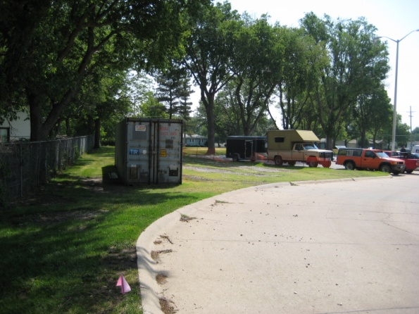 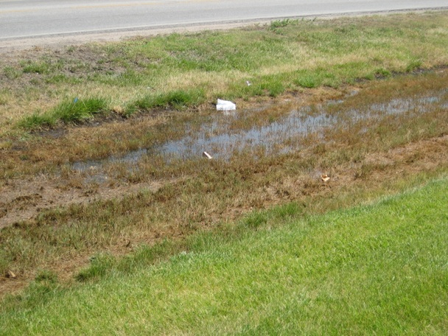

Figures 2, 3: Unscreened storage of equipment and materials and standing water on site.

1. *Deterioration of site or other improvements*

*Yes.* Relatively recent drainage improvements appear to be defective in their purpose. Also, parking surfaces and curbs in the southern area of the site appear be degrading.

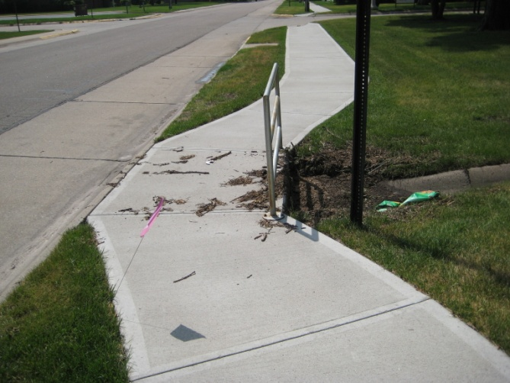 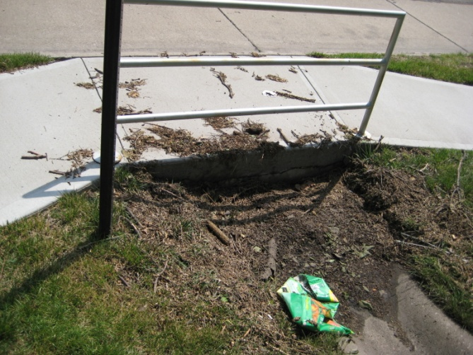

Figures 4, 5: Evidence of failing drainage improvements in the southeastern area of the study area.

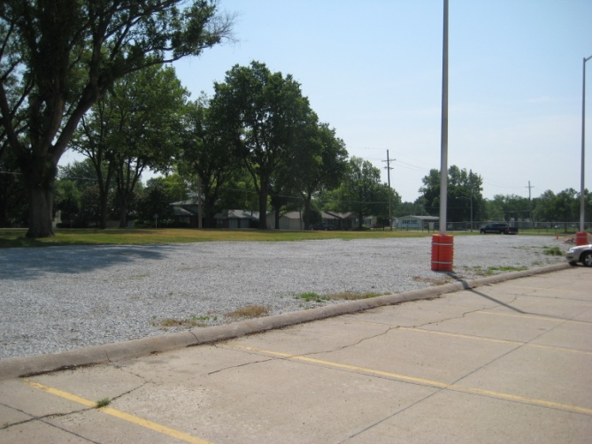 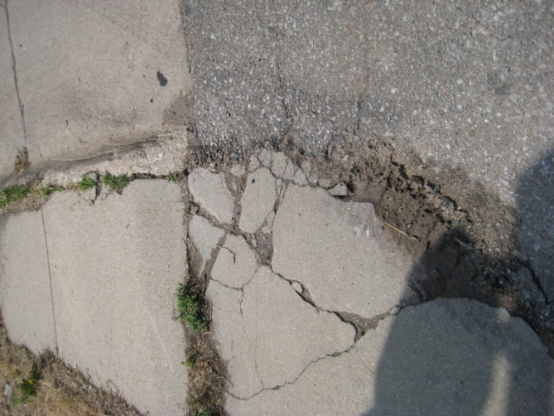

Figures 6, 7: Degrading conditions in parking surfaces and curbs

1. *Diversity of ownership*

*No.* The study area is held under the single ownership of the United States Government.

1. *Tax or special delinquency exceeding the fair value of the land*

*No.* The entirety of the study area is held by the federal government and is exempt from local and state taxation.

1. *Defective or unusual conditions of title*

*Unknown.* Evaluation of this criterion requires detailed title analysis of individual properties.

# *Improper subdivision or obsolete platting*

*Unknown.* Evaluation of this criterion requires detailed title analysis of individual properties.

# *The existence of conditions which endanger life or property by fire and other causes*

*Yes.*According to maps from the Federal Emergency Management Agency, the northwest corner and entire northern site boundary lay within the 500 year flood plain. This suggests an ongoing threat to property from water inundation and damage for structures not elevated out of the floodplain. This condition also creates drainage problems with standing water.

1. *Any combination of such factors that substantially impairs or arrests the sound growth of the community, retards the provision of housing accommodations, or constitutes an economic or social liability and is detrimental to the public health, safety, morals, or welfare in its present condition and use.*

*Yes.*Few structures within the study area pose environmental, economic, and potential sanitary threats in their present condition. However, environmentally, the combination of degraded areas and elements within the site, and the unscreened storage of vehicles, equipment and materials, create areas that serve to diminish the quality of the surrounding areas. Without redevelopment or rehabilitation, this site will likely continue to exert – at best – a net neutral effect on the vitality and development of Grand Island.

# Substandard Declaration

The above findings, including the platting deficiencies, lack of streets, and storage of deteriorated materials demonstrate the existence of conditions which endanger life or property by fire and other causes and create conditions that are detrimental to the public health, safety, morals or welfare.

# Conclusions

This study substantiates the presence of at least one of the objective criteria and one of the subjective criteria for designation as a blighted area set forth by Section 18-2103 of Nebraska Revised Statutes. Thus, the designated area is hereby determined to be eligible for a declaration of ‘blighted and substandard’, pursuant to the requirements of Section 18-2103 of Nebraska Revised Statutes.