**Purpose of this Analysis**

The purpose of this analysis is to identify and determine if an area within the City of Grand Island, Nebraska should be considered blighted and substandard under the criteria for such areas as set forth in the Nebraska Community Development Law, Section 18-2103.

A field survey of an area within the City of Grand Island was conducted in October 2008 and updated in February, 2013 to determine if this area, in fact, has experienced structure and site deterioration or if the area is experiencing other negative influences which decrease the potential for redevelopment or new development. The boundaries of this area are indicated in Figure 1 and described in Appendix A. The following report describes this Analysis Area in detail, as well as, specifying the methods and procedures used to determine if this Area should be declared blighted and substandard under the Nebraska Community Development Law.

**Definitions**

The following are the specific definitions of "substandard" and "blighted" according to Nebraska State Law. These definitions serve to be the basis of this entire analysis and each portion of the definitions are examined individually throughout this document.

**Substandard Area Definition**

Under the above referenced Nebraska Statute, a substandard area is an area in which there is a predominance of buildings or improvements, whether non-residential or residential in character, which by reason of:

* dilapidation / deterioration,
* age or obsolescence,
* inadequate provision for ventilation, light, air, sanitation or open spaces,
* high density of population or overcrowding,
* the existence of conditions which endanger life or property by fire and other causes, or
* any combination of such factors, is conducive to ill health, transmission of disease, infant mortality, juvenile delinquency and crime, and is detrimental to the public health, safety, morals and welfare of the residents of the community.

**Blighted Area Definition**

Section 18-2103 of the Nebraska Revised Statutes indicates that a blighted area shall mean an area, which by reason of the presence of:

* a substantial number of deteriorated or deteriorating structures,
* existence of defective or inadequate street layout,
* faulty lot layout in relation to size, adequacy, accessibility or usefulness,
* unsanitary or unsafe conditions,
* deterioration of site or other improvements,
* diversity of ownership,
* tax or special assessment delinquency exceeding the fair value of the land,
* defective or unusual conditions of title,

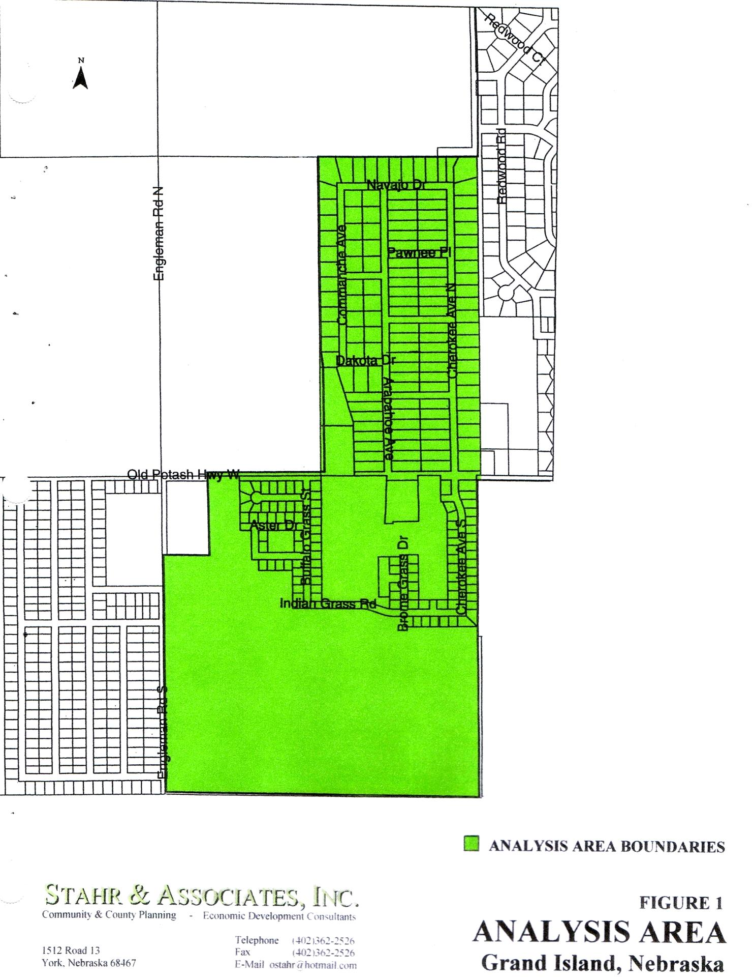

* improper subdivision or obsolete platting,
* the existence of conditions which endanger the life or property by fire and other causes, or any combination of such factors which substantially impairs or arrests the sound growth of the

community, retards the provision of housing accommodations or constitutes an economic or social liability and is detrimental to the public health, safety, morals, or welfare in its present condition and use and in which there is at least one of the following present:

* unemployment in the designated area is at least one hundred twenty percent of the State of National average,
* the average age of the structures in the area is at least forty years old or older,
* more than one-half of the platted and subdivided property in the area is unimproved land that has been within the City for forty years and has remained unimproved during that time,
* the per capita income of the area is lower than the average per capita income of the municipality in which the area is designated, or
* the area has had either a stable or decreasing population based on the last two decennial censuses.

**analysis approach**

The approach and methodology utilized by Stahr & Associates, Inc. in conducting the Blighted and Substandard Area Determination Analysis included an assessment of all factors listed in the Nebraska Community Development Law as factors that indicate or contribute to making an area blighted and substandard. Data relating to factors such as building condition, building age, site conditions, adequacy of building sites, condition of public improvements and unsanitary or unsafe conditions were developed through field surveys on a structure by structure basis or through collection of data on a unit by unit basis available from public records at the Hall County Courthouse. Data relating to other factors such as the adequateness of street layouts, lot layouts and overall subdivision design were investigated on an area-wide basis.

Assessment of potential blighting factors stemming from diversity of ownership and tax or special assessment delinquencies were conducted through evaluation of courthouse records on all property within the analysis area, now referred to as CRA Analysis Area No. 12. This analysis also utilized two guideposts in the investigation of blighted or substandard conditions. These included:

**additional public intervention necessary**

Although the presence of one or more of these substandard or blighting conditions may make it appropriate to declare an area substandard and blighted under the Statue, this analysis was conducted on the basis that additional public intervention over and above the exercise of the police power is necessary to overcome the problems that exist in any substandard and blighted area. Specifically, Section 18-2012 of the Nebraska Community Development Law states that a determination shall be made that the conditions existing in any such substandard and blighted area are beyond remedy and control solely by regulatory process in the exercise of police power and cannot be dealt with effectively by the ordinary operations of private enterprise without the aids provided under the Community Development Law.

**Substandard or Blighted Factor Distribution**

This analysis was conducted on the basis that the substandard or blighting conditions, as defined in the Statute, must be reasonably distributed within any area that is determined to be substandard or blighted. This basic distribution factor, used as a control factor in determining the extent of any substandard or blighted area, assures that areas or neighborhoods which are in good condition are not determined to be substandard or blighted due to proximity to areas which are to be substandard or blighted.

**Existing Land Use**

The land uses that now exist within the Analysis Area are depicted on Figure 2, consist of land uses which can be placed in three categories, including:

* Residential (single-family, mobile home and manufactured homes)
  + - Public streets and alleys
    - Vacant / undeveloped land

**Table 1**

**EXISTING LAND USE – CRA ANALYSIS AREA No. 12**

**Grand Island, Nebraska**

|  |  |  |
| --- | --- | --- |
| **LAND USE CATEGORY** | **CRA ANALYSIS AREA NO. 8** | |
|  | **AREA (ACRES)\*** | **PERCENT OF TOTAL AREA** |
| Residential | 63.9 | 27.3% |
| Street / Alley Rights-of-Way | 25.9 | 11.0% |
| Vacant / Undeveloped Land | 144.6 | 61.7% |
| **TOTAL** | **234.4** | **100.0%** |

Source: Stahr & Associates, Inc., (2013)

* Existing land use acreage totals are tabulated based upon scaled plat maps and field surveys

The land uses indicated for the Analysis Area on Figure 2 are analyzed further in Table 1. The data detail the breakdown of land uses within this Analysis Area, as well as the total acreage within this Analysis Area.

As indicated in Table 1, the largest land use in this Analysis Area is that of vacant and undeveloped land. This undeveloped land comprises a total of 144.58 acres, or 61.7% of the Analysis Area. This is the area that is expected to develop and redevelop during the next several years. It is located along south side of Old Potash Highway, in the west central edge of the City of Grand Island.

The second largest land use in this Analysis Area is that of residential. This use comprises a total of 63.9 acres, or 27.3% of the Analysis Area. Residential uses consist of single-family dwellings, mobile homes and manufactured homes.

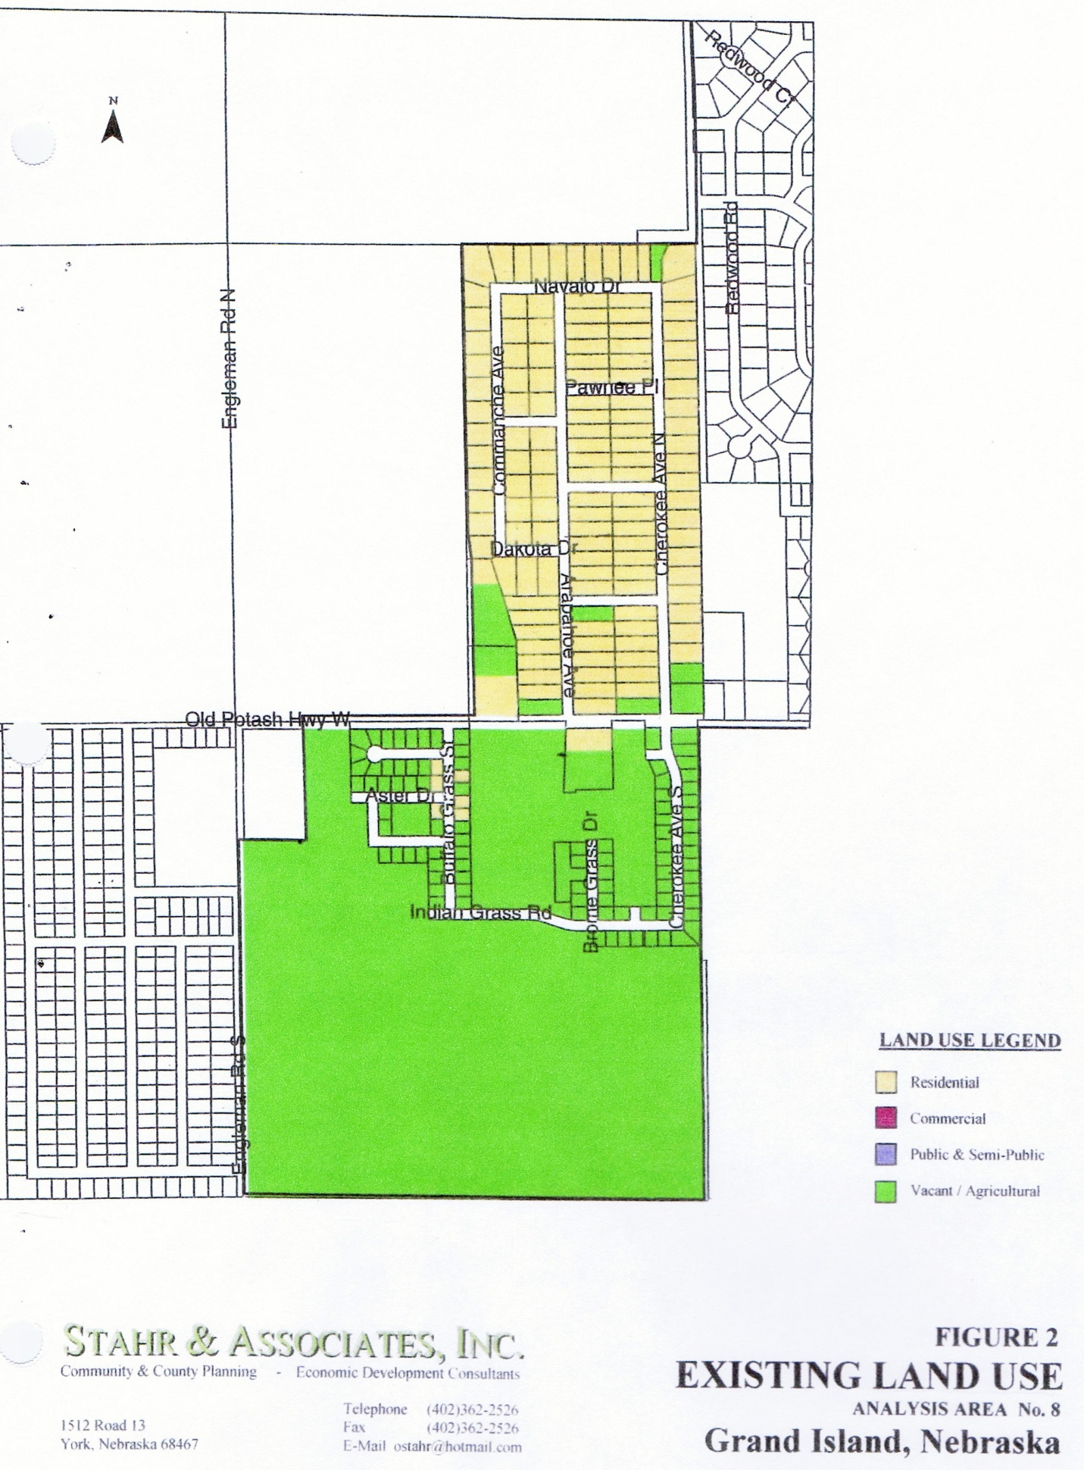

12

The smallest land use within this Analysis Area is Public street rights-of-way. The street pattern in the Analysis Area consists primarily of a square to rectangular grid system. This system is relatively inefficient and typically is one of the larger land uses within an Analysis Area. However, in this case, due to the amount of undeveloped land without streets, it comprises 25.9 acres or only 11.0% of the Analysis Area.

**Current Zoning within the Analysis Area**

Although not included in the statutory list of factors which may contribute to blight or result in substandard conditions in an urban area, local zoning regulations may contribute to further blighting or retention of substandard conditions if such zoning is inconsistent with the demands of the land use marketplace or such zoning discourages redevelopment or improvement of existing built-up areas. For these reasons an evaluation of the consistency of the land uses present in the Analysis Area with the current zoning districts and regulations applied to land in the Analysis Area was conducted.

Land use within the Analysis Area is regulated through zoning districts established by the City of Grand Island. The City of Grand Island has established and applied 3 zoning districts to this Area as depicted on Figure 3. These zoning districts include the:

TA Transitional Agricultural Zoning District,

LLR Large Lot Residential Zoning District

M Manufactured Home Overly Zone

R2 Lower Density Residential Zoning District

An analysis of the consistency of the existing land use with the applicable zoning and the appropriateness of the zoning district applications and regulations as they relate to encouraging or minimizing blighting conditions indicates that the current zoning districts applied to the land within the Analysis Area reflects the land uses in place and the residential character of the Area. The district regulations allow a variety of housing types which is also consistent with the Area. The existing zoning is thus not a factor which could contribute to substandard or blighted conditions in this Analysis Area.

**Analysis of Substandard Factors**

**1. Dilapidation/Deterioration of Structures**

The determination and rating of building structure conditions is a major part of any substandard area determination. Therefore the system utilized for classifying the conditions is a major part of any substandard area determination. The system utilized for classifying the conditions of buildings and structures must be based upon established and consistent criteria. Stahr & Associates, Inc. utilized a field survey method for evaluating the exterior conditions and to identify and classify building sites and other localized environmental conditions or deficiencies of all structures within the Analysis Areas.

All data regarding each structure was dated and recorded on a Structure / Site / Infrastructure Survey Form. This form was utilized not only to record the data collected for later evaluation, but to assure that similar data for each structure was evaluated. (See Structure / Site / Infrastructure Survey Form, Appendix B).

During the field survey, each component of each structure in the Analysis Area was examined to determine whether it was in sound condition or had minor, major or critical defects. Two types of building components were evaluated. These included:

* Major Components

These components include the basic structural elements of any building; the foundation

walls, load bearing walls and columns and roof structure.

* Minor Components

These components include the necessary secondary elements of any building; the wall

surfaces and condition, paint or wall covering condition, the roof condition, windows,

doors, porches, steps and stairways, fire escapes, chimneys and vents, gutters and

downspouts, etc. Both the major and minor components were evaluated and ranked in one of four categories and each category was assigned a numerical value as follows:

|  |  |
| --- | --- |
| Ranking Category | Numerical Value |
| No Problems | 1 |
| Minor Problems | 2 |
| Major Problems | 3 |
| Critical Problems | 4 |

The numerical rankings of each major and minor component were then combined to generate an overall building condition evaluation comprised of five categories as follows:

|  |  |  |  |
| --- | --- | --- | --- |
| Major Component Numerical Ranking | Minor Component Numerical Ranking | Combined Numerical Ranking | Overall Building Condition |
| 2 or less | 6 or less | 8 or less | Sound |
| 3 – 5 | 7 – 8 | 10 – 13 | Minor Deficiencies |
| 6 – 7 | 9 – 17 | 14 – 24 | Major Deficiencies |
| 7 – 9 | 18 – 19 | 25 – 29 | Substandard |
| 10 or more | 20 or more | 30 or more | Dilapidated |
|  |  |  |  |

The overall building conditions are defined as follows:

sound: A sound building is one that has been and can be kept in good condition with normal maintenance. A sound building has no major component defects, no minor component defects ranked as major or critical or with major deficiencies, but may have up to three minor components ranked as having minor defects.

minor deficient: Buildings ranked as deficient are those that require only minor repairs, which have not more than one major component defect that is minor in nature, which has not more than one minor component defect that is ranked as major in nature, nor more than three minor component defects ranked as minor in nature.

major deficient (deteriorating): Buildings ranked as deficient are buildings that require major repairs, which have not more than one major component ranked as critical or not more than two ranked as having deficiencies that are major in nature, nor more than five minor component defects ranked as major in nature.

substandard: A structurally substandard building contains defects which are so serious and so extensive that the building may not be economically repairable. Buildings classified as substandard have not more than two major component defects ranked as critical or major in nature, nor more than four minor component defects ranked as critical.

dilapidated: A dilapidated building contains such a combination of serious defects that there is no question that the building is uninhabitable and should be razed. All major components of a dilapidated building have defects that are major or critical in nature or a combination of less serious major component defects together with at least four minor component defects that are ranked as critical in nature.

Field Survey Results

As indicated in Table 2, the field survey of exterior building conditions in this Analysis Area indicates the following:

**Table 2**

**EXISTING LAND USE – CRA ANALYSIS AREA No. 12**

**Grand Island, Nebraska**

|  |  |  |  |  |  |  |  |  |
| --- | --- | --- | --- | --- | --- | --- | --- | --- |
| **BUILDING**  **TYPE** | **SOUND** | **DEFICIENT**  **(MINOR)** | **DEFICIENT**  **(MAJOR)** | **SUBSTANDARD** | **DILAPIDATED** | **TOTAL**  **BUILDINGS** | **TOTAL**  **SUBSTANDARD**  **BUILDINGS** | **%** |
| Residential | 72 | 16 | 17 | 13 | 11 | 129 | 41 | 31.8% |
| Outbuildings | 57 | 37 | 22 | 13 | 12 | 141 | 47 | 33.3% |
| **TOTAL** | **129** | **53** | **39** | **26** | **23** | **270** | **88** | **32.6%** |

Source: Stahr & Associates, Inc., (2013)

* 88 out of 129 primary structures in the Analysis Area are classified as being in sound condition or as having only minor defects. The additional outbuilding analysis indicates that 94 out of 141 outbuilding structures are in sound condition or have only minor defects.
* 17 out of 129 primary structures in the Analysis Area are classified as deteriorating because of having major deficiencies or major component defects. The outbuilding analysis indicated that 22 outbuildings are classified as having major defects within the Area.
* 13 of the 129 primary structures and 13 outbuilding structures in this Analysis Area are classified as substandard are probably beyond economically feasible rehabilitation. In addition, 11 primary structure and 12 outbuildings are classified as dilapidated and uninhabitable.
* Combined, 88 of the total 270 structures, or nearly 32.6% of all structures in this Analysis Area, are classified, in accordance with the Nebraska Community Development Law, as being deteriorated, substandard or dilapidated.

As indicated on Figure 3, the structures with major deficiencies or in worse condition are distributed throughout the central and northern portions of this Analysis Area. This distribution of substandard / obsolete structures is an indication that this Area is experiencing deterioration. The location of older and deteriorating structures within this Area significantly diminishes the marketability of property, as well as, redevelopment potential throughout the Area and, as a result, is a factor contributing to the substandard conditions within the Analysis Area.

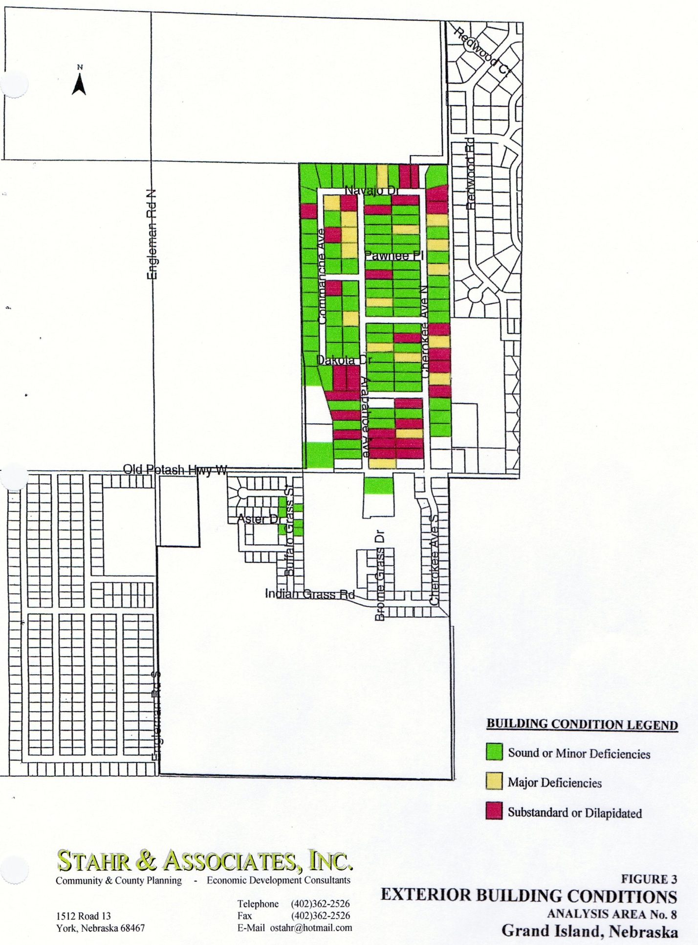

12

**Conclusion**:

The results of the field survey of exterior building conditions indicate that there a number of structures that have major deficiencies or are in substandard condition and probably cannot be economically rehabilitated. Nearly 1 in every 3 structures within this Analysis Area can be classified by the Nebraska Community Development Law as being substandard. The existence of this level of substandard structures constitutes a substantial presence of substandard conditions in this Analysis Area.

**2. Age or Obsolescence**

As presented in Table 3, observations made and data collected with regard to age of structures indicates the following:

**Table 3**

**AGE OF STRUCTURES – CRA ANALYSIS AREA No. 12**

**Grand Island, Nebraska**

|  |  |  |  |  |  |  |  |  |
| --- | --- | --- | --- | --- | --- | --- | --- | --- |
| **BUILDING**  **TYPE** | **NEW**  **TO 1**  **YEAR** | **1 - 5**  **YEARS** | **6 - 10**  **YEARS** | **11 - 20**  **YEARS** | **21 - 40**  **YEARS** | **41 YEARS**  **OR OLDER** | **TOTAL**  **STRUCTURES** | **PERCENT**  **OVER 40**  **YEARS OLD** |
| Residential | 6 | 7 | 9 | 16 | 75 | 16 | 129 | 11.7% |
| Outbuildings | 2 | 6 | 14 | 36 | 48 | 35 | 141 | 24.8% |
| **TOTAL** | **8** | **13** | **23** | **52** | **123** | **51** | **270** | **18.9%** |

Source: Stahr & Associates, Inc., (2013)

* Survey results indicate that 91 primary structures and 83 outbuilding structures were constructed over 20 years ago. Of this total, 16 primary structures and 35 outbuildings were constructed over 40 years ago. In the Analysis Area a total of 51 structures out of 270 total structures, or 18.9%, are 40 plus years old.
* Analysis of the Hall County Assessors assessment records for each parcel in this Analysis Area indicated that over 83% of the structures in the 21 - 40 age group were at least 37 years old. The housing in this Area is rapidly aging.

**Conclusion**:

The findings of the field survey and analysis and interpretation of the resulting data indicates that 18.9% of all the structures in the Analysis Area are in excess of 40 years old. In order for an area to be designated substandard, the law specifies that there must be a predominance of older structures. In this analysis the word predominance is defined as meaning "most frequent" or "a majority". In accordance with this definition, structures which are in excess of 40 years old are not in the majority of this Area, thus this Area cannot, at this time, be considered to be substandard by reasons of structure age and / or obsolescence.

**3. Inadequate Provisions for Ventilation, Light, Air, Sanitation or Open Space**

During the field survey conducted to determine building conditions, building and lot conditions were also evaluated with regard to factors that present on-going negative conditions or impacts and thus contribute to the physical decline of any developed urban area. The lack of adequate ventilation, sun light, clean air, proper

sanitation facilities and open space can be a contributing factor to the decline of any urban area and the presence

of any or all of these in reasonable numbers or intensity is considered, under Nebraska Community Development Law, to contribute to the substandard character of any urban area.

The survey did not reveal any appreciable problems with ventilation of structures or where the size of the building on the lot and / or the small lot size itself did contribute to situations where there is a lack of sunlight and lack of open space. There was adequate front and side yards according to adopted zoning regulations.

As documented later in this report, the northern portion of this Analysis Area does have some substantial problems relative to sanitation. There are a number of instances in the northern portion of this Analysis Area where poor surface drainage results in areas of standing, stagnant water. This ponding of water can become a health hazard for area residents due to infestation of mosquitoes during the warmer months.

The southern portion of this Analysis Area also exhibits problems with sanitation relating to inadequate surface drainage due to lack of a complete surface drainage system. As indicated in the photographs below, the incomplete surface drainage structures leave open swales and ditches where water ponds and stagnates, creating not only a physical, but potential health hazard for area residents due to increased potential for increased mosquito production.

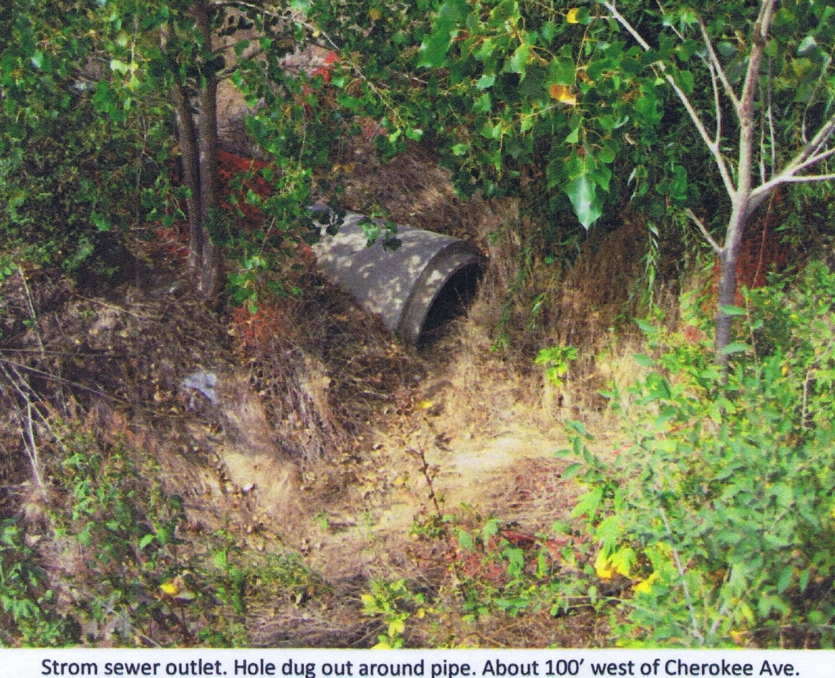

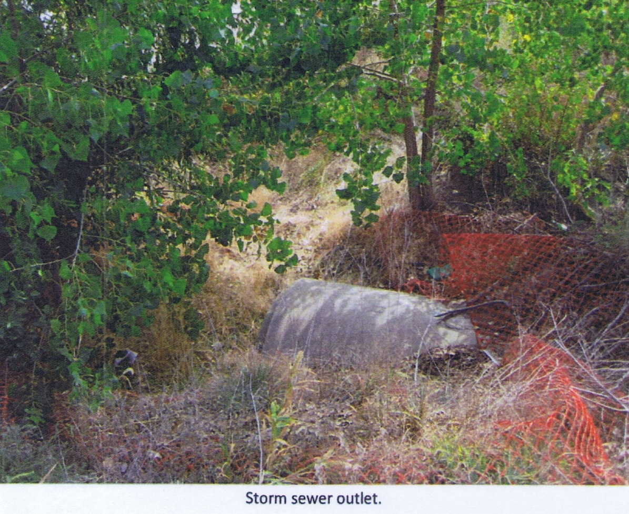

**Conclusion:**

The field investigation documented that there are not any properties within the Analysis Area where the lack of adequate provisions for ventilation, light, air or open space contribute to the substandard factors of the Analysis Area. However, the severity of the problem with poor surface drainage and the ponding of water is a factor that contributes to substandard conditions in this Analysis Area.

**4. Existence of Conditions which Endanger Life or Property by Fire or other Causes**

The field survey indicated that there are several conditions which endanger life or property to varying degrees within the Analysis Areas. These include:

* There are 34 instances in the Analysis Area where various amounts of combustible items are stored or where there are junk, debris or waste tires stored very near or against the walls of the primary building on the lot. The presence of this combustible material, junk and debris constitutes a substantial fire hazard which could endanger both life and property.
* The analysis of the average age of structures within the Analysis Area indicates that 174 of the 270, or over 64% of all structures in the Area are in excess of 20 years old. Also, 69 of the 129, or 53% of the primary structures are either mobile or manufactured homes that are 20 years old. These types of structures and there age are by nature highly flammable, and along with the presence of large amounts of junk and debris create a fire hazard.
* There are numerous locations in the southern portion of the Analysis Area where open manholes and storm drainage structures present a severe falling and entrapment hazards. As indicated in the photographs below, these structures are only partially finished and their continued existence also can provide breeding grounds for mosquitos and other vermin which could present additional life threatening hazards.

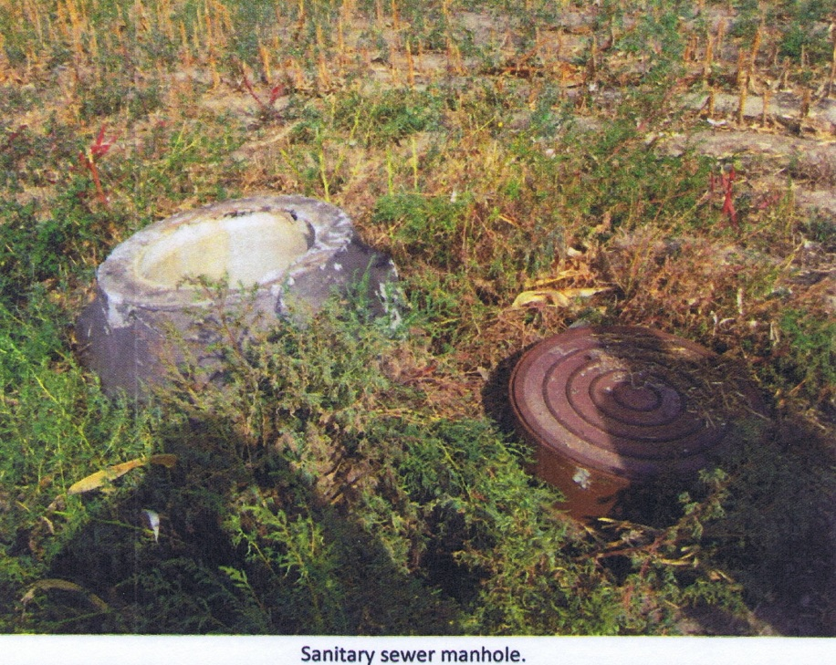

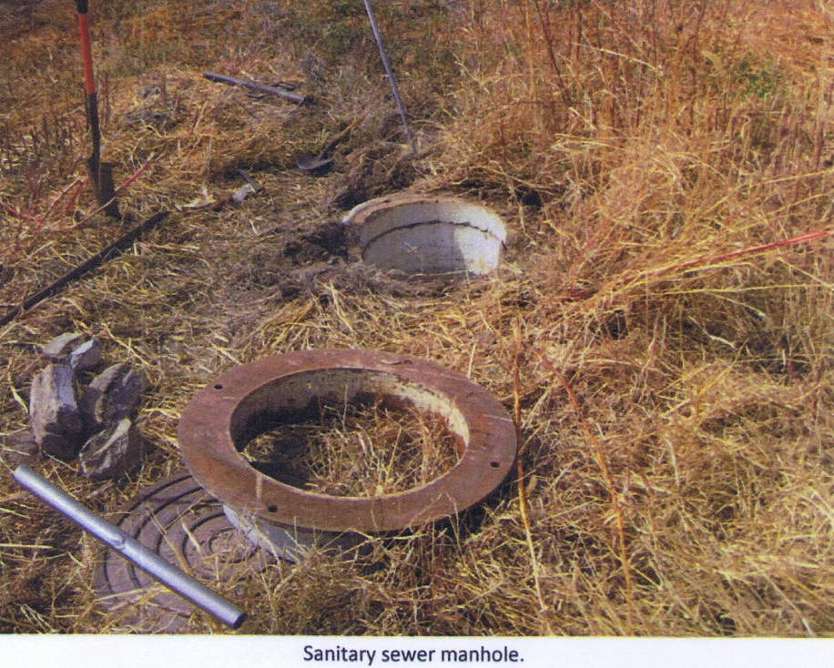

**Conclusion:**

A number of conditions which endanger life or property through fire or other causes, do now exist in this Analysis Area. These conditions are sufficient in number and distribution to be a contributing factor to a blighted designation.

**5. Any Combination of Factors which are conducive to Ill Health, Transmission of Disease, Infant Mortality, Juvenile Delinquency and Crime, and is Detrimental to the Public Health, Safety, Morals or Welfare**

The above listed factors indicate substandard conditions that do exist in the Analysis Areas. These conditions also present a real potential for detrimental effects on the safety and health of the citizens residing within the Analysis Areas when two or more of the substandard conditions occur in the Area. An evaluation of the various combinations of substandard conditions listed above produced the following findings.

The combination of older housing, type of housing and a high percentage of junk or debris present within the Area (all factors listed above), combine to create negative factors that are detrimental to the public health, safety, morals and welfare of the citizens residing within this Analysis Area:

* The combination of the presence of flammable junk and debris create a fire-spreading hazard resulting in possible property loss and endangerment of life.
* The presence of older housing, the significant numbers of either mobile or manufactured homes and the presence of large amounts of junk increases the risk of fire spreading from one structure to another again resulting in possible property loss and endangerment of life.
* The presence of junk and debris on the lots not only create potential fire hazards, but also create unsanitary conditions, as well as, diminishes the overall physical appearance of the Area. In addition, this combined with the fact that rats and other vermin frequently utilize these areas for breeding grounds; all conditions that are detrimental to the health and welfare of the citizens.
* The existence of an inadequate surface system in the southern portion of the Area presents additional threats to health. The incomplete surface drainage structures leave open swales and ditches where water ponds and stagnates, creating not only a physical, but potential health hazard for area residents due to increased potential for increased mosquito production.

**Conclusion**:

The combination of these types of substandard factors throughout the Analysis Area significantly effects the local population working and residing in this Area. The level of impacted population is sufficient to conclude that this combination of negative factors is in and of itself a contributing factor to a blighted and substandard designation.

**Analysis of Blight Factors**

**1. Presence of a Substantial Number of Deteriorated or Deteriorating Structures**

As presented in the previous evaluation of the "Substandard Factors", a total of 88 of the 270 primary and accessory buildings in the Analysis Area are judged to be in deteriorating or worse condition. These deteriorating buildings represent over 32% of all structures in the Analysis Area.

**Conclusion**:

The presence of over 1 substandard structure for every 3 structures in the Analysis Area indicates that deteriorating and deteriorated structures represent a reasonable number of the total structures in the Analysis Area. This level of substandard structures is a contributing condition of blight.

**2. Existence of Defective or Inadequate Street Layout**

The street pattern in the Analysis Area consists primarily of a network of arterials, collectors and local streets that provide access to locations throughout the area. The street system in the Analysis Area, for the most part, is a typical grid pattern that provides reasonable access to individual properties.

**Conclusion**:

The Analysis Area does not have inadequacies in the form of traffic movement capabilities and real property access. Defective or inadequate street layout thus cannot be considered a factor contributing to blighted conditions in this Area.

**3. Faulty Lot Layout in Relation to Size, Adequacy, Accessibility or Usefulness**

The field survey, combined with investigations of property ownership and plat maps indicate that few problems exist relative to lot layout, lot size, adequacy, accessibility or usefulness within the Analysis Area. Those problems that do exist with regard to faulty lot layout are limited. There are two large lots on the north side of Old Potash Highway and west of Dale Roush Second Subdivision in which further subdivision will be difficult due to lack of accessibility.

**Conclusion:**

Although there are a limited number of problems associated with faulty lot layout and usefulness within this Analysis Area, the problems that currently exist, indicated above, should be considered only a limited factor contributing to blighted conditions in this Analysis Area.

**4. Unsanitary and Unsafe Conditions**

As stated previously in the analysis of "substandard" factors, there are several instances within the Analysis Areas where unsanitary and unsafe conditions exist. These include:

* The 34 instances in the Analysis Area where various amounts of combustible items are stored or where there are junk, debris or waste tires stored very near or against the walls of the primary building on the lot. The presence of this combustible material, junk and debris constitutes a substantial fire hazard which creates unsafe conditions within the Area.
* The average age of residential structures within the Analysis Area indicate that over 62% of such structures in the Area are in excess of 20 years old and the field survey indicates that most of these structures are either mobile or manufactured homes. These types of structures are by nature highly flammable.
* The existence of W. Old Potash Road, an arterial street, crossing through the center of the Analysis Area, presents a safety hazard for pedestrians and traffic along this road. The lack of sidewalks contributes to the increased risk for pedestrians along this road.
* Nearly all sites within the Analysis Area do not have sidewalks. The lack of sidewalks contributes to the increased risk for pedestrians throughout the Analysis Area, as pedestrians must use the streets/roads to move from one portion of the Area to another.
* The existence of large amounts of junk and / or debris in this area presents a significant fire hazard, in that a fire can spread easily from one structure to another. This creates unsafe conditions within the Area. In addition, the presence of junk and debris can create breeding ground for rats and other vermin that would result in unsanitary conditions within the Analysis Area.
* Over 83% of the lots within the Analysis Area have some type of drainage problem. This can become problematic as winter snow falls and / or melts or as spring and summer rains fall resulting in situations that disallow easy access to personal property within the Area. In addition, in both the northern and southern portions of this Analysis Area ponding water often becomes a health hazard with the infestation of mosquitoes during the warmer months.

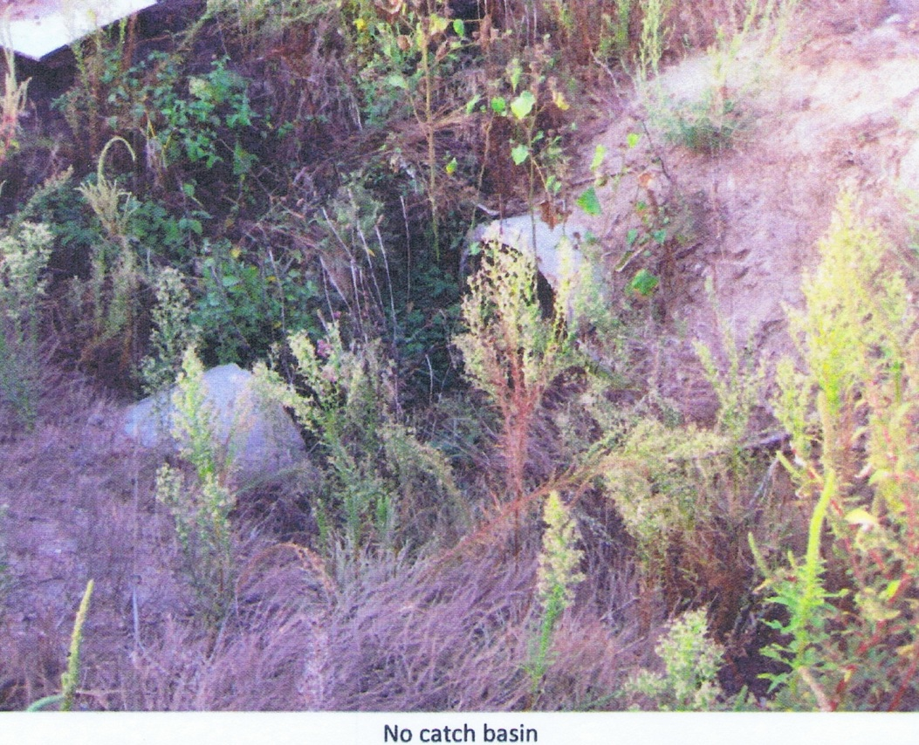

* There are numerous locations in the southern portion of the Analysis Area where open manholes and storm drainage structures present a severe falling and entrapment hazards. As indicated in the photographs below, these structures are only partially finished and their continued existence also can provide breeding grounds for mosquitos and other vermin which could present additional life threatening hazards.

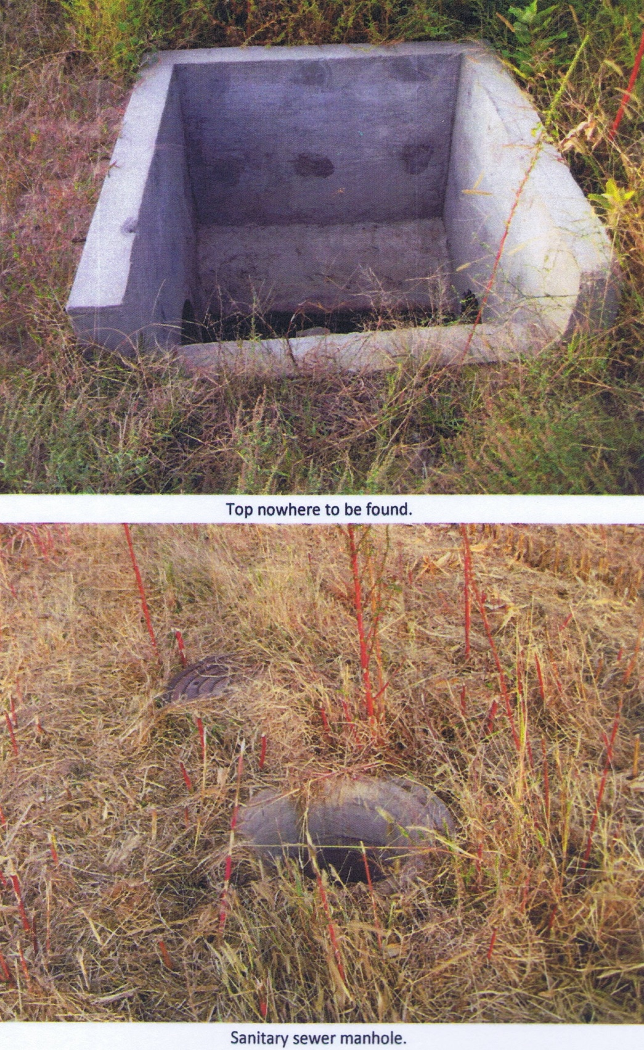

**Conclusion:**

There are numerous instances in the Analysis Area where unsanitary and unsafe conditions exist. These conditions do contribute to the unattractiveness of the Area and can thus be considered a major contributing factor to a blighted condition.

**5. Deterioration of Site and Other Improvements**

The field survey also included an evaluation of the condition of site improvements including: street surface conditions, curbs and gutters, street width adequacy, sidewalks, driveways, and off-street parking facilities,

fencing and drainage facilities. The data presented in Table 4 document the present condition of these improvements in the Analysis Areas. The lack of or deterioration of site improvements include:

* All of the primary structures have off-street parking. However, 89 of the 129, or nearly 70% of the primary structures have off-street parking on gravel / dirt surfaces. Often this parking can become problematic as winter snow falls and / or melts or as spring and summer rains fall resulting in situations that disallow easy access to personal property within the Area.
* In the southern portion of this Analysis Area, there is at least one instance where natural gas and storm sewer lines and pipes are uncovered and exposed to the elements. This can result in deterioration of these lines and pipes and present substantial safety hazards.

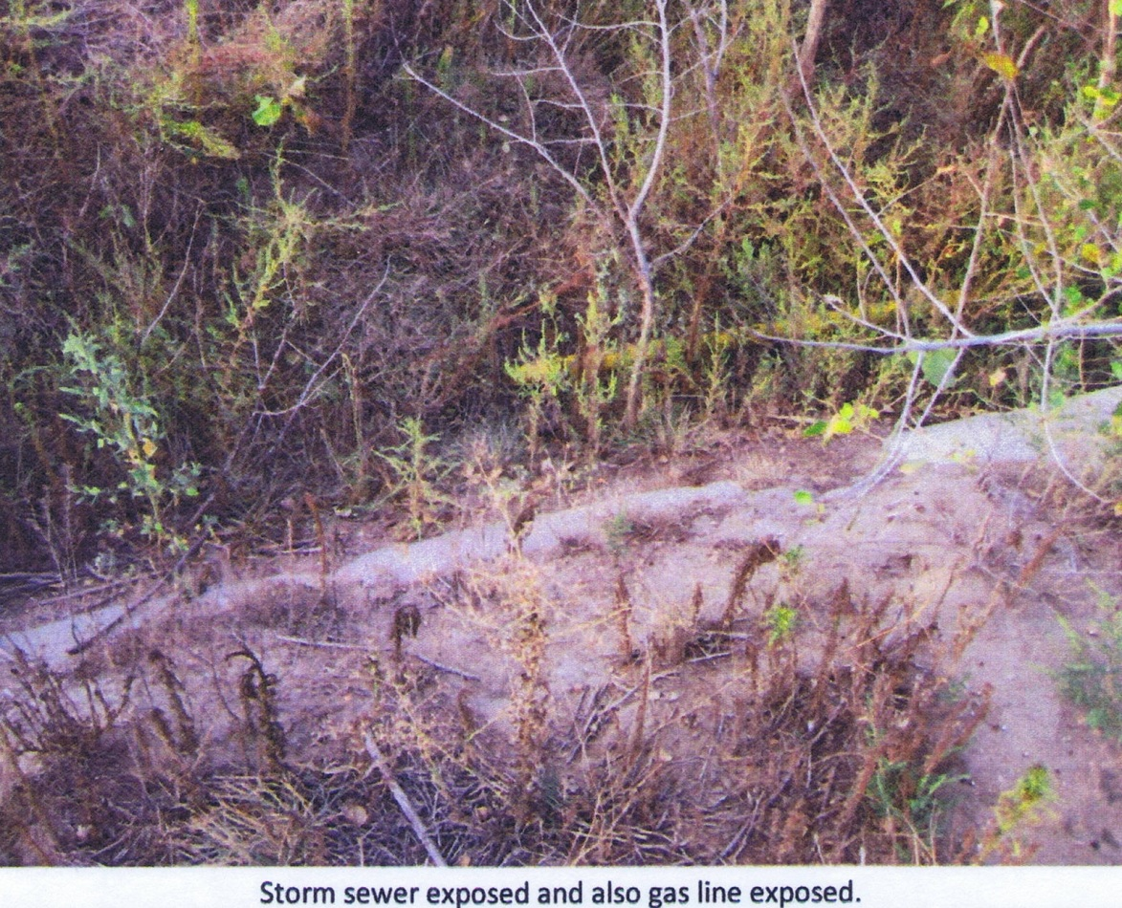

**Table 3**

**SITE COMPONENT CONDITIONS – CRA ANALYSIS AREA No. 12**

**Grand Island, Nebraska**

|  |  |  |
| --- | --- | --- |
|  | **TOTAL** | **RESIDENTIAL** |
| **STREET CONSTRUCTION** |  |  |
| CONCRETE/ASPHALT | 130 | 130 |
| GRAVEL / DIRT | 0 | 0 |
|  |  |  |
| **STREET WIDTH** |  |  |
| ADEQUATE | 130 | 130 |
| INADEQUATE | 0 | 0 |
|  |  |  |
| **STREET/CURB AND GUTTER CONDITION** |  |  |
| GOOD | 130 | 130 |
| FAIR | 0 | 0 |
| POOR | 0 | 0 |
|  |  |  |
| **SIDEWALK CONDITION** |  |  |
| GOOD | 7 | 7 |
| FAIR | 3 | 3 |
| POOR | 0 | 0 |
| NONE | 120 | 120 |
|  |  |  |
| **DRIVEWAY / OFF-STREET PARKING CONSTRUCTION** |  |  |
| CONCRETE/ASPHALT | 41 | 41 |
| GRAVEL / DIRT | 89 | 89 |
| NONE | 0 | 0 |
|  |  |  |
| **DRIVEWAY / OFF-STREET PARKING CONDITION** |  |  |
| GOOD | 71 | 71 |
| FAIR | 41 | 41 |
| POOR | 18 | 18 |
|  |  |  |
| **FENCING** |  |  |
| GOOD | 42 | 42 |
| FAIR | 10 | 10 |
| POOR | 14 | 14 |
| NONE | 64 | 64 |
|  |  |  |
| **APPEARANCE** |  |  |
| UNKEPT | 6 | 6 |
| DEBRIS / JUNK | 34 | 34 |
|  |  |  |
| **SURFACE DRAINAGE** |  |  |
| ADEQUATE | 113 | 113 |
| MINOR PROBLEMS | 13 | 13 |
| MAJOR PROBLEMS | 4 | 4 |
|  |  |  |
| **OVERALL SITE CONDITION** |  |  |
| GOOD | 85 | 85 |
| FAIR | 19 | 19 |
| POOR | 26 | 26 |

Source: Stahr & Associates, Inc. Field Survey, February, 2013

* Nearly all of the primary structures in this Area, are not served by a sidewalk system. The non-existence of a sidewalk system contributes to generating traffic hazards for children and other pedestrians and to decreasing the desirability of this Area and thus contributes to the blighting factors that now exist.
* Over 30% of the lots in this Area are unkept and / or contain substantial amounts of junk and debris. This relatively high level of poorly maintained properties within this Analysis Area represents a considerable blighting factor.
* Over 83% of the lots within the Analysis Area have some type of drainage problem. This can become problematic as winter snow falls and / or melts or as spring and summer rains fall resulting in situations that disallow easy access to personal property within the Area. In addition, in both the northern and southern portions of this Analysis Area ponding water often becomes a health hazard with the infestation of mosquitoes during the warmer months.

**Conclusion**:

A combined rating of overall site improvements, as indicated on Table 4, indicates the majority of overall site improvements are in good condition. However, the fact that over 34% of the existing lots contain deteriorating site improvements creating a fair or poor rating implies that the Area is experiencing deterioration thus strongly contributing to the blighted conditions already present. In addition, the lack of site improvements in locations throughout the Analysis Area also serves to be a limiting factor to future development in the Area and thus is an additional factor contributing to blight.

**6. Diversity of Ownership**

Stability and the livelihood of any urban area is dependent to a large extent on slow, but consistent, renewal of the area through maintenance and modernization or replacement of the existing developments. The ability to renew an area is thus partially dependent on the ability of the private and public sectors to acquire land of sufficient size to develop new housing or other land uses. The existence of smaller than optimal lots, under separate ownership make it difficult and expensive, if not impossible, to consolidate a sufficient amount of land to facilitate such renewal or redevelopment.

Analysis of assessment records and plat maps of the Analysis Area indicate that, although the majority of platted lots are individually owned, the platted lots are of sufficient size to respond to the markets.

**Conclusion**

Diversity of ownership is not a significant factor contributing to blight in the Analysis Areas.

**7. Tax or Special Assessment Delinquency Exceeding the Fair Value of the Land**

Correspondence with the Hall County Treasurer's Office, as well as, the Hall County Assessor's Office indicated that there are not any tax or special assessment delinquencies in excess of the fair value of the property within this Analysis Area.

**Conclusion**

Tax or special assessment delinquencies exceeding the fair value of the land are not found to be a significant factor contributing to blight in the Analysis Areas.

**8. Defective or Unusual Conditions of Title**

A random examination of deeds and encumbrances on properties within the Analysis Areas was conducted as part of this Blighted and Substandard Area Determination Analysis. The examination indicated that few, if any defective or unusual conditions of title in this Analysis Area.

**Conclusion**

Defective or unusual conditions of title are not found to be a significant factor contributing to blight in the Analysis Areas.

**9. Improper Subdivision and Obsolete Platting**

The field surveys, combined with investigations of property ownership and plat maps, indicate that any a few problems exist in the Analysis Areas with regard to improper subdivision or obsolete platting.

There are two large lots on the north side of Old Potash Highway and west of Dale Roush Second Subdivision in which further subdivision will be difficult due to lack of accessibility.

**Conclusion**

Improper subdivision and obsolete platting is a limited factor contributing to blight in the Analysis Areas.

**10. Existence of Conditions which Endanger Life or Property by Fire and other Causes**

The same factors listed in the "substandard factor" analysis that endangers life or property by fire and other causes can directly be correlated to conditions that cause blight. Therefore, those factors also contribute to the blighted character within the Areas. These factors include:

* The 34 instances in the Analysis Area where various amounts of combustible items are stored or where there are junk, debris or waste tires stored very near or against the walls of the primary building on the lot. The presence of this combustible material, junk and debris constitutes a substantial fire hazard which could endanger both life and property.
* The analysis of the average age of residential structures within the Analysis Area indicate that over 62% of such structures in the Area are in excess of 20 years old and the field survey indicates that a majority of these structures are mobile or older manufactured homes, which by nature are highly flammable. This combination of older and type of structures presents a substantial potential for endangerment of life and property.
* The existence of W. Old Potash Road, an arterial road that extends through the center of the Analysis Area, presents a safety hazard for pedestrians and traffic around this road. The lack of sidewalks contributes to the increased risk for pedestrians along this road.
* Nearly all sites within the Analysis Area do not have sidewalks. The lack of sidewalks contributes to the increased risk for pedestrians throughout the Analysis Area, as the must use the streets/roads to move from one portion of the Area to another.
* There are numerous locations in the southern portion of the Analysis Area where open manholes and storm drainage structures present a severe falling and entrapment hazards. As indicated in the photographs below, these structures are only partially finished and their continued existence also can provide breeding grounds for mosquitos and other vermin which could present additional life threatening hazards.

**Conclusion**:

A number of conditions which endanger life or property through fire or other causes now exist in this Analysis Area. These conditions, listed above, are sufficient in number and distribution in this Analysis Area to qualify as a major blighting factor.

**11. Combination of Blighting Factors**

Section 18-2103 of the Nebraska Community Development Law, in its definition of blighted area, indicates that an area may be considered blighted if there exists any combination of the above factors which substantially impairs or arrests the sound growth of the community, retards the provisions of housing accommodations or constitutes an economic or social liability and is detrimental to the public health, safety, morals, or welfare in its present condition or use, and in which there is at least one of the following present:

* Unemployment in the designated area is at least 120% of the state or national average;
* The average age of the residential or commercial units in the area is at least forty years;
* More than one-half of the platted and subdivided property in the area is unimproved land that has been within the City for forty years and has remained unimproved during that time;
* The per capita income of the area is lower than the average per capita income of the City in which the area is designated; or
* The area has had either stable or decreasing population in the last two decennial censuses.

Examination of U. S. Census data completed as part of this Analysis indicates the existence of the following conditions which impede the sound growth of the Analysis Area:

* The per capita income of the area, U.S. Census Bureau Lots 1013 - 1016 is lower than the average per capita income of entire U.S. Census Bureau Tract 6 and the City of Grand Island in which the Analysis Area is located.
* The area has had either stable or decreasing population in the last two decennial censuses.

**Conclusion**:

The combination of the above factors which limit sound development of the City, impede development and

redevelopment and produce an ongoing economic liability, are sufficient to be considered blighting factors in

the Analysis Area. In addition, in accordance with the requirements of this Section of the law, the per capita income of the area, U. S. Census Lots 1013 - 1016 is lower than the average per capita income of U. S. Census Tract 6 and also the City of Grand Island and the Area has had a stable population during the last two decennial censuses.

**12. Other Blighting Factors**

In Section 18-2102, the Legislative Findings and Declarations (Introduction) of the Community Development Law, states in part some additional criteria for identifying blighting conditions including "economically or socially undesirable land uses". Factors which are commonly used to evaluate undesirable land uses include: 1) mixing of incompatible land uses, 2) economic obsolescence of the land uses or the land uses ability to compete in the market place, and 3) functional obsolescence of the land uses or the physical utility of the land and structures.

* + This Analysis Area has a number of properties where the unsecured storage of junk and other debris constitutes a fire hazard and potential health hazards and where poor surface drainage results in problems with access to property and mosquito health hazards. Considerable amounts of junk and debris and poor drainage are "unattractive" environmental factors which contribute to undesirable land usage.
  + The southern portion of the Analysis Area which is occupied by the Copper Creek Estates Subdivision is in very poor condition and has remained only partially developed due to the fact that it is economically obsolete in today’s residential market. Copper Creek Estates is presently perceived as a poor area to locate in and has become a blighting influence in and of itself.

**Conclusion:**

Economically and socially undesirable land uses exist in this Analysis Area and constitute a blighting influence within this Analysis Area and the City of Grand Island. These negative factors will continue to be a blighting influence without proper measures and public intervention.

**summary determination of the analysis area as blighted and substandard**

The land area contained within the Analysis Area, as set forth in Figure 1, meet the requirements of the Nebraska Community Development Law for designation as both a "substandard" and "blighted" area.

As documented in this report, there is a varying, but reasonable distribution of 4 of the 6 factors that indicate that Analysis Area is substandard. These substandard factors and the intensity of occurrence are as follows:

Present to a Strong Degree

* + Existence of conditions which endanger life or property by fire and other causes, and
  + Dilapidation and deterioration of buildings and improvements, and
  + Combinations of these factors which are conducive to ill health and detrimental to the public health, safety and welfare.

Present to a Reasonable Degree

* + Inadequate Provisions for Ventilation, Light, Air, Sanitation or Open Space

Not Present

* + Age and obsolescence of buildings and improvements,
  + High density of population or overcrowding.

Also documented in this report, there is a predominance of the factors regarding the characteristics of buildings and improvements, as set forth in the Nebraska Community Development Law. In fact, 6 of the 10 factors set forth in the law are predominate in the Analysis Area and thus the Area can be considered blighted in accordance with the Law.

Present to a Strong Degree

* + Unsanitary and unsafe conditions, and
  + Existence of conditions which endanger the life or property by fire and other causes.

Present to a Reasonable Degree

* + - A substantial number of deteriorated or deteriorating structures,
    - Improper subdivision or obsolete platting,
    - Deterioration of site and other improvements, and
    - Faulty lot layout in relation to size, adequacy, accessibility or usefulness,

Not Present

* + - Existence of defective or inadequate street layout,
    - Tax or special assessment delinquency exceeding the fair value of the land,
    - Diversity of ownership, and
    - Defective or unusual conditions of title.

Combinations of these blighting factors which substantially impair or arrest the sound growth of the community, retards the provisions for housing accommodations and constitute an economic and social liability and which area detrimental to the public health, safety and welfare are present to a reasonable degree. In addition, two of the five critical factors for blight determination is present as follows:

Present

* The per capita income of the area is lower than the average per capita income of the City in which the area is designated.
* The area has had either stable or decreasing population in the last two decennial censuses.

**determination of need for public intervention**

Section 18-2102 of the Nebraska Community Development Law requires that in determining whether or not any area is blighted or substandard, the conditions of the area must be such that arresting of the blight and substandard conditions within the area be beyond the remedy and control of the City solely by regulatory control and exercise of the police power and cannot be effectively dealt with by the ordinary operations of private enterprise without the aids provided under this law.

Evaluation of the conditions of the Analysis Area, as determined by the analysis of each substandard or blight factor, indicate that although Grand Island can encourage long-term improvement of conditions within the Analysis Areas through implementation of zoning districts and zoning regulations, through replacement or improvement of streets, sidewalks, alleys and utilities and through improved overall law enforcement, it cannot overcome these problems without substantially increasing property taxes or creating property assessment districts to finance the

improvements needed. Increasing taxes or assessments over the existing levels will only serve to reduce spendable incomes in the City resulting in a further decline in the maintenance and thus the quality of structures and infrastructure within the areas.

Copper Creek Estates Subdivision, which comprises the majority of this Analysis Area, has failed to be completed and sold as a residential subdivision because the costs associated with the acquisition of the land and installation of the necessary public infrastructure improvements have proven to make the sale of lots in the subdivision impossible. As a result, the subdivision has been left unmaintained with substantially incomplete infrastructure improvements which, in turn, has resulted in a perception of poor quality and an undesirable place to reside. In short, Copper Creek Estates itself has become a substandard area and a blighting influence which not only has but will continue to negatively impact the development of the subdivision and the areas adjoining this subdivision.

As documented in prior housing market studies for the City, a primary housing demand which is not being met is that of housing for middle income households. An analysis of the current residential housing and lots on the market indicates that Copper Creek Estates is the only subdivision in the City at the present time which is designed to provide such affordable housing. If the development of Copper Creek Estates is to be successfully completed in a manner which will provide “affordable” housing in Grand Island, a method of offsetting at least a portion of the development cost has been proven and will be necessary.

In summary, if the blighting and substandard conditions in the Analysis Area are to be effectively arrested within a time frame that will minimize further deterioration of the Area, the City of Grand Island and private enterprise working together through actions of local investors, government officials, the aids provided through Tax Increment Financing (TIF) and the use of other grant funds targeted to arrest the causes of the blighted and substandard conditions, identified herein, is necessary, essential and warranted.

APPENDIX A

**LEGAL DESCRIPTION - CRA ANALYSIS AREA No. 12**

**Grand Island, Nebraska**

Beginning at the northeast corner of Center Township M and M Subdivision, Lot 1 in the NW1/4, NW1/4, Section 23, Township 11 North, Range 10 West of the 6th P. M., Hall County, Nebraska, thence north along an extension of the east line of said M and M Subdivision to the north right-of-way line of Old Potash Highway, thence eastward along the north right-of-way line of Old Potash Highway to the west line of Miscellaneous Tracts14-11-10 Part of the East ½, Southwest ¼, Section 14, Township 11 North, Range 10 West, thence north along the west line of said Miscellaneous Tracts 14,11-10, Part of the East 1/2 , Southwest ¼, Section 14 and the west line of Dale Roush Second Subdivision to the north line of Dale Roush Second Subdivision, thence eastward along the north line of said Dale Roush Second Subdivision to the east line of said Dale Roush Second Subdivision, thence southward along the east line of said Dale Roush Subdivision to the south line of Dale Roush Second Subdivision, thence south along an extension of the east line of said Dale Roush Second Subdivision to the south right-of-way line of Old Potash Highway, thence westward along the south right-of-way line of Old Potash Highway to a point on a line which is a northward extension of the east line of Lot 23, Copper Creek Estates Subdivision, thence southward along said extension line and the east line of Copper Creek Estates Subdivision and the east line of Miscellaneous Tracts in Section 23-11-10, Part of the E ½, Northwest ¼ , except the east 35’ and part of the West ½, Northwest ¼ of said Section 23 to the south line of said Miscellaneous Tracts in Section 23-11-10, Part of the E ½, Northwest ¼, except the east 35’ and part of the West ½, Northwest ¼, of said Section 23, thence westward along the south line of said Miscellaneous Tracts in Section 23-11-10, Part of the E ½, Northwest ¼, except the east 35’ and part of the West ½, Northwest ¼, of said Section 23 to the west line of said Miscellaneous Tracts in Section 23-11-10, Part of the E ½, Northwest ¼, except the east 35’ and part of the West ½, Northwest ¼, of said Section 23, thence northward along the west line of said Miscellaneous Tracts in Section 23-11-10, Part of the E ½, Northwest ¼, except the east 35’ and part of the West ½, Northwest ¼, of said Section 23 to the south line of Center Township, M and M Subdivision, Lot 1 in the NW1/4, NW1/4, Section 23, Township 11 North, Range 10 West of the 6th P.M, Hall County, Nebraska, thence eastward along the south line of said Center Township, M and M Subdivision, Lot 1 in the NW1/4, NW1/4, Section 23, Township 11 North, Range 10 West of the 6th P.M, Hall County, Nebraska to the east line of said Center Township, M and M Subdivision, Lot 1 in the NW1/4, NW1/4, Section 23, Township 11 North, Range 10 West of the 6th P.M, Hall County, Nebraska, thence northward along the east line of said Center Township, M and M Subdivision, Lot 1 in the NW1/4, NW1/4, Section 23, Township 11 North, Range 10 West of the 6th P.M, Hall County, Nebraska to the northeast corner of said Center Township, M and M Subdivision, Lot 1 in the NW1/4, NW1/4, Section 23, Township 11 North, Range 10 West of the 6th P.M, Hall County, Nebraska, which is the point of beginning.

APPENDIX B

